**String Programs**

**1. Write a Java program to get the character at the given index within the String.**

**Flowchart:**

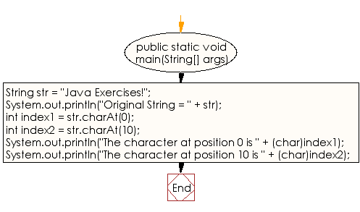

**public** **class** Program_1 {

**public** **static** **void** main(String[] args) {

// **TODO** Auto-generated method stub

String s = "Java Exercises!";

System.***out***.println("original string:"+s);

**char** c = s.charAt(0);

System.***out***.println("The character at index 0 is :"+c);

**char** ch = s.charAt(10);

System.***out***.println("The character at index 10 is :"+ch);

}

}

**Output:**

original string:Java Exercises!

The character at index 0 is :J

The character at index 10 is :i

**2. Write a Java program to get the character (Unicode code point) at the given index within the String.**

**Flowchart:**

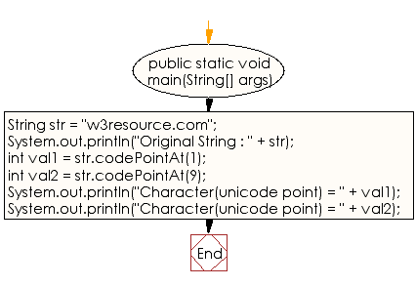

**public** **class** Program_2 {

**public** **static** **void** main(String[] args) {

// **TODO** Auto-generated method stub

String str = "w3resource.com";

System.***out***.println("Original String : " + str);

// codepoint at index 1

**int** val1 = str.codePointAt(1);

// codepoint at index 9

**int** val2 = str.codePointAt(9);

// prints character at index1 in string

System.***out***.println("Character(unicode point) = " + val1);

// prints character at index9 in string

System.***out***.println("Character(unicode point) = " + val2);

}

}

**Output:**

Original String : w3resource.com

Character(unicode point) = 51

Character(unicode point) = 101

**3. Write a Java program to get the character (Unicode code point) before the specified index within the String.**

**Flowchart:**

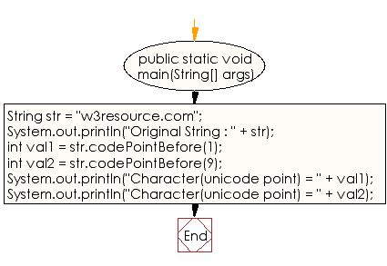

**public** **class** Program_3 {

**public** **static** **void** main(String[] args) {

// **TODO** Auto-generated method stub

String str = "w3resource.com";

System.***out***.println("Original String : " + str);

// codepoint before index 1

**int** val1 = str.codePointBefore(1);

// codepoint before index 9

**int** val2 = str.codePointBefore(9);

// prints character before index1 in string

System.***out***.println("Character(unicode point) = " + val1);

// prints character before index9 in string

System.***out***.println("Character(unicode point) = " + val2);

}

}

**Output:**

Original String : w3resource.com

Character(unicode point) = 119

Character(unicode point) = 99

**4. Write a java program to count a number of Unicode code points in the specified text range of a String.**

**Flowchart:**

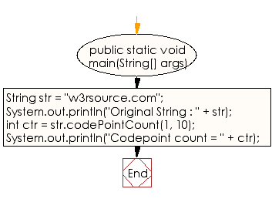

**public** **class** Program_4 {

**public** **static** **void** main(String[] args) {

// **TODO** Auto-generated method stub

String str = "w3rsource.com";

System.***out***.println("Original String : " + str);

// codepoint from index 1 to index 10

**int** ctr = str.codePointCount(1, 10);

// prints character from index 1 to index 10

System.***out***.println("Codepoint count = " + ctr);

}

}

**Output:**

Original String : w3rsource.com

Codepoint count = 9

**5. Write a java program to compare two strings lexicographically.**

**Flowchart:**

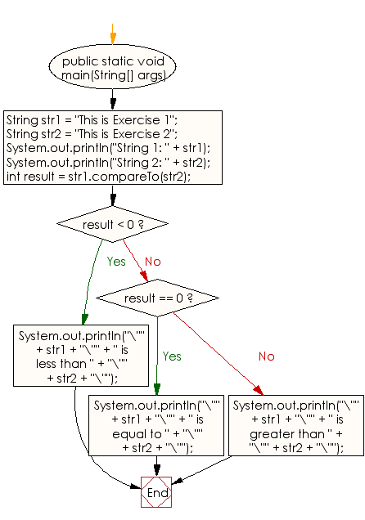

**public** **class** Program_5 {

**public** **static** **void** main(String[] args) {

// **TODO** Auto-generated method stub

String str1 = "This is Exercise 1";

String str2 = "This is Exercise 2";

System.***out***.println("String 1: " + str1);

System.***out***.println("String 2: " + str2);

// Compare the two strings.

**int** result = str1.compareTo(str2);

// Display the results of the comparison.

**if** (result < 0)

{

System.***out***.println("\"" + str1 + "\"" +

" is less than " +

"\"" + str2 + "\"");

}

**else** **if** (result == 0)

{

System.***out***.println("\"" + str1 + "\"" +

" is equal to " +

"\"" + str2 + "\"");

}

**else** // if (result > 0)

{

System.***out***.println("\"" + str1 + "\"" +

" is greater than " +

"\"" + str2 + "\"");

}

}

}

**Output:**

String 1: This is Exercise 1

String 2: This is Exercise 2

"This is Exercise 1" is less than "This is Exercise 2"

**6. Write a java program to compare two strings lexicographically, ignoring case differences.**

**Flowchart:**

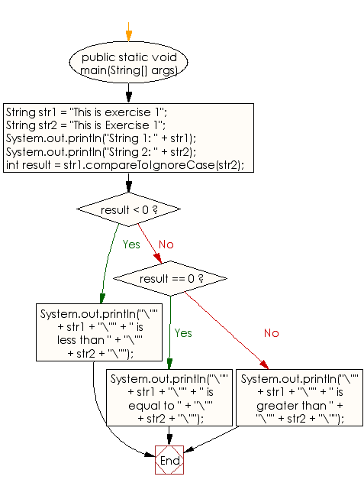

**public** **class** Program_6 {

**public** **static** **void** main(String[] args) {

// **TODO** Auto-generated method stub

String str1 = "This is exercise 1";

String str2 = "This is Exercise 1";

System.***out***.println("String 1: " + str1);

System.***out***.println("String 2: " + str2);

// Compare the two strings.

**int** result = str1.compareToIgnoreCase(str2);

// Display the results of the comparison.

**if** (result < 0)

{

System.***out***.println("\"" + str1 + "\"" +

" is less than " +

"\"" + str2 + "\"");

}

**else** **if** (result == 0)

{

System.***out***.println("\"" + str1 + "\"" +

" is equal to " +

"\"" + str2 + "\"");

}

**else** // if (result > 0)

{

System.***out***.println("\"" + str1 + "\"" +

" is greater than " +

"\"" + str2 + "\"");

}

}

}

**Output:**

String 1: This is exercise 1

String 2: This is Exercise 1

"This is exercise 1" is equal to "This is Exercise 1"

**7. Write a Java program to concatenate a given string to the end of another string.**

**Flowchart:**

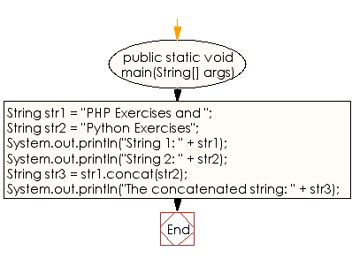

**public** **class** Program_7 {

**public** **static** **void** main(String[] args) {

// **TODO** Auto-generated method stub

String str1 = "PHP Exercises and ";

String str2 = "Python Exercises";

System.***out***.println("String 1: " + str1);

System.***out***.println("String 2: " + str2);

// Concatenate the two strings together.

String str3 = str1.concat(str2);

// Display the new String.

System.***out***.println("The concatenated string: " + str3);

}

}

**Output:**

String 1: PHP Exercises and

String 2: Python Exercises

The concatenated string: PHP Exercises and Python Exercises

**8. Write a Java program to test if a given string contains the specified sequence of char values.**

**Flowchart:**

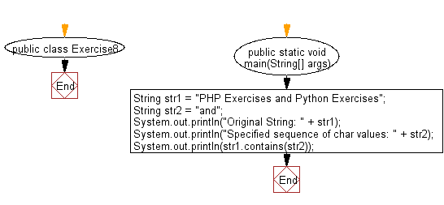

**public** **class** Program_8 {

**public** **static** **void** main(String[] args) {

// **TODO** Auto-generated method stub

String str1 = "PHP Exercises and Python Exercises";

String str2 = "and";

System.***out***.println("Original String: " + str1);

System.***out***.println("Specified sequence of char values: " + str2);

System.***out***.println(str1.contains(str2));

}

}

**Output:**

Original String: PHP Exercises and Python Exercises

Specified sequence of char values: and

true

**9. Write a Java program to compare a given string to the specified character sequence.**

**Flowchart:**

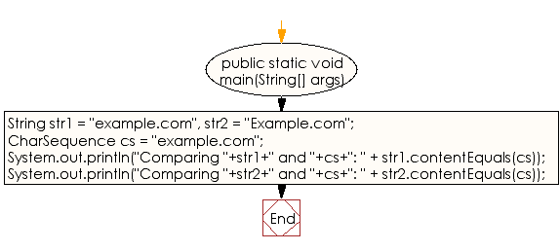

**public** **class** Program_9 {

**public** **static** **void** main(String[] args) {

// **TODO** Auto-generated method stub

String str1 = "example.com", str2 = "Example.com";

CharSequence cs = "example.com";

System.***out***.println("Comparing "+str1+" and "+cs+": " + str1.contentEquals(cs));

System.***out***.println("Comparing "+str2+" and "+cs+": " + str2.contentEquals(cs));

}

}

**Output:**

Comparing example.com and example.com: true

Comparing Example.com and example.com: false

**10. Write a Java program to compare a given string to the specified string buffer.**

**Flowchart:**

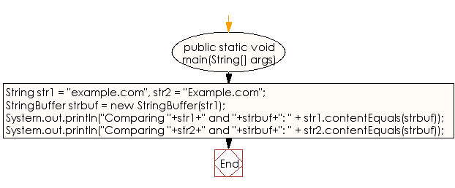

**public** **class** Program_10 {

**public** **static** **void** main(String[] args) {

// **TODO** Auto-generated method stub

String str1 = "example.com", str2 = "Example.com";

StringBuffer strbuf = **new** StringBuffer(str1);

System.***out***.println("Comparing "+str1+" and "+strbuf+": " + str1.contentEquals(strbuf));

System.***out***.println("Comparing "+str2+" and "+strbuf+": " + str2.contentEquals(strbuf));

}

}

**Output:**

Comparing example.com and example.com: true

Comparing Example.com and example.com: false

**11. Write a Java program to create a new String object with the contents of a character array.**

**Flowchart:**

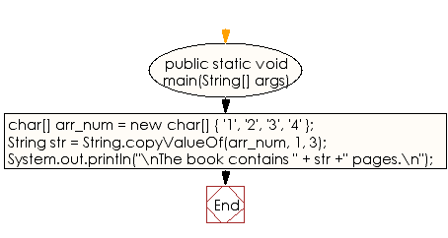

**public** **class** Program_11 {

**public** **static** **void** main(String[] args) {

// **TODO** Auto-generated method stub

// Character array with data.

**char**[] arr_num = **new** **char**[] { '1', '2', '3', '4' };

// Create a String containig the contents of arr_num

// starting at index 1 for length 2.

String str = String.*copyValueOf*(arr_num, 1, 3);

// Display the results of the new String.

System.***out***.println("\nThe book contains " + str +" pages.\n");

}

}

**Output:**

The book contains 234 pages.

**12. Write a Java program to check whether a given string ends with the contents of another string.**

**Flowchart:**

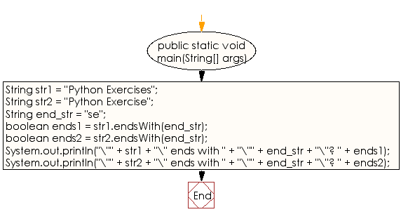

**public** **class** Program_12 {

**public** **static** **void** main(String[] args) {

// **TODO** Auto-generated method stub

String str1 = "Python Exercises";

String str2 = "Python Exercise";

// The String to check the above two Strings to see

// if they end with this value (se).

String end_str = "se";

// Check first two Strings end with end_str

**boolean** ends1 = str1.endsWith(end_str);

**boolean** ends2 = str2.endsWith(end_str);

// Display the results of the endsWith calls.

System.***out***.println("\"" + str1 + "\" ends with " +

"\"" + end_str + "\"? " + ends1);

System.***out***.println("\"" + str2 + "\" ends with " +

"\"" + end_str + "\"? " + ends2);

}

}

**Output:**

"Python Exercises" ends with "se"? false

"Python Exercise" ends with "se"? true

**13. Write a Java program to check whether two String objects contain the same data.**

**Flowchart:**

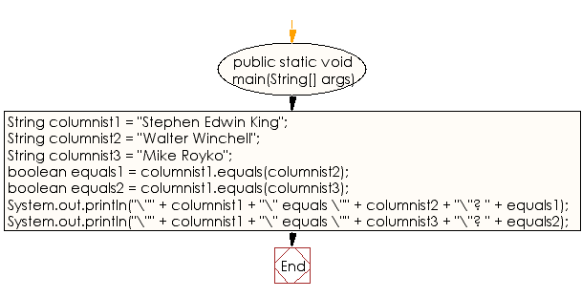

**public** **class** Program_13 {

**public** **static** **void** main(String[] args) {

// **TODO** Auto-generated method stub

String columnist1 = "Stephen Edwin King";

String columnist2 = "Walter Winchell";

String columnist3 = "Mike Royko";

// Are any of the above Strings equal to one another?

**boolean** equals1 = columnist1.equals(columnist2);

**boolean** equals2 = columnist1.equals(columnist3);

// Display the results of the equality checks.

System.***out***.println("\"" + columnist1 + "\" equals \"" +

columnist2 + "\"? " + equals1);

System.***out***.println("\"" + columnist1 + "\" equals \"" +

columnist3 + "\"? " + equals2);

}

}

**Output:**

"Stephen Edwin King" equals "Walter Winchell"? false

"Stephen Edwin King" equals "Mike Royko"? false

**14. Write a Java program to compare a given string to another string, ignoring case considerations**

**Flowchart:**

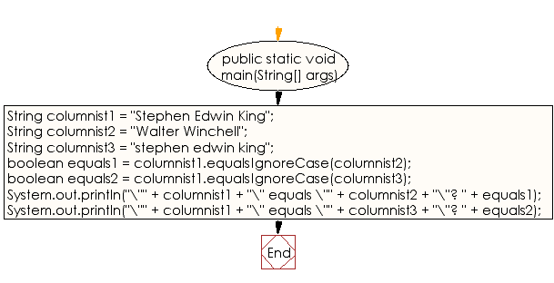

**public** **class** Program_14 {

**public** **static** **void** main(String[] args) {

// **TODO** Auto-generated method stub

String columnist1 = "Stephen Edwin King";

String columnist2 = "Walter Winchell";

String columnist3 = "stephen edwin king";

// Test any of the above Strings equal to one another

**boolean** equals1 = columnist1.equalsIgnoreCase(columnist2);

**boolean** equals2 = columnist1.equalsIgnoreCase(columnist3);

// Display the results of the equality checks.

System.***out***.println("\"" + columnist1 + "\" equals \"" +

columnist2 + "\"? " + equals1);

System.***out***.println("\"" + columnist1 + "\" equals \"" +

columnist3 + "\"? " + equals2);

}

}

**Output:**

"Stephen Edwin King" equals "Walter Winchell"? false

"Stephen Edwin King" equals "stephen edwin king"? true

**15. Write a java program to print current date and time in the specified format.**

**Flowchart:**

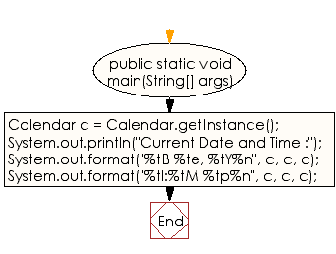

**public** **class** Program_15 {

**public** **static** **void** main(String[] args) {

// **TODO** Auto-generated method stub

Calendar c = Calendar.*getInstance*();

System.***out***.println("Current Date and Time :");

System.***out***.format("%tB %te, %tY%n", c, c, c);

System.***out***.format("%tl:%tM %tp%n", c, c, c);

}

}

**Output:**

Current Date and Time :

April 17, 2020

6:57 pm

**16. Write a Java program to get the contents of a given string as a byte array**

**Flowchart:**

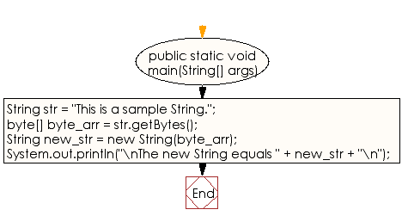

**public** **class** Program_16 {

**public** **static** **void** main(String[] args) {

// **TODO** Auto-generated method stub

String str = "This is a sample String.";

// Copy the contents of the String to a byte array.

**byte**[] byte_arr = str.getBytes();

// Create a new String using the contents of the byte array.

String new_str = **new** String(byte_arr);

// Display the contents of the byte array.

System.***out***.println("\nThe new String equals " +

new_str + "\n");

}

}

**Output:**

The new String equals This is a sample String.

**17. Write a Java program to get the contents of a given string as a character array.**

**Flowchart:**

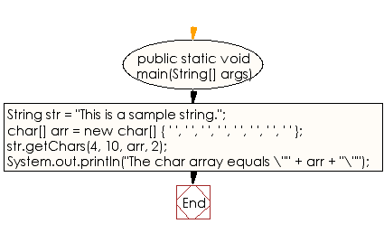

**public** **class** Program_17 {

**public** **static** **void** main(String[] args) {

// **TODO** Auto-generated method stub

String str = "This is a sample string.";

// Copy the contents of the String to a byte array.

// Only copy characters 4 through 10 from str.

// Fill the source array starting at position 2.

**char**[] arr = **new** **char**[] { ' ', ' ', ' ', ' ',

' ', ' ', ' ', ' ' };

str.getChars(4, 10, arr, 2);

// Display the contents of the byte array.

System.***out***.println("The char array equals \"" +

arr + "\"");

}

}

**Output:**

The char array equals "[C@4617c264"

**18. Write a Java program to create a unique identifier of a given string.**

**Flowchart:**

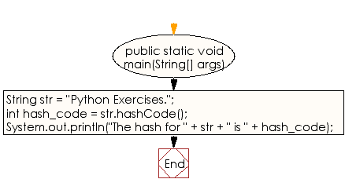

**public** **class** Program_18 {

**public** **static** **void** main(String[] args) {

// **TODO** Auto-generated method stub

String str = "Python Exercises.";

// Get the hash code for the above string.

**int** hash_code = str.hashCode();

// Display the hash code.

System.***out***.println("The hash for " + str +

" is " + hash_code);

}

}

**Output:**

The hash for Python Exercises. is 863132599

**19. Write a Java program to get the index of all the characters of the alphabet.**

**Flowchart:**

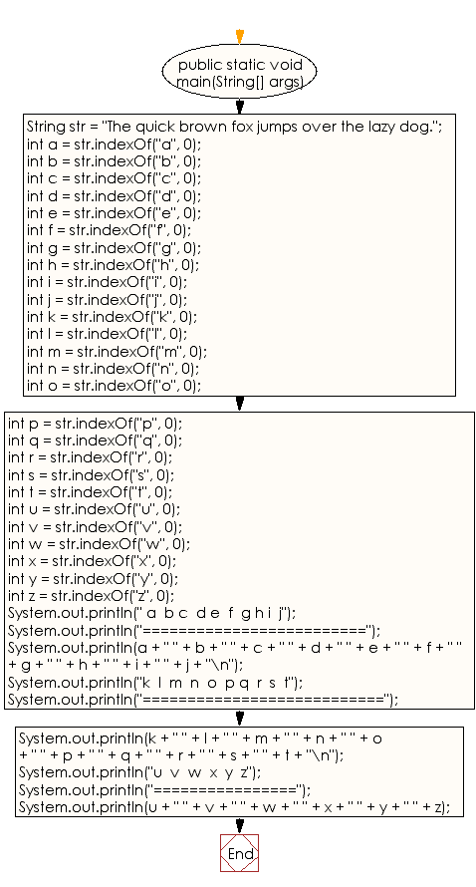

**public** **class** Program_19 {

**public** **static** **void** main(String[] args) {

// **TODO** Auto-generated method stub

String str = "The quick brown fox jumps over the lazy dog.";

// Get the index of all the characters of the alphabet

// starting from the beginning of the String.

**int** a = str.indexOf("a", 0);

**int** b = str.indexOf("b", 0);

**int** c = str.indexOf("c", 0);

**int** d = str.indexOf("d", 0);

**int** e = str.indexOf("e", 0);

**int** f = str.indexOf("f", 0);

**int** g = str.indexOf("g", 0);

**int** h = str.indexOf("h", 0);

**int** i = str.indexOf("i", 0);

**int** j = str.indexOf("j", 0);

**int** k = str.indexOf("k", 0);

**int** l = str.indexOf("l", 0);

**int** m = str.indexOf("m", 0);

**int** n = str.indexOf("n", 0);

**int** o = str.indexOf("o", 0);

**int** p = str.indexOf("p", 0);

**int** q = str.indexOf("q", 0);

**int** r = str.indexOf("r", 0);

**int** s = str.indexOf("s", 0);

**int** t = str.indexOf("t", 0);

**int** u = str.indexOf("u", 0);

**int** v = str.indexOf("v", 0);

**int** w = str.indexOf("w", 0);

**int** x = str.indexOf("x", 0);

**int** y = str.indexOf("y", 0);

**int** z = str.indexOf("z", 0);

// Display the results of all the indexOf method calls.

System.***out***.println(" a b c d e f g h i j");

System.***out***.println("=========================");

System.***out***.println(a + " " + b + " " + c + " " + d + " " +

e + " " + f + " " + g + " " + h + " " +

i + " " + j + "\n");

System.***out***.println("k l m n o p q r s t");

System.***out***.println("===========================");

System.***out***.println(k + " " + l + " " + m + " " + n + " " +

o + " " + p + " " + q + " " + r + " " +

s + " " + t + "\n");

System.***out***.println("u v w x y z");

System.***out***.println("================");

System.***out***.println(u + " " + v + " " + w + " " + x + " " +

y + " " + z);

}

}

**Output:**

a b c d e f g h i j

=========================

36 10 7 40 2 16 42 1 6 20

k l m n o p q r s t

===========================

8 35 22 14 12 23 4 11 24 31

u v w x y z

================

5 27 13 18 38 37

**20. Write a Java program to get the canonical representation of the string object.**

**Flowchart:**

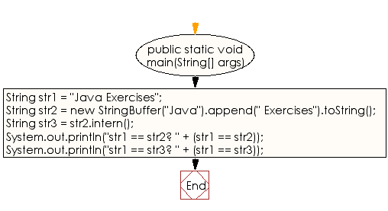

**public** **class** Program_20 {

**public** **static** **void** main(String[] args) {

// **TODO** Auto-generated method stub

String str1 = "Java Exercises";

String str2 = **new** StringBuffer("Java").append(" Exercises").toString();

String str3 = str2.intern();

// Determine which strings are equivalent using the ==

// operator (as compared to calling equals(), which is

// a more expensive operation.

System.***out***.println("str1 == str2? " + (str1 == str2));

System.***out***.println("str1 == str3? " + (str1 == str3));

}

}

**Output:**

str1 == str2? false

str1 == str3? true

**21. Write a Java program to get the last index of a string within a string.**

**Flowchart:**

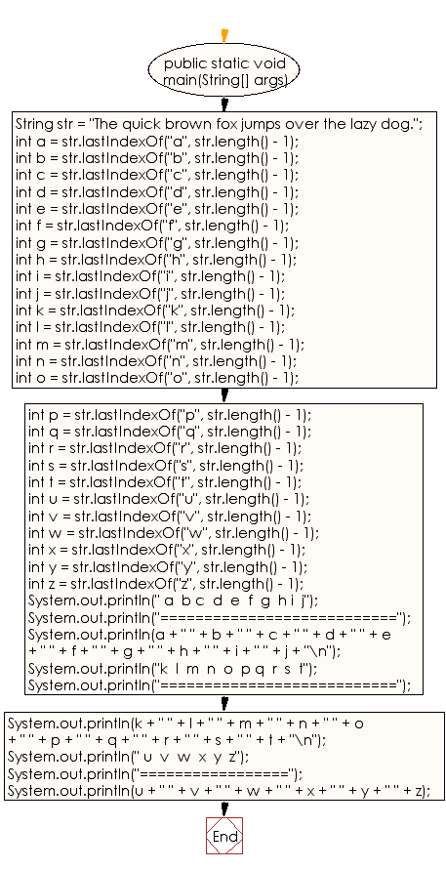

**public** **class** Program_21 {

**public** **static** **void** main(String[] args) {

// **TODO** Auto-generated method stub

String str = "The quick brown fox jumps over the lazy dog.";

// Get the index of all the characters of the alphabet

// starting from the beginning of the String.

**int** a = str.lastIndexOf("a", str.length() - 1);

**int** b = str.lastIndexOf("b", str.length() - 1);

**int** c = str.lastIndexOf("c", str.length() - 1);

**int** d = str.lastIndexOf("d", str.length() - 1);

**int** e = str.lastIndexOf("e", str.length() - 1);

**int** f = str.lastIndexOf("f", str.length() - 1);

**int** g = str.lastIndexOf("g", str.length() - 1);

**int** h = str.lastIndexOf("h", str.length() - 1);

**int** i = str.lastIndexOf("i", str.length() - 1);

**int** j = str.lastIndexOf("j", str.length() - 1);

**int** k = str.lastIndexOf("k", str.length() - 1);

**int** l = str.lastIndexOf("l", str.length() - 1);

**int** m = str.lastIndexOf("m", str.length() - 1);

**int** n = str.lastIndexOf("n", str.length() - 1);

**int** o = str.lastIndexOf("o", str.length() - 1);

**int** p = str.lastIndexOf("p", str.length() - 1);

**int** q = str.lastIndexOf("q", str.length() - 1);

**int** r = str.lastIndexOf("r", str.length() - 1);

**int** s = str.lastIndexOf("s", str.length() - 1);

**int** t = str.lastIndexOf("t", str.length() - 1);

**int** u = str.lastIndexOf("u", str.length() - 1);

**int** v = str.lastIndexOf("v", str.length() - 1);

**int** w = str.lastIndexOf("w", str.length() - 1);

**int** x = str.lastIndexOf("x", str.length() - 1);

**int** y = str.lastIndexOf("y", str.length() - 1);

**int** z = str.lastIndexOf("z", str.length() - 1);

// Display the results of all the lastIndexOf method calls.

System.***out***.println(" a b c d e f g h i j");

System.***out***.println("===========================");

System.***out***.println(a + " " + b + " " + c + " " + d + " " +

e + " " + f + " " + g + " " + h + " " +

i + " " + j + "\n");

System.***out***.println("k l m n o p q r s t");

System.***out***.println("===========================");

System.***out***.println(k + " " + l + " " + m + " " + n + " " +

o + " " + p + " " + q + " " + r + " " +

s + " " + t + "\n");

System.***out***.println(" u v w x y z");

System.***out***.println("=================");

System.***out***.println(u + " " + v + " " + w + " " + x + " " +

y + " " + z);

}

}

**Output:**

a b c d e f g h i j

===========================

36 10 7 40 33 16 42 32 6 20

k l m n o p q r s t

===========================

8 35 22 14 41 23 4 29 24 31

u v w x y z

=================

21 27 13 18 38 37

**22. Write a java program to get the length of a given string.**

**Flowchart:**

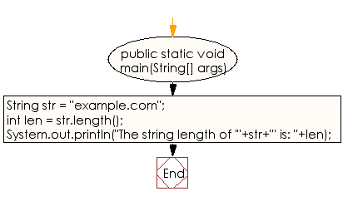

**public** **class** Program_22 {

**public** **static** **void** main(String[] args) {

// **TODO** Auto-generated method stub

String str = "example.com";

// Get the length of str.

**int** len = str.length();

System.***out***.println("The string length of '"+str+"' is: "+len);

}

}

**Output:**

The string length of 'example.com' is: 11

**23. Write a Java program to find whether a region in the current string matches a region in another string.**

**Flowchart:**

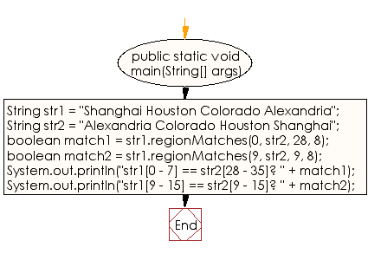

**public** **class** Program_23 {

**public** **static** **void** main(String[] args) {

// **TODO** Auto-generated method stub

String str1 = "Shanghai Houston Colorado Alexandria";

String str2 = "Alexandria Colorado Houston Shanghai";

// Determine whether characters 0 through 7 in str1

// match characters 28 through 35 in str2.

//boolean java.lang.String.regionMatches(int toffset, String other, int ooffset, int len)

**boolean** match1 = str1.regionMatches(0, str2, 28, 8);

// Determine whether characters 9 through 15 in str1

// match characters 9 through 15 in str2.

**boolean** match2 = str1.regionMatches(9, str2, 9, 8);

// Display the results of the regionMatches method calls.

System.***out***.println("str1[0 - 7] == str2[28 - 35]? " + match1);

System.***out***.println("str1[9 - 15] == str2[9 - 15]? " + match2);

}

}

**Output:**

str1[0 - 7] == str2[28 - 35]? true

str1[9 - 15] == str2[9 - 15]? false

**24. Write a Java program to replace all the 'd' characters with 'f' characters.**

**Flowchart:**

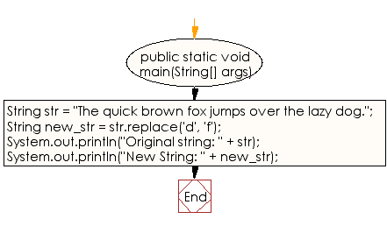

**public** **class** Program_24 {

**public** **static** **void** main(String[] args) {

// **TODO** Auto-generated method stub

String str = "The quick brown fox jumps over the lazy dog.";

// Replace all the 'd' characters with 'f' characters.

String new_str = str.replace('d', 'f');

// Display the strings for comparison.

System.***out***.println("Original string: " + str);

System.***out***.println("New String: " + new_str);

}

}

**Output:**

Original string: The quick brown fox jumps over the lazy dog.

New String: The quick brown fox jumps over the lazy fog.

**25. Write a Java program to replace each substring of a given string that matches the given regular expression with the given replacement.**

**Flowchart:**

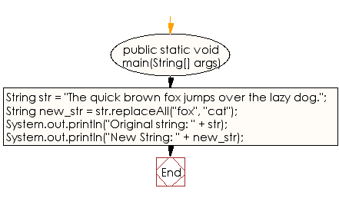

**public** **class** Program_25 {

**public** **static** **void** main(String[] args) {

// **TODO** Auto-generated method stub

String str = "The quick brown fox jumps over the lazy dog.";

// Replace all the 'dog' with 'cat'.

String new_str = str.replaceAll("fox", "cat");

// Display the strings for comparison.

System.***out***.println("Original string: " + str);

System.***out***.println("New String: " + new_str);

}

}

**Output:**

Original string: The quick brown fox jumps over the lazy dog.

New String: The quick brown cat jumps over the lazy dog.

**26. Write a Java program to check whether a given string starts with the contents of another string.**

**Flowchart:**

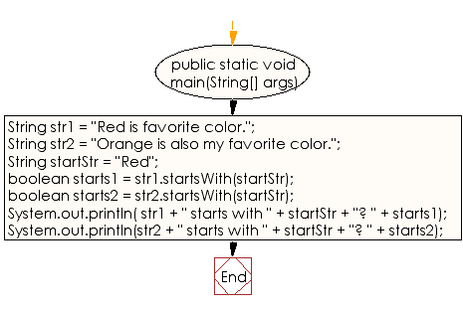

**public** **class** Program_26 {

**public** **static** **void** main(String[] args) {

// **TODO** Auto-generated method stub

String str1 = "Red is favorite color.";

String str2 = "Orange is also my favorite color.";

// The String to check the above two Strings to see

// if they start with this value (Red).

String startStr = "Red";

// Do either of the first two Strings start with startStr?

**boolean** starts1 = str1.startsWith(startStr);

**boolean** starts2 = str2.startsWith(startStr);

// Display the results of the startsWith calls.

System.***out***.println( str1 + " starts with " +

startStr + "? " + starts1);

System.***out***.println(str2 + " starts with " +

startStr + "? " + starts2);

}

}

**Output:**

Red is favorite color. starts with Red? true

Orange is also my favorite color. starts with Red? false

**27. Write a Java program to get a substring of a given string between two specified positions.**

**Flowchart:**

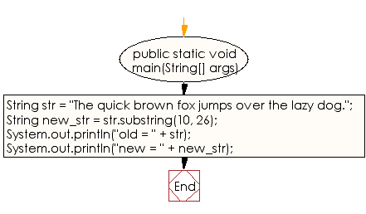

**public** **class** Program_27 {

**public** **static** **void** main(String[] args) {

// **TODO** Auto-generated method stub

String str = "The quick brown fox jumps over the lazy dog.";

// Get a substring of the above string starting from

// index 10 and ending at index 26.

String new_str = str.substring(10, 26);

// Display the two strings for comparison.

System.***out***.println("old = " + str);

System.***out***.println("new = " + new_str);

}

}

**Output:**

old = The quick brown fox jumps over the lazy dog.

new = brown fox jumps

**28. Write a Java program to create a character array containing the contents of a string.**

**Flowchart:**

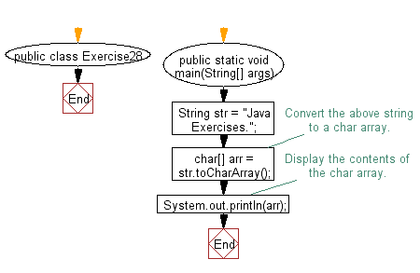

**public** **class** Program_28 {

**public** **static** **void** main(String[] args) {

// **TODO** Auto-generated method stub

String str = "Java Exercises.";

// Convert the above string to a char array.

**char**[] arr = str.toCharArray();

// Display the contents of the char array.

System.***out***.println(arr);

}

}

**Output:**

Java Exercises.

**29. Write a Java program to convert all the characters in a string to lowercase**

**Flowchart:**

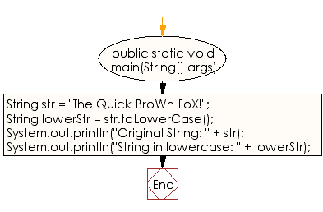

**public** **class** Program_29 {

**public** **static** **void** main(String[] args) {

// **TODO** Auto-generated method stub

String str = "The Quick BroWn FoX!";

// Convert the above string to all lowercase.

String lowerStr = str.toLowerCase();

// Display the two strings for comparison.

System.***out***.println("Original String: " + str);

System.***out***.println("String in lowercase: " + lowerStr);

}

}

**Output:**

Original String: The Quick BroWn FoX!

String in lowercase: the quick brown fox!

**30. Write a Java program to convert all the characters in a string to uppercase.**

**Flowchart:**

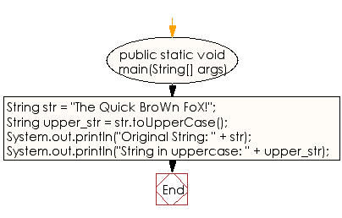

**public** **class** Program_30 {

**public** **static** **void** main(String[] args) {

// **TODO** Auto-generated method stub

String str = "The Quick BroWn FoX!";

// Convert the above string to all uppercase.

String upper_str = str.toUpperCase();

// Display the two strings for comparison.

System.***out***.println("Original String: " + str);

System.***out***.println("String in uppercase: " + upper_str);

}

}

**Output:**

Original String: The Quick BroWn FoX!

String in uppercase: THE QUICK BROWN FOX!

**31. Write a Java program to trim any leading or trailing whitespace from a given string.**

**Flowchart:**

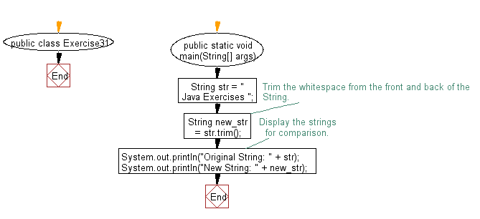

**public** **class** Program_31 {

**public** **static** **void** main(String[] args) {

// **TODO** Auto-generated method stub

String str = " Java Exercises ";

// Trim the whitespace from the front and back of the

// String.

String new_str = str.trim();

// Display the strings for comparison.

System.***out***.println("Original String: " + str);

System.***out***.println("New String: " + new_str);

}

}

**Output:**

Original String: Java Exercises

New String: Java Exercises

**32. Write a Java program to find longest Palindromic Substring within a string.**

**Flowchart:**

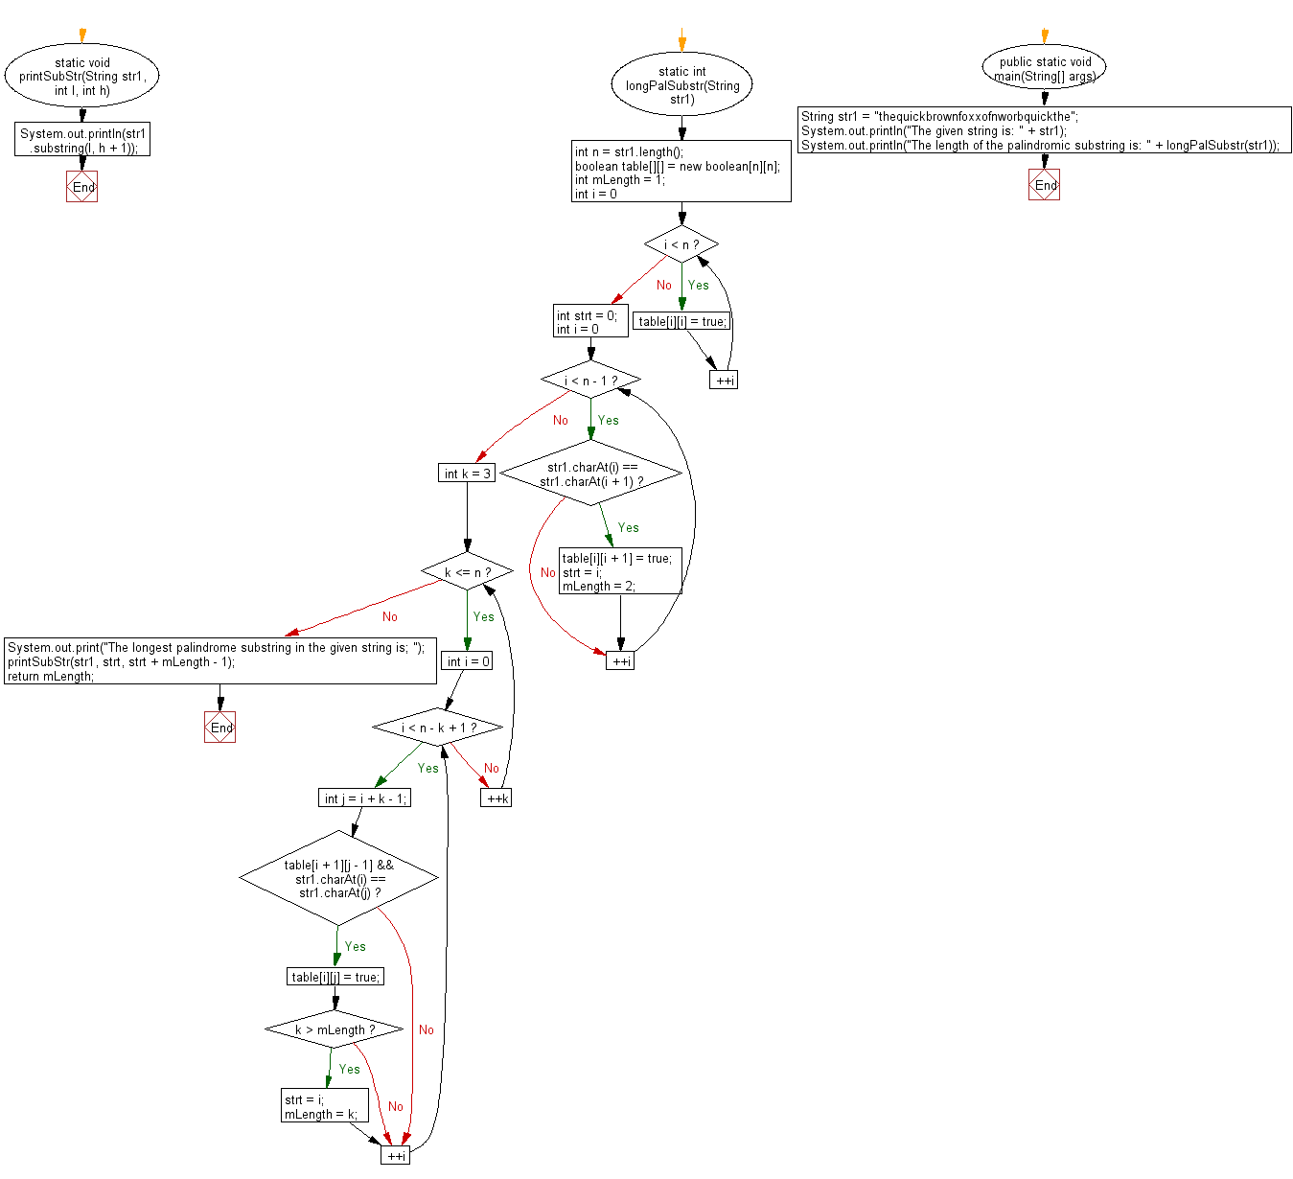

**public** **class** Program_32 {

**static** **void** printSubStr(String str1, **int** l, **int** h) {

System.***out***.println(str1.substring(l, h + 1));

}

**static** **int** longPalSubstr(String str1) {

**int** n = str1.length();

**boolean** table[][] = **new** **boolean**[n][n];

**int** mLength = 1;

**for** (**int** i = 0; i < n; ++i)

table[i][i] = **true**;

**int** strt = 0;

**for** (**int** i = 0; i < n - 1; ++i) {

**if** (str1.charAt(i) == str1.charAt(i + 1)) {

table[i][i + 1] = **true**;

strt = i;

mLength = 2;

}

}

**for** (**int** k = 3; k <= n; ++k) {

**for** (**int** i = 0; i < n - k + 1; ++i) {

**int** j = i + k - 1;

**if** (table[i + 1][j - 1] && str1.charAt(i) == str1.charAt(j)) {

table[i][j] = **true**;

**if** (k > mLength) {

strt = i;

mLength = k;

}

}

}

}

System.***out***.print("The longest palindrome substring in the given string is; ");

*printSubStr*(str1, strt, strt + mLength - 1);

**return** mLength;

}

**public** **static** **void** main(String[] args) {

// **TODO** Auto-generated method stub

String str1 = "thequickbrownfoxxofnworbquickthe";

System.***out***.println("The given string is: " + str1);

System.***out***.println("The length of the palindromic substring is: " + *longPalSubstr*(str1));

}

}

**Output:**

The given string is: thequickbrownfoxxofnworbquickthe

The longest palindrome substring in the given string is; brownfoxxofnworb

The length of the palindromic substring is: 16

**33. Write a Java program to find all interleavings of given strings.**

**Flowchart:**

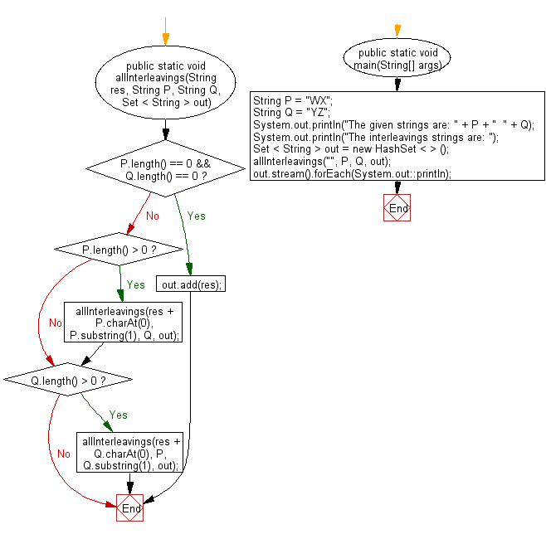

**import** java.util.HashSet;

**import** java.util.Set;

**public** **class** Program_33 {

**public** **static** **void** allInterleavings(String res, String P, String Q, Set < String > out) {

**if** (P.length() == 0 && Q.length() == 0) {

out.add(res);

**return**;

}

**if** (P.length() > 0) {

*allInterleavings*(res + P.charAt(0), P.substring(1), Q, out);

}

**if** (Q.length() > 0) {

*allInterleavings*(res + Q.charAt(0), P, Q.substring(1), out);

}

}

**public** **static** **void** main(String[] args) {

// **TODO** Auto-generated method stub

String P = "WX";

String Q = "YZ";

System.***out***.println("The given strings are: " + P + " " + Q);

System.***out***.println("The interleavings strings are: ");

Set < String > out = **new** HashSet < > ();

*allInterleavings*("", P, Q, out);

out.stream().forEach(System.***out***::println);

}

}

**Output:**

The given strings are: WX YZ

The interleavings strings are:

YWZX

WYZX

YWXZ

WXYZ

YZWX

WYXZ

**34. Write a Java program to find the second most frequent character in a given string.**

**Flowchart:**

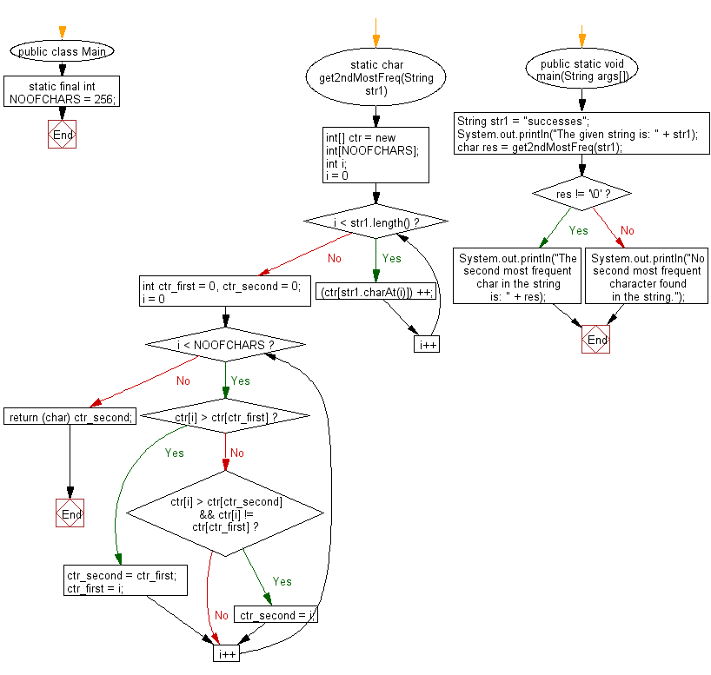

**public** **class** Program_34 {

**static** **final** **int** ***NOOFCHARS*** = 256;

**static** **char** get2ndMostFreq(String str1) {

**int**[] ctr = **new** **int**[***NOOFCHARS***];

**int** i;

**for** (i = 0; i < str1.length(); i++)

(ctr[str1.charAt(i)]) ++;

**int** ctr_first = 0, ctr_second = 0;

**for** (i = 0; i < ***NOOFCHARS***; i++) {

**if** (ctr[i] > ctr[ctr_first]) {

ctr_second = ctr_first;

ctr_first = i;

} **else** **if** (ctr[i] > ctr[ctr_second] && ctr[i] != ctr[ctr_first])

ctr_second = i;

}

**return** (**char**) ctr_second;

}

**public** **static** **void** main(String[] args) {

// **TODO** Auto-generated method stub

String str1 = "successes";

System.***out***.println("The given string is: " + str1);

**char** res = *get2ndMostFreq*(str1);

**if** (res != '\0')

System.***out***.println("The second most frequent char in the string is: " + res);

**else**

System.***out***.println("No second most frequent character found in the string.");

}

}

**Output:**

The given string is: successes

The second most frequent char in the string is: c

**35. Write a Java program to print all permutations of a given string with repetition.**

**Flowchart:**

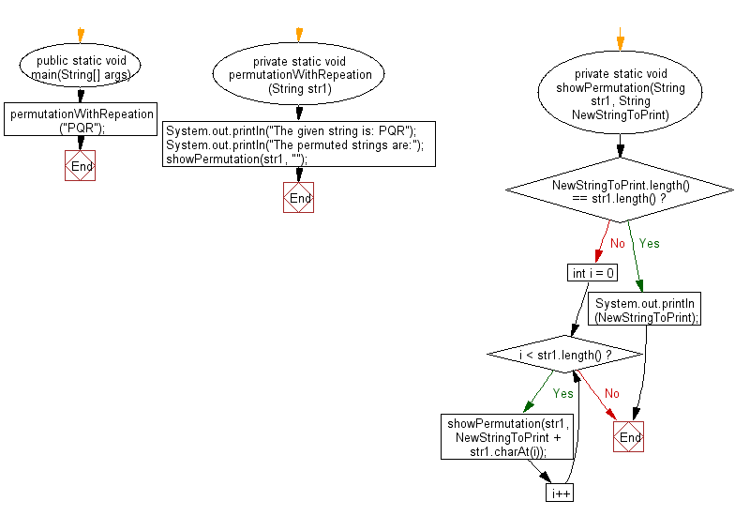

**public** **class** Program_35 {

**public** **static** **void** main(String[] args) {

// **TODO** Auto-generated method stub

*permutationWithRepeation*("PQR");

}

**private** **static** **void** permutationWithRepeation(String str1) {

System.***out***.println("The given string is: PQR");

System.***out***.println("The permuted strings are:");

*showPermutation*(str1, "");

}

**private** **static** **void** showPermutation(String str1, String NewStringToPrint) {

**if** (NewStringToPrint.length() == str1.length()) {

System.***out***.println(NewStringToPrint);

**return**;

}

**for** (**int** i = 0; i < str1.length(); i++) {

*showPermutation*(str1, NewStringToPrint + str1.charAt(i));

}

}

}

**Output:**

The given string is: PQR

The permuted strings are:

PPP

PPQ

PPR

PQP

PQQ

PQR

PRP

PRQ

PRR

QPP

QPQ

QPR

QQP

QQQ

QQR

QRP

QRQ

QRR

RPP

RPQ

RPR

RQP

RQQ

RQR

RRP

RRQ

RRR

**36. Write a Java program to check whether two strings are interleaving of a given string. Assuming that the unique characters in both strings.**

**Flowchart:**

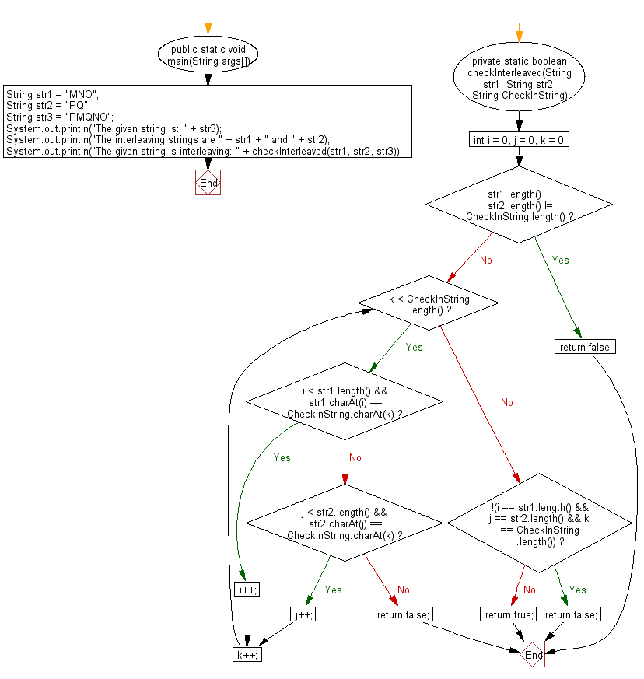

**public** **class** Program_36 {

**public** **static** **void** main(String[] args) {

// **TODO** Auto-generated method stub

String str1 = "MNO";

String str2 = "PQ";

String str3 = "PMQNO";

System.***out***.println("The given string is: " + str3);

System.***out***.println("The interleaving strings are " + str1 + " and " + str2);

System.***out***.println("The given string is interleaving: " + *checkInterleaved*(str1, str2, str3));

}

**private** **static** **boolean** checkInterleaved(String str1, String str2, String CheckInString) {

**int** i = 0, j = 0, k = 0;

**if** (str1.length() + str2.length() != CheckInString.length()) {

**return** **false**;

}

**while** (k < CheckInString.length()) {

**if** (i < str1.length() && str1.charAt(i) == CheckInString.charAt(k)) {

i++;

} **else** **if** (j < str2.length() && str2.charAt(j) == CheckInString.charAt(k)) {

j++;

} **else** {

**return** **false**;

}

k++;

}

**if** (!(i == str1.length() && j == str2.length() && k == CheckInString.length())) {

**return** **false**;

}

**return** **true**;

}

}

**Output:**

The given string is: PMQNO

The interleaving strings are MNO and PQ

The given string is interleaving: true

**37. Write a Java program to find Length of the longest substring without repeating characters.**

**Flowchart:**

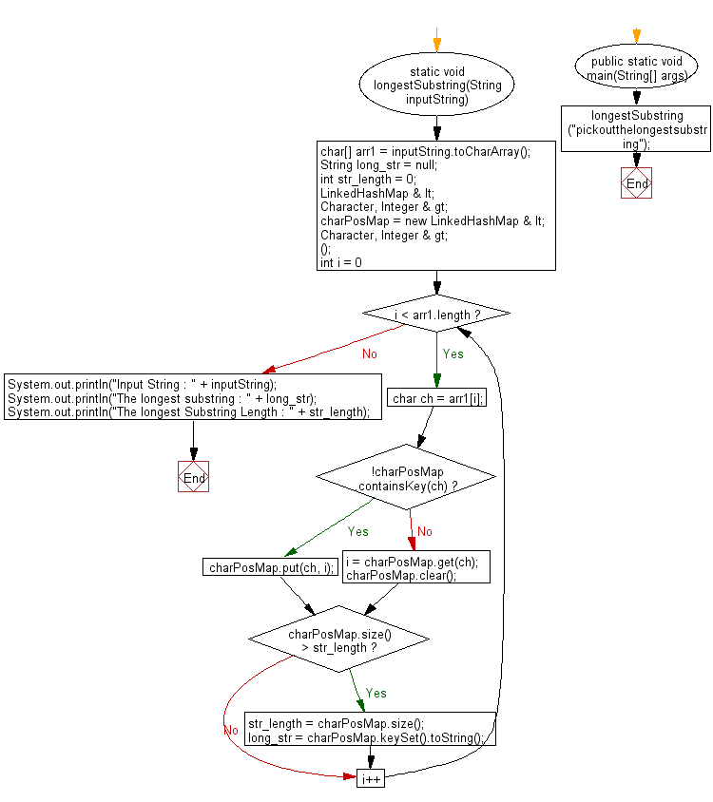

**import** java.util.LinkedHashMap;

**public** **class** Program_37 {

**static** **void** longestSubstring(String inputString) {

**char**[] arr1 = inputString.toCharArray();

String long_str = **null**;

**int** str_length = 0;

LinkedHashMap <

Character, Integer >

charPosMap = **new** LinkedHashMap <

Character, Integer >

();

**for** (**int** i = 0; i < arr1.length; i++) {

**char** ch = arr1[i];

**if** (!charPosMap.containsKey(ch)) {

charPosMap.put(ch, i);

} **else** {

i = charPosMap.get(ch);

charPosMap.clear();

}

**if** (charPosMap.size() > str_length) {

str_length = charPosMap.size();

long_str = charPosMap.keySet().toString();

}

}

System.***out***.println("Input String : " + inputString);

System.***out***.println("The longest substring : " + long_str);

System.***out***.println("The longest Substring Length : " + str_length);

}

**public** **static** **void** main(String[] args) {

// **TODO** Auto-generated method stub

*longestSubstring*("pickoutthelongestsubstring");

}

}

**Output:**

Input String : pickoutthelongestsubstring

The longest substring : [u, b, s, t, r, i, n, g]

The longest Substring Length : 8

**38. Write a Java program to print after removing duplicates from a given string.**

**Flowchart:**

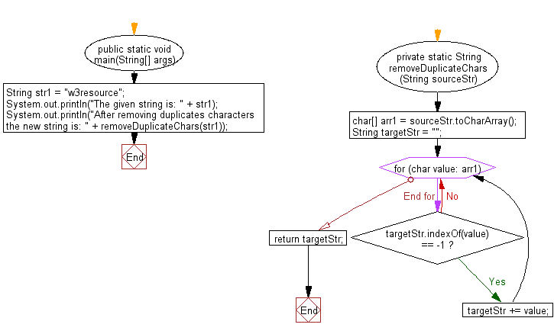

**public** **class** Program_38 {

**public** **static** **void** main(String[] args) {

// **TODO** Auto-generated method stub

String str1 = "w3resource";

System.***out***.println("The given string is: " + str1);

System.***out***.println("After removing duplicates characters the new string is: " + *removeDuplicateChars*(str1));

}

**private** **static** String removeDuplicateChars(String sourceStr) {

**char**[] arr1 = sourceStr.toCharArray();

String targetStr = "";

**for** (**char** value: arr1) {

**if** (targetStr.indexOf(value) == -1) {

targetStr += value;

}

}

**return** targetStr;

}

}

**Output:**

The given string is: w3resource

After removing duplicates characters the new string is: w3resouc

**39. Write a Java program to find first non repeating character in a string.**

**Flowchart:**

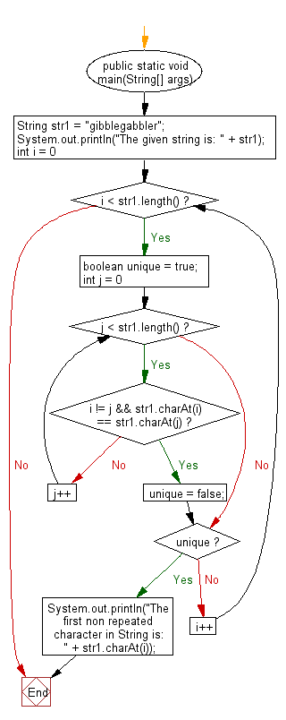

**public** **class** Program_39 {

**public** **static** **void** main(String[] args) {

// **TODO** Auto-generated method stub

String str1 = "gibblegabbler";

System.***out***.println("The given string is: " + str1);

**for** (**int** i = 0; i < str1.length(); i++) {

**boolean** unique = **true**;

**for** (**int** j = 0; j < str1.length(); j++) {

**if** (i != j && str1.charAt(i) == str1.charAt(j)) {

unique = **false**;

**break**;

}

}

**if** (unique) {

System.***out***.println("The first non repeated character in String is: " + str1.charAt(i));

**break**;

}

}

}

}

**Output:**

The given string is: gibblegabbler

The first non repeated character in String is: i

**40. Write a Java program to divide a string in n equal parts.**

**Flowchart:**

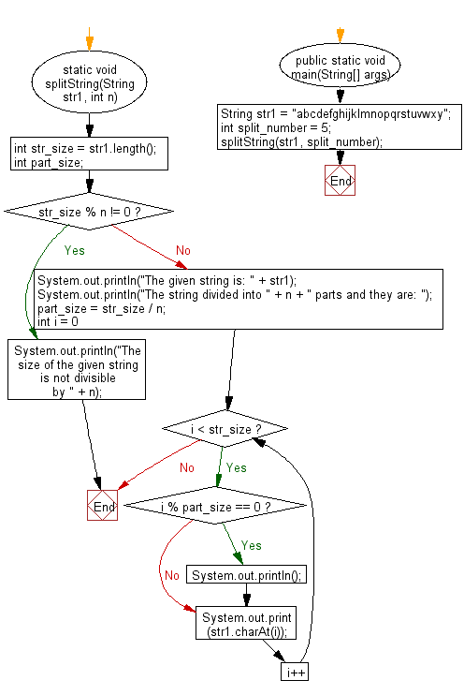

**public** **class** Program_40 {

**static** **void** splitString(String str1, **int** n) {

**int** str_size = str1.length();

**int** part_size;

**if** (str_size % n != 0) {

System.***out***.println("The size of the given string is not divisible by " + n);

**return**;

} **else** {

System.***out***.println("The given string is: " + str1);

System.***out***.println("The string divided into " + n + " parts and they are: ");

part_size = str_size / n;

**for** (**int** i = 0; i < str_size; i++) {

**if** (i % part_size == 0) System.***out***.println();

System.***out***.print(str1.charAt(i));

}

}

}

**public** **static** **void** main(String[] args) {

// **TODO** Auto-generated method stub

String str1 = "abcdefghijklmnopqrstuvwxy";

**int** split_number = 5;

*splitString*(str1, split_number);

}

}

**Output:**

The given string is: abcdefghijklmnopqrstuvwxy

The string divided into 5 parts and they are:

abcde

fghij

klmno

pqrst

uvwxy

**41. Write a Java program to remove duplicate characters from a given string presents in another given string.**

**Flowchart:**

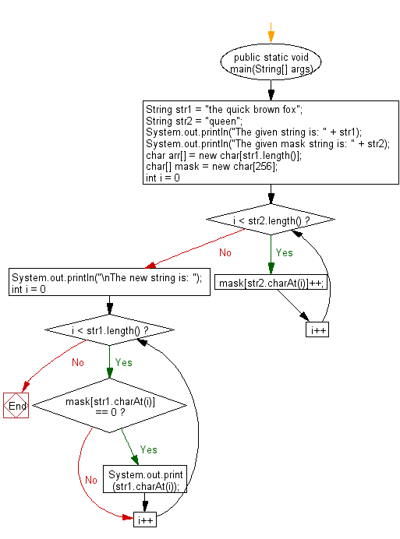

**public** **class** Program_41 {

**public** **static** **void** main(String[] args) {

// **TODO** Auto-generated method stub

String str1 = "the quick brown fox";

String str2 = "queen";

System.***out***.println("The given string is: " + str1);

System.***out***.println("The given mask string is: " + str2);

**char**[] arr = **new** **char**[str1.length()];

**char**[] mask = **new** **char**[256];

**for** (**int** i = 0; i < str2.length(); i++)

mask[str2.charAt(i)]++;

System.***out***.println("\nThe new string is: ");

**for** (**int** i = 0; i < str1.length(); i++) {

**if** (mask[str1.charAt(i)] == 0)

System.***out***.print(str1.charAt(i));

}

}

}

**Output:**

The given string is: the quick brown fox

The given mask string is: queen

The new string is:

th ick brow fox

**42. Write a Java program to print list items containing all characters of a given word.**

**Flowchart:**

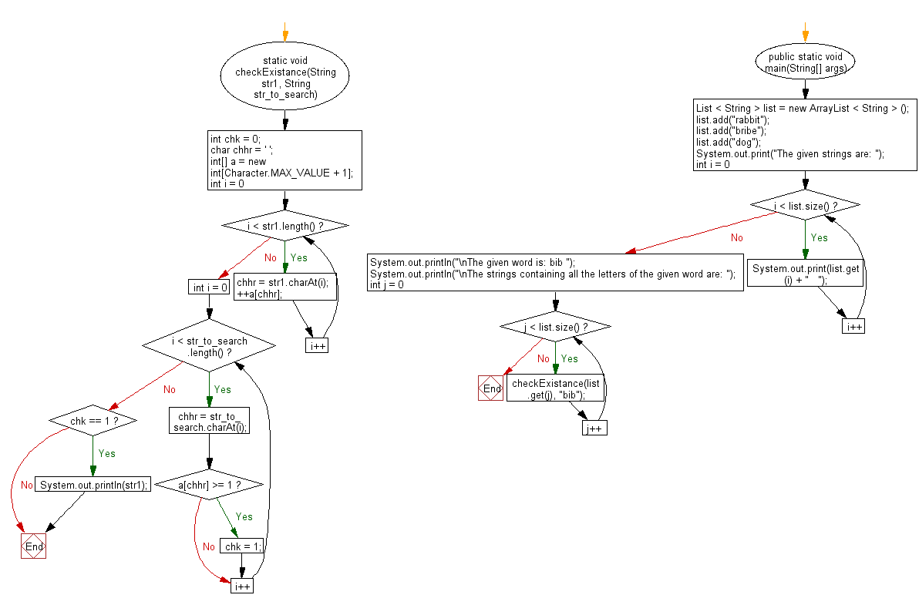

**import** java.util.ArrayList;

**import** java.util.List;

**public** **class** Program_42 {

**static** **void** checkExistance(String str1, String str_to_search) {

**int** chk = 0;

**char** chhr = ' ';

**int**[] a = **new** **int**[Character.***MAX_VALUE*** + 1];

**for** (**int** i = 0; i < str1.length(); i++) {

chhr = str1.charAt(i);

++a[chhr];

}

**for** (**int** i = 0; i < str_to_search.length(); i++) {

chhr = str_to_search.charAt(i);

**if** (a[chhr] >= 1)

chk = 1;

}

**if** (chk == 1)

System.***out***.println(str1);

}

**public** **static** **void** main(String[] args) {

// **TODO** Auto-generated method stub

List < String > list = **new** ArrayList < String > ();

list.add("rabbit");

list.add("bribe");

list.add("dog");

System.***out***.print("The given strings are: ");

**for** (**int** i = 0; i < list.size(); i++) {

System.***out***.print(list.get(i) + " ");

}

System.***out***.println("\nThe given word is: bib ");

System.***out***.println("\nThe strings containing all the letters of the given word are: ");

**for** (**int** j = 0; j < list.size(); j++) {

*checkExistance*(list.get(j), "bib");

}

}

}

**Output:**

The given strings are: rabbit bribe dog

The given word is: bib

The strings containing all the letters of the given word are:

rabbit

bribe

**43. Write a Java program to find the maximum occurring character in a string.**

**Flowchart:**

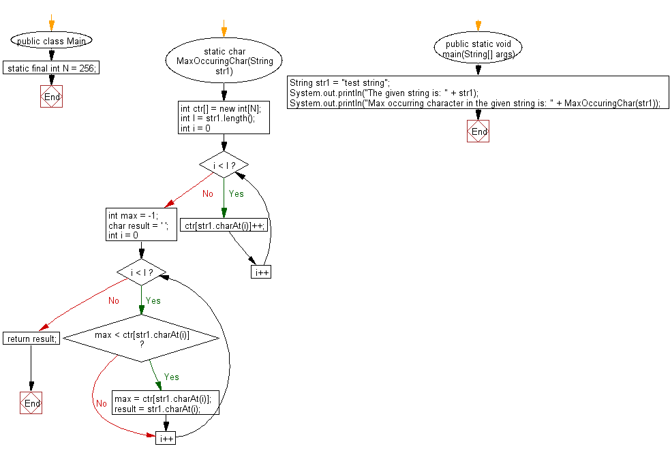

**public** **class** Program_43 {

**static** **final** **int** ***N*** = 256;

**static** **char** MaxOccuringChar(String str1) {

**int** ctr[] = **new** **int**[***N***];

**int** l = str1.length();

**for** (**int** i = 0; i < l; i++)

ctr[str1.charAt(i)]++;

**int** max = -1;

**char** result = ' ';

**for** (**int** i = 0; i < l; i++) {

**if** (max < ctr[str1.charAt(i)]) {

max = ctr[str1.charAt(i)];

result = str1.charAt(i);

}

}

**return** result;

}

**public** **static** **void** main(String[] args) {

// **TODO** Auto-generated method stub

String str1 = "test string";

System.***out***.println("The given string is: " + str1);

System.***out***.println("Max occurring character in the given string is: " + *MaxOccuringChar*(str1));

}

}

**Output:**

The given string is: test string

Max occurring character in the given string is: t

**44. Write a Java program to reverse a string using recursion.**

**Flowchart:**

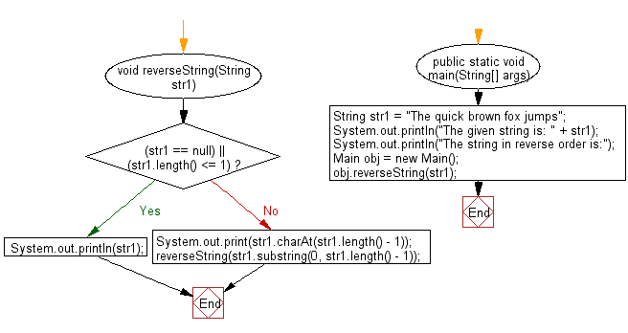

**public** **class** Program_44 {

**void** reverseString(String str1) {

**if** ((str1 == **null**) || (str1.length() <= 1))

System.***out***.println(str1);

**else** {

System.***out***.print(str1.charAt(str1.length() - 1));

reverseString(str1.substring(0, str1.length() - 1));

}

}

**public** **static** **void** main(String[] args) {

// **TODO** Auto-generated method stub

String str1 = "The quick brown fox jumps";

System.***out***.println("The given string is: " + str1);

System.***out***.println("The string in reverse order is:");

Program_44 obj = **new** Program_44();

obj.reverseString(str1);

}

}

**Output:**

The given string is: The quick brown fox jumps

The string in reverse order is:

spmuj xof nworb kciuq ehT

**45. Write a Java program to reverse words in a given string.**

**Flowchart:**

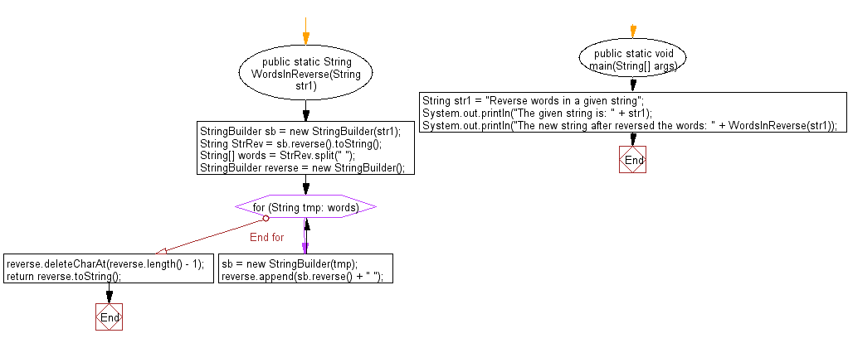

**public** **class** Program_45 {

**public** **static** String WordsInReverse(String str1) {

StringBuilder sb = **new** StringBuilder(str1);

String StrRev = sb.reverse().toString();

String[] words = StrRev.split(" ");

StringBuilder reverse = **new** StringBuilder();

**for** (String tmp: words) {

sb = **new** StringBuilder(tmp);

reverse.append(sb.reverse() + " ");

}

reverse.deleteCharAt(reverse.length() - 1);

**return** reverse.toString();

}

**public** **static** **void** main(String[] args) {

// **TODO** Auto-generated method stub

String str1 = "Reverse words in a given string";

System.***out***.println("The given string is: " + str1);

System.***out***.println("The new string after reversed the words: " + *WordsInReverse*(str1));

}

}

**Output:**

The given string is: Reverse words in a given string

The new string after reversed the words: string given a in words Reverse

**46. Write a Java program to reverse every word in a string using methods.**

**Flowchart:**

String str = "the fox is eating grapes.";

char[] arr = str.toCharArray();

String res = " ";

int i = arr.length-1

i>=0 ?

i--

res+=arr[i]

END FOR

System.out.println("The given string is: "+str);

System.out.println("The reverse of the given string is: "+res);

**public** **class** Program_46 {

**public** **static** **void** main(String[] args) {

// **TODO** Auto-generated method stub

String str = "the fox is eating grapes.";

**char**[] arr = str.toCharArray();

String res = " ";

**for**(**int** i=arr.length-1;i>=0;i--) {

res+=arr[i];

}

System.***out***.println("The given string is: "+str);

System.***out***.println("The reverse of the given string is: "+res);

}

}

**Output:**

The given string is: the fox is eating grapes.

The reverse of the given string is: .separg gnitae si xof eht

**47. Write a Java program to rearrange a string so that all same characters become d distance away.**

**Flowchart:**

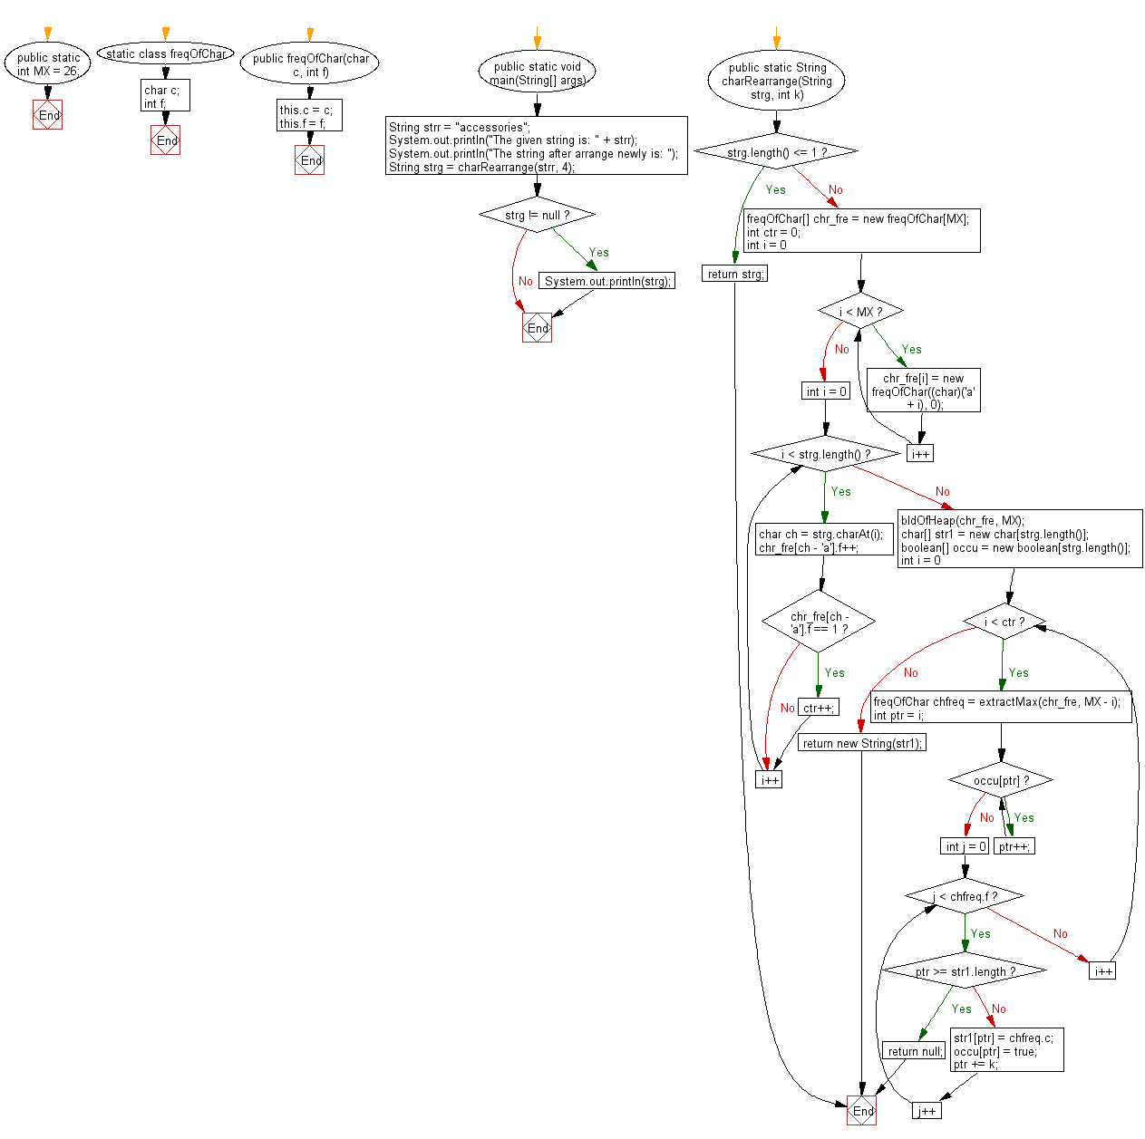

**public** **class** Program_47 {

**public** **static** **int** *MX* = 26;

**static** **class** freqOfChar {

**char** c;

**int** f;

**public** freqOfChar(**char** c, **int** f) {

**this**.c = c;

**this**.f = f;

}

}

**public** **static** **void** main(String[] args) {

// **TODO** Auto-generated method stub

String strr = "accessories";

System.***out***.println("The given string is: " + strr);

System.***out***.println("The string after arrange newly is: ");

String strg = *charRearrange*(strr, 4);

**if** (strg != **null**)

System.***out***.println(strg);

}

**public** **static** String charRearrange(String strg, **int** k) {

**if** (strg.length() <= 1) **return** strg;

freqOfChar[] chr_fre = **new** freqOfChar[*MX*];

**int** ctr = 0;

**for** (**int** i = 0; i < *MX*; i++) {

chr_fre[i] = **new** freqOfChar((**char**)('a' + i), 0);

}

**for** (**int** i = 0; i < strg.length(); i++) {

**char** ch = strg.charAt(i);

chr_fre[ch - 'a'].f++;

**if** (chr_fre[ch - 'a'].f == 1) ctr++;

}

*bldOfHeap*(chr_fre, *MX*);

**char**[] str1 = **new** **char**[strg.length()];

**boolean**[] occu = **new** **boolean**[strg.length()];

**for** (**int** i = 0; i < ctr; i++) {

freqOfChar chfreq = *extractMax*(chr_fre, *MX* - i);

**int** ptr = i;

**while** (occu[ptr]) ptr++;

**for** (**int** j = 0; j < chfreq.f; j++) {

**if** (ptr >= str1.length)

**return** **null**;

str1[ptr] = chfreq.c;

occu[ptr] = **true**;

ptr += k;

}

}

**return** **new** String(str1);

}

**private** **static** **void** bldOfHeap(freqOfChar[] chr_fre, **int** size) {

**int** i = (size - 1) / 2;

**while** (i >= 0) {

*maxHeapify*(chr_fre, i, size);

i--;

}

}

**private** **static** **void** swap(freqOfChar cf1, freqOfChar cf2) {

**char** c = cf1.c;

**int** f = cf1.f;

cf1.c = cf2.c;

cf1.f = cf2.f;

cf2.c = c;

cf2.f = f;

}

**private** **static** **void** maxHeapify(freqOfChar[] chr_fre, **int** node, **int** size) {

**int** l = node * 2 + 1;

**int** r = node * 2 + 2;

**int** largest = node;

**if** (l < size && chr_fre[l].f > chr_fre[node].f) {

largest = l;

}

**if** (r < size && chr_fre[r].f > chr_fre[largest].f) {

largest = r;

}

**if** (largest != node) {

*swap*(chr_fre[node], chr_fre[largest]);

*maxHeapify*(chr_fre, largest, size);

}

}

**private** **static** freqOfChar extractMax(freqOfChar[] chr_fre, **int** size) {

freqOfChar max = chr_fre[0];

chr_fre[0] = chr_fre[size - 1];

chr_fre[size - 1] = **null**;

*maxHeapify*(chr_fre, 0, size - 1);

return max;

}

}

**Output:**

The given string is: accessories

The string after arrange newly is:

secrsecisao

**48. Write a Java program to remove "b" and "ac" from a given string.**

**Flowchart:**

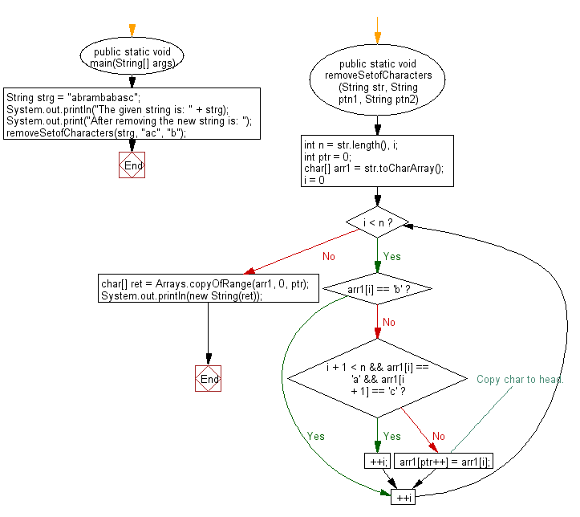

**import** java.util.Arrays;

**public** **class** Program_48 {

**public** **static** **void** main(String[] args) {

// **TODO** Auto-generated method stub

String strg = "abrambabasc";

System.***out***.println("The given string is: " + strg);

System.***out***.print("After removing the new string is: ");

*removeSetofCharacters*(strg, "ac", "b");

}

**public** **static** **void** removeSetofCharacters(String str, String ptn1, String ptn2) {

**int** n = str.length(), i;

**int** ptr = 0;

**char**[] arr1 = str.toCharArray();

**for** (i = 0; i < n; ++i) {

**if** (arr1[i] == 'b') {

**continue**;

} **else** **if** (i + 1 < n && arr1[i] == 'a' && arr1[i + 1] == 'c') {

++i;

} **else** {

arr1[ptr++] = arr1[i]; // Copy char to head.

}

}

**char**[] ret = Arrays.*copyOfRange*(arr1, 0, ptr);

System.***out***.println(**new** String(ret));

}

}

**Output:**

The given string is: abrambabasc

After removing the new string is: aramaasc

**49. Write a Java program to find first non-repeating character from a stream of**

**characters.**

**Flowchart:**

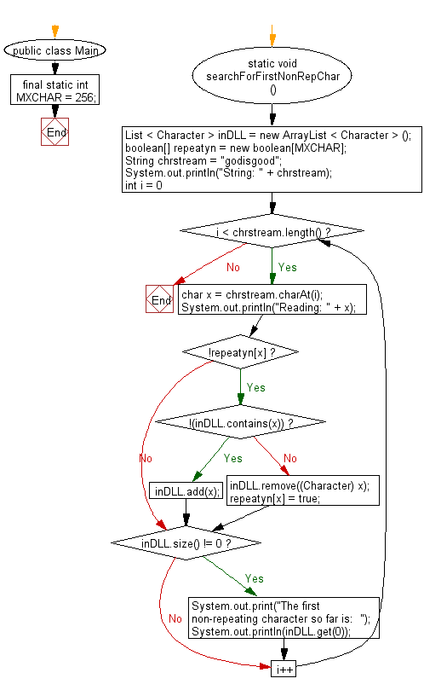

**public** **class** Program_49 {

**public** **static** **void** main(String[] args) {

// **TODO** Auto-generated method stub

**int** MXCHAR = 256;

List < Character > inDLL = **new** ArrayList < Character > ();

**boolean**[] repeatyn = **new** **boolean**[MXCHAR];

String chrstream = "godisgood";

System.***out***.println("String: " + chrstream);

**for** (**int** i = 0; i < chrstream.length(); i++) {

**char** x = chrstream.charAt(i);

System.***out***.println("Reading: " + x);

**if** (!repeatyn[x]) {

**if** (!(inDLL.contains(x))) {

inDLL.add(x);

} **else** {

inDLL.remove((Character) x);

repeatyn[x] = **true**;

}

}

**if** (inDLL.size() != 0) {

System.***out***.print("The first non-repeating character so far is: ");

System.***out***.println(inDLL.get(0));

}

}

}

}

**Output:**

String: godisgood

Reading: g

The first non-repeating character so far is: g

Reading: o

The first non-repeating character so far is: g

Reading: d

The first non-repeating character so far is: g

Reading: i

The first non-repeating character so far is: g

Reading: s

The first non-repeating character so far is: g

Reading: g

The first non-repeating character so far is: o

Reading: o

The first non-repeating character so far is: d

Reading: o

The first non-repeating character so far is: d

Reading: d

The first non-repeating character so far is: i

**50.** **Write a Java program to find lexicographic rank of a given string.**

**Flowchart:**

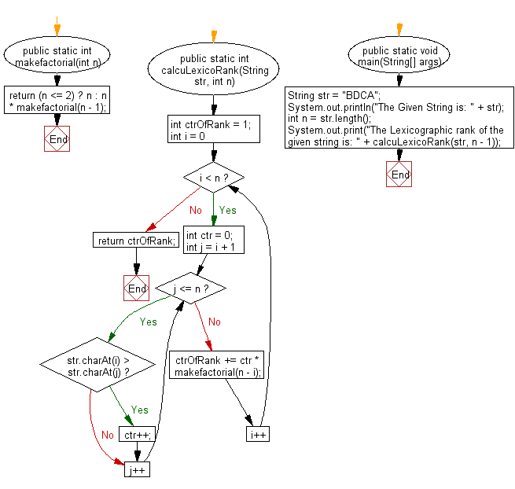

**public** **class** Program_50 {

**public** **static** **int** makefactorial(**int** n) {

**return** (n <= 2) ? n : n * *makefactorial*(n - 1);

}

**public** **static** **int** calcuLexicoRank(String str, **int** n) {

**int** ctrOfRank = 1;

**for** (**int** i = 0; i < n; i++) {

**int** ctr = 0;

**for** (**int** j = i + 1; j <= n; j++) {

**if** (str.charAt(i) > str.charAt(j))

ctr++;

}

ctrOfRank += ctr * *makefactorial*(n - i);

}

**return** ctrOfRank;

}

**public** **static** **void** main(String[] args) {

// **TODO** Auto-generated method stub

String str = "BDCA";

System.***out***.println("The Given String is: " + str);

**int** n = str.length();

System.***out***.print("The Lexicographic rank of the given string is: " + *calcuLexicoRank*(str, n - 1));

}

}

**Output:**

The Given String is: BDCA

The Lexicographic rank of the given string is: 12

**51. Write a Java program to count and print all the duplicates in the input string.**

**Flowchart:**

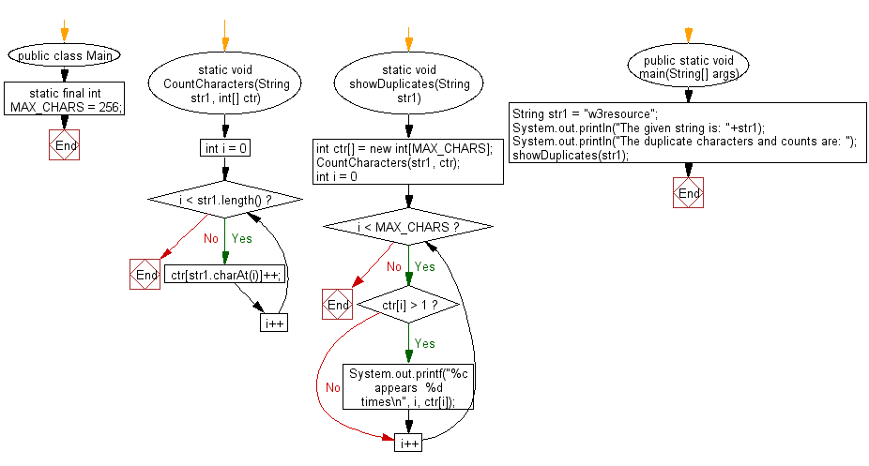

**public** **class** Program_51 {

**static** **final** **int** ***MAX_CHARS*** = 256;

**static** **void** CountCharacters(String str1, **int**[] ctr)

{

**for** (**int** i = 0; i < str1.length(); i++)

ctr[str1.charAt(i)]++;

}

**static** **void** showDuplicates(String str1)

{

**int** ctr[] = **new** **int**[***MAX_CHARS***];

*CountCharacters*(str1, ctr);

**for** (**int** i = 0; i < ***MAX_CHARS***; i++)

**if**(ctr[i] > 1)

System.***out***.printf("%c appears %d times\n", i, ctr[i]);

}

**public** **static** **void** main(String[] args) {

// **TODO** Auto-generated method stub

String str1 = "w3resource";

System.***out***.println("The given string is: "+str1);

System.***out***.println("The duplicate characters and counts are: ");

*showDuplicates*(str1);

}

}

**Output:**

The given string is: w3resource

The duplicate characters and counts are:

e appears 2 times

r appears 2 times

**52. Write a Java program to check if two given strings are rotations of each other**

**Flowchart:**

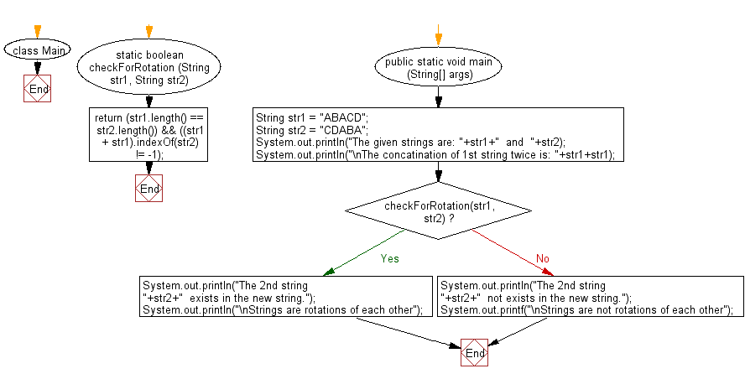

**public** **class** Program_52 {

**static** **boolean** checkForRotation (String str1, String str2)

{

**return** (str1.length() == str2.length()) && ((str1 + str1).indexOf(str2) != -1);

}

**public** **static** **void** main(String[] args) {

// **TODO** Auto-generated method stub

String str1 = "ABACD";

String str2 = "CDABA";

System.***out***.println("The given strings are: "+str1+" and "+str2);

System.***out***.println("\nThe concatination of 1st string twice is: "+str1+str1);

**if** (*checkForRotation*(str1, str2))

{

System.***out***.println("The 2nd string "+str2+" exists in the new string.");

System.***out***.println("\nStrings are rotations of each other");

}

**else**

{

System.***out***.println("The 2nd string "+str2+" not exists in the new string.");

System.***out***.printf("\nStrings are not rotations of each other");

}

}

}

**Output:**

The given strings are: ABACD and CDABA

The concatination of 1st string twice is: ABACDABACD

The 2nd string CDABA exists in the new string.

Strings are rotations of each other

**53. Write a Java program to match two strings where one string contains wildcard characters.**

**Flowchart:**

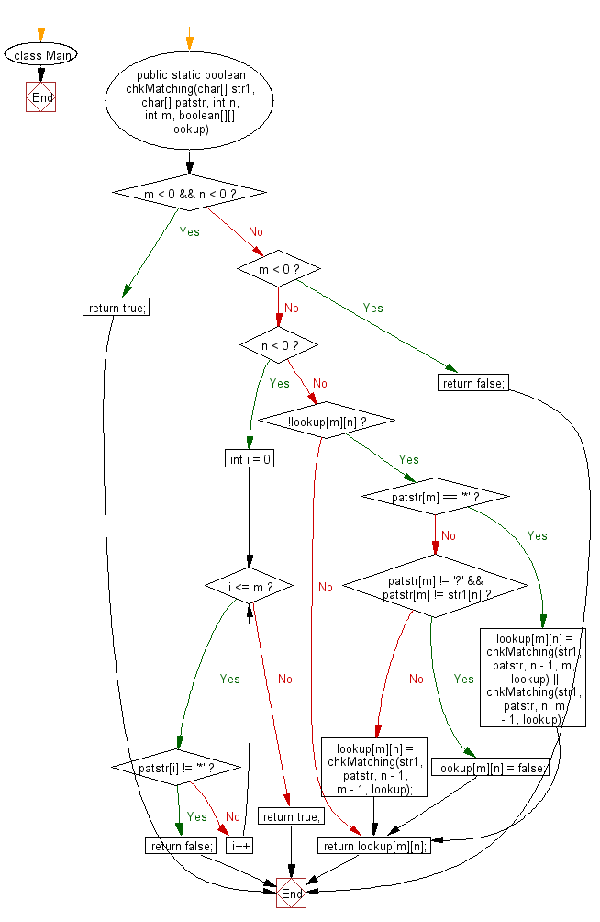

**public** **class** Program_53 {

**public** **static** **boolean** chkMatching(**char**[] str1, **char**[] patstr, **int** n, **int** m,

**boolean**[][] lookup)

{

**if** (m < 0 && n < 0)

{

**return** **true**;

}

**else** **if** (m < 0)

{

**return** **false**;

}

**else** **if** (n < 0)

{

**for** (**int** i = 0; i <= m; i++)

{

**if** (patstr[i] != '*')

{

**return** **false**;

}

}

**return** **true**;

}

**if** (!lookup[m][n])

{

**if** (patstr[m] == '*')

{

lookup[m][n] = *chkMatching*(str1, patstr, n - 1, m, lookup) ||

*chkMatching*(str1, patstr, n, m - 1, lookup);

}

**else**

{

**if** (patstr[m] != '?' && patstr[m] != str1[n])

{

lookup[m][n] = **false**;

}

**else**

{

lookup[m][n] = *chkMatching*(str1, patstr, n - 1, m - 1, lookup);

}

}

}

**return** lookup[m][n];

}

**public** **static** **void** main(String[] args) {

// **TODO** Auto-generated method stub

String st1="abcdhgh";

String st2="abc*d?*";

System.***out***.println("The given string is: "+st1);

System.***out***.println("The given pattern string is: "+st2);

**char**[] str1 = st1.toCharArray();

**char**[] patstr = st2.toCharArray();

**boolean**[][] lookup = **new** **boolean**[str1.length + 1][patstr.length + 1];

**if** (*chkMatching*(str1, patstr, str1.length - 1, patstr.length - 1, lookup))

{

System.***out***.println("The given pattern is matching.");

}

**else**

{

System.***out***.println("The given pattern is not matching.");

}

}

}

**Output:**

The given string is: abcdhgh

The given pattern string is: abc*d?*

The given pattern is matching.

**54. Write a Java program to find the smallest window in a string containing all characters of another string.**

**Flowchart:**

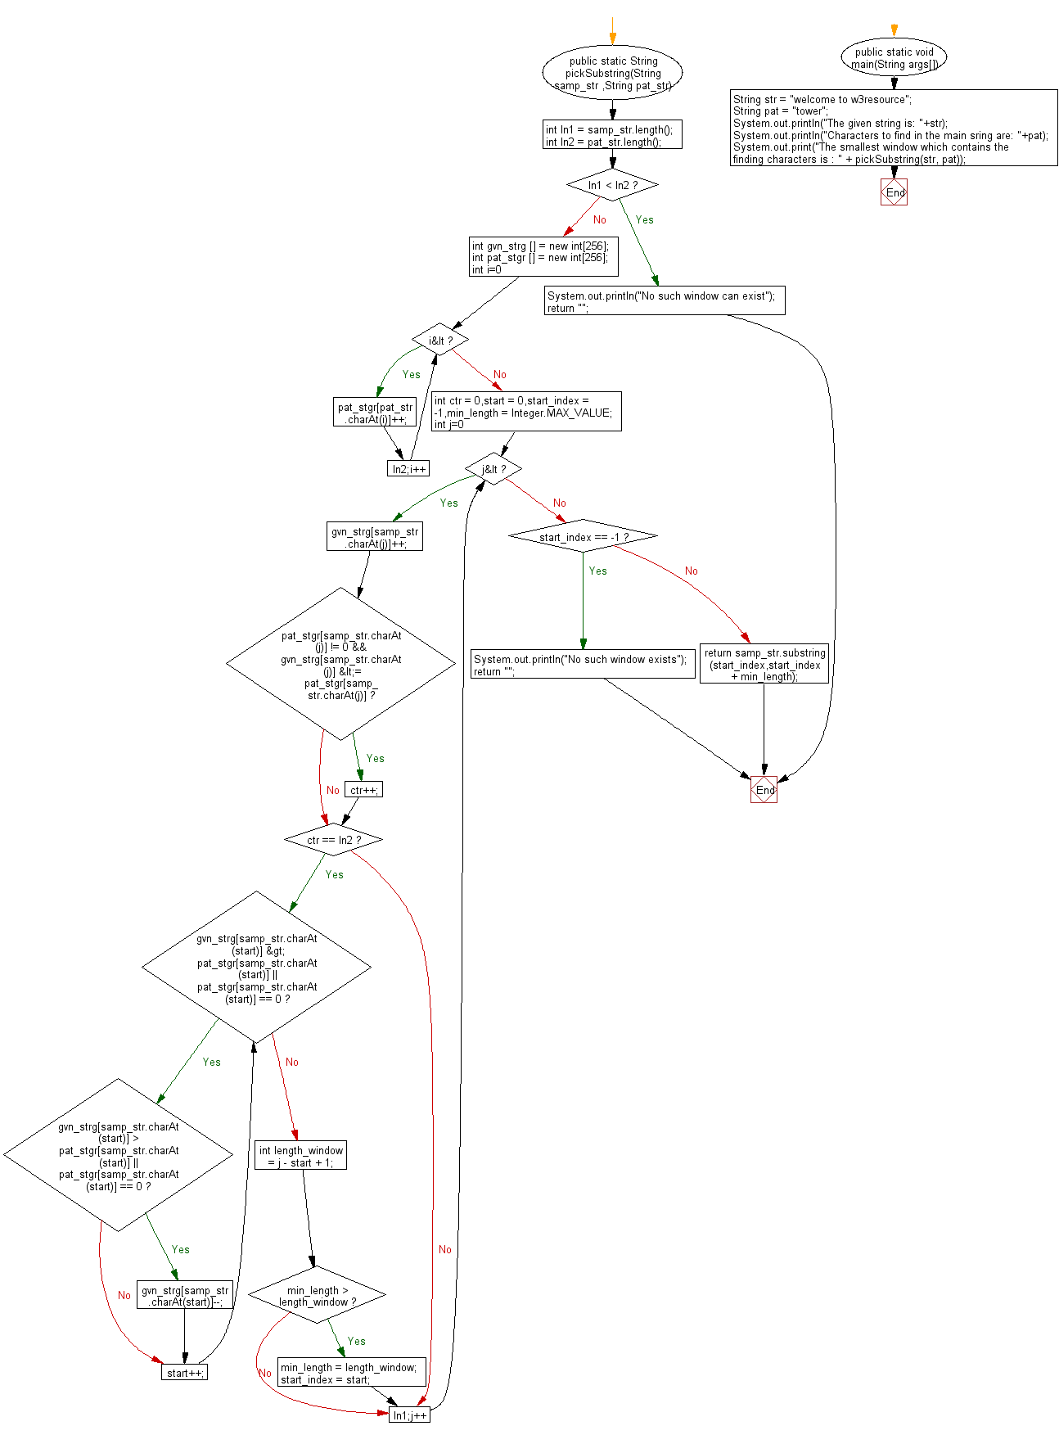

**public** **class** Program_54 {

**public** **static** String pickSubstring(String samp_str ,String pat_str)

{

**int** ln1 = samp_str.length();

**int** ln2 = pat_str.length();

**if**(ln1 < ln2)

{

System.***out***.println("No such window can exist");

**return** "";

}

**int** gvn_strg [] = **new** **int**[256];

**int** pat_stgr [] = **new** **int**[256];

**for**(**int** i=0;i<ln2;i++)

pat_stgr[pat_str.charAt(i)]++;

**int** ctr = 0,start = 0,start_index = -1,min_length = Integer.***MAX_VALUE***;

**for**(**int** j=0;j<ln1;j++)

{

gvn_strg[samp_str.charAt(j)]++;

**if**(pat_stgr[samp_str.charAt(j)] != 0 && gvn_strg[samp_str.charAt(j)] <= pat_stgr[samp_str.charAt(j)])

ctr++;

**if**(ctr == ln2)

{

**while**(gvn_strg[samp_str.charAt(start)] > pat_stgr[samp_str.charAt(start)] || pat_stgr[samp_str.charAt(start)] == 0)

{

**if**(gvn_strg[samp_str.charAt(start)] > pat_stgr[samp_str.charAt(start)] || pat_stgr[samp_str.charAt(start)] == 0)

gvn_strg[samp_str.charAt(start)]--;

start++;

}

**int** length_window = j - start + 1;

**if**(min_length > length_window)

{

min_length = length_window;

start_index = start;

}

}

}

**if**(start_index == -1)

{

System.***out***.println("No such window exists");

**return** "";

}

**return** samp_str.substring(start_index,start_index + min_length);

}

**public** **static** **void** main(String[] args) {

// **TODO** Auto-generated method stub

String str = "welcome to w3resource";

String pat = "tower";

System.***out***.println("The given string is: "+str);

System.***out***.println("Characters to find in the main string are: "+pat);

System.***out***.print("The smallest window which contains the finding characters is : " + *pickSubstring*(str, pat));

}

}

**Output:**

The given string is: welcome to w3resource

Characters to find in the main string are: tower

The smallest window which contains the finding characters is : to w3re

**55. Write a Java program to remove all adjacent duplicates recursively from a given string.**

**Flowchart:**

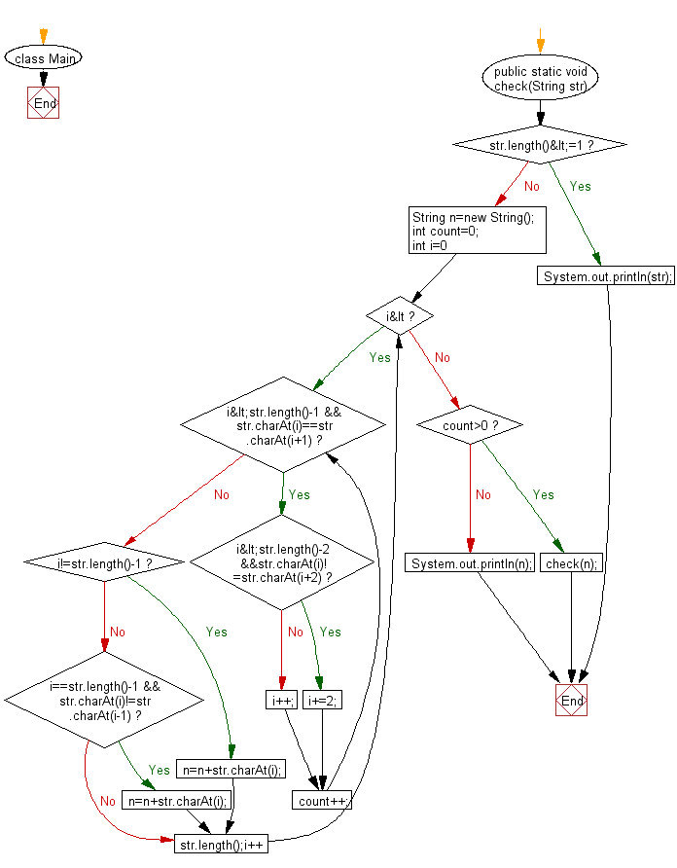

**public** **class** Program_55 {

**public** **static** **void** check(String str)

{

**if**(str.length()<=1)

{

System.***out***.println(str);

**return**;

}

String n=**new** String();

**int** count=0;

**for**(**int** i=0;i<str.length();i++)

{

**while**(i<str.length()-1 && str.charAt(i)==str.charAt(i+1))

{

**if**(i<str.length()-2 &&str.charAt(i)!=str.charAt(i+2))

i+=2;

**else**

i++;

count++;

}

**if**(i!=str.length()-1)

n=n+str.charAt(i);

**else**

{**if**(i==str.length()-1 && str.charAt(i)!=str.charAt(i-1))

n=n+str.charAt(i);

}

}

**if**(count>0)

*check*(n);

**else**

System.***out***.println(n);

}

**public** **static** **void** main(String[] args) {

// **TODO** Auto-generated method stub

String ab="aabaarbarccrabmq";

System.***out***.println("The given string is: "+ab);

System.***out***.println("The new string after removing all adjacent duplicates is:");

*check*(ab);

}

}

**Output:**

The given string is: aabaarbarccrabmq

The new string after removing all adjacent duplicates is:

brmq

**56. Write a Java program to append two given strings such that, if the concatenation creates a double characters then omit one of the characters.**

**Flowchart:**

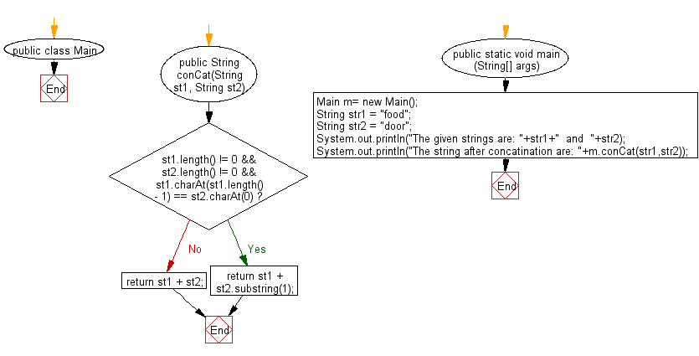

**public** **class** Program_56 {

**public** String conCat(String st1, String st2)

{

**if** (st1.length() != 0 && st2.length() != 0

&& st1.charAt(st1.length() - 1) == st2.charAt(0))

**return** st1 + st2.substring(1);

**return** st1 + st2;

}

**public** **static** **void** main(String[] args) {

// **TODO** Auto-generated method stub

Program_56 m= **new** Program_56();

String str1 = "food";

String str2 = "door";

System.***out***.println("The given strings are: "+str1+" and "+str2);

System.***out***.println("The string after concatination are: "+m.conCat(str1,str2));

}

}

**Output:**

The given strings are: food and door

The string after concatination are: foodoor

**57. Write a Java program to return a new string where the last two characters of a given string, if present, are swapped.**

**Flowchart:**

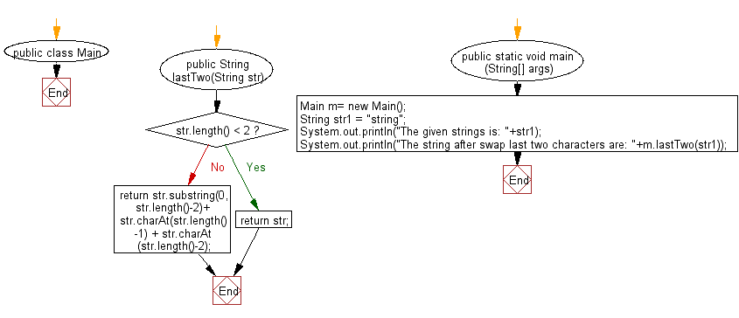

**public** **class** Program_57 {

**public** String lastTwo(String str)

{

**if** (str.length() < 2) **return** str;

**return** str.substring(0, str.length()-2)+ str.charAt(str.length()-1) + str.charAt(str.length()-2);

}

**public** **static** **void** main(String[] args) {

// **TODO** Auto-generated method stub

Program_57 m= **new** Program_57();

String str1 = "string";

System.***out***.println("The given strings is: "+str1);

System.***out***.println("The string after swap last two characters are: "+m.lastTwo(str1));

}

}

**Output:**

The given strings is: string

The string after swap last two characters are: strign

**58. Write a Java program to read a string and return true if it ends in "ng".**

**Flowchart:**

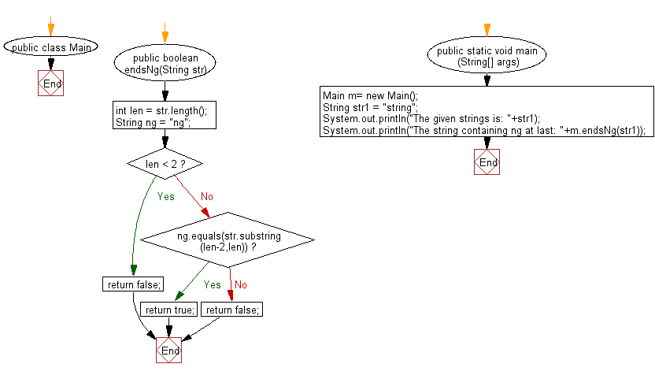

**public** **class** Program_58 {

**public** **boolean** endsNg(String str)

{

**int** len = str.length();

String ng = "ng";

**if** (len < 2)

**return** **false**;

**else** **if** (ng.equals(str.substring(len-2,len)))

**return** **true**;

**else**

**return** **false**;

}

**public** **static** **void** main(String[] args) {

// **TODO** Auto-generated method stub

Program_58 m= **new** Program_58();

String str1 = "string";

System.***out***.println("The given strings is: "+str1);

System.***out***.println("The string containing ng at last: "+m.endsNg(str1));

}

}

**Output:**

The given strings is: string

The string containing ng at last: true

**59. Write a Java program to read a string,if the string begins with &quot;red&quot; or &quot;black&quot; return that color string, otherwise return the empty string.**

**Flowchart:**

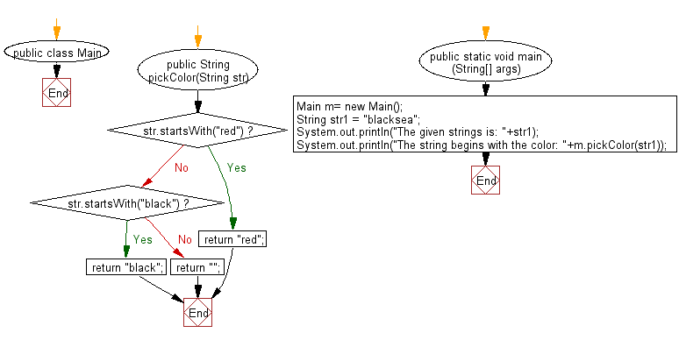

**public** **class** Program_59 {

**public** String pickColor(String str)

{

**if** (str.startsWith("red"))

**return** "red";

**if** (str.startsWith("black"))

**return** "black";

**else**

**return** "";

}

**public** **static** **void** main(String[] args) {

// **TODO** Auto-generated method stub

Program_59 m= **new** Program_59();

String str1 = "blacksea";

System.***out***.println("The given strings is: "+str1);

System.***out***.println("The string begins with the color: "+m.pickColor(str1));

}

}

**Output:**

The given strings is: blacksea

The string begins with the color: black

**60. Write a Java program to read two strings append them together and return the result. If the strings are different lengths, omit chars from the beginning of longer string and make them equal length.**

**Flowchart:**

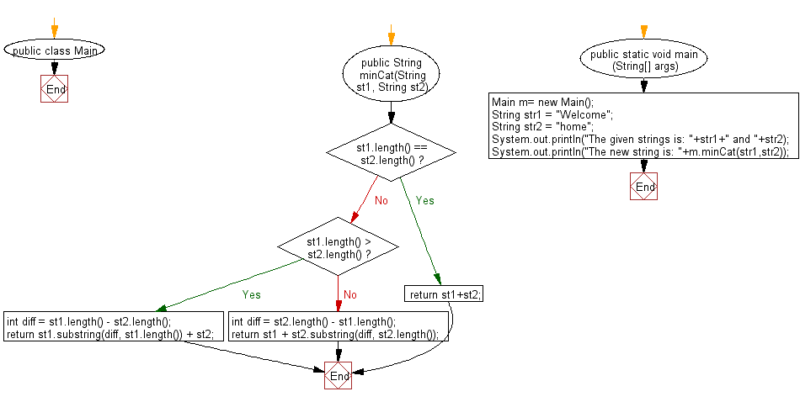

**public** **class** Program_60 {

**public** String minCat(String st1, String st2)

{

**if** (st1.length() == st2.length())

**return** st1+st2;

**if** (st1.length() > st2.length())

{

**int** diff = st1.length() - st2.length();

**return** st1.substring(diff, st1.length()) + st2;

} **else**

{

**int** diff = st2.length() - st1.length();

**return** st1 + st2.substring(diff, st2.length());

}

}

**public** **static** **void** main(String[] args) {

// **TODO** Auto-generated method stub

Program_60 m= **new** Program_60();

String str1 = "Welcome";

String str2 = "home";

System.***out***.println("The given strings is: "+str1+" and "+str2);

System.***out***.println("The new string is: "+m.minCat(str1,str2));

}

}

**Output:**

The given strings is: Welcome and home

The new string is: comehome

**61. Write a Java program to read a string and an int n, return a string made of the first and last n characters from the string.**

**Flowchart:**

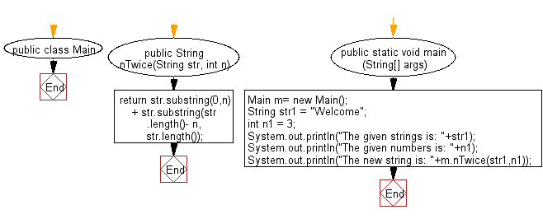

**public** **class** Program_61 {

**public** String nTwice(String str, **int** n)

{

**return** str.substring(0,n) + str.substring(str.length()- n, str.length());

}

**public** **static** **void** main(String[] args) {

// **TODO** Auto-generated method stub

Program_61 m= **new** Program_61();

String str1 = "Welcome";

**int** n1 = 3;

System.***out***.println("The given strings is: "+str1);

System.***out***.println("The given numbers is: "+n1);

System.***out***.println("The new string is: "+m.nTwice(str1,n1));

}

}

**Output:**

The given strings is: Welcome

The given numbers is: 3

The new string is: Welome

**62. Write a Java program to read a string and return true if "good" appears starting at index 0 or 1 in the given string.**

**Flowchart:**

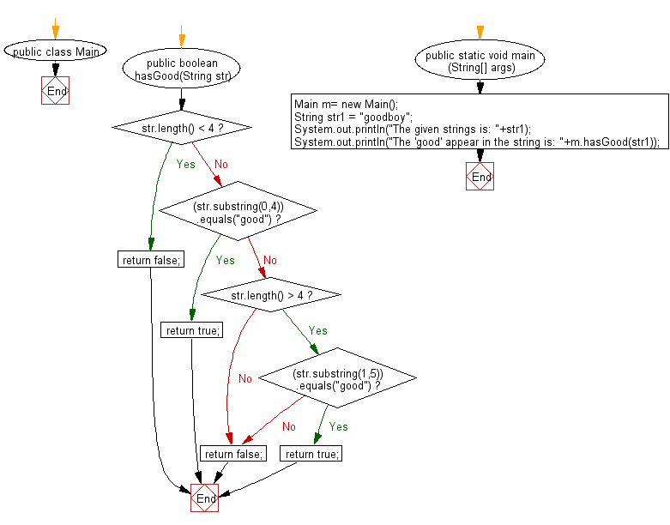

**public** **class** Program_62 {

**public** **boolean** hasGood(String str)

{

**if**(str.length() < 4)

**return** **false**;

**else** **if** ((str.substring(0,4)).equals("good"))

**return** **true**;

**else** **if** (str.length() > 4)

{

**if** ((str.substring(1,5)).equals("good"))

**return** **true**;

}

**return** **false**;

}

**public** **static** **void** main(String[] args) {

// **TODO** Auto-generated method stub

Program_62 m= **new** Program_62();

String str1 = "goodboy";

System.***out***.println("The given strings is: "+str1);

System.***out***.println("The 'good' appear in the string is: "+m.hasGood(str1));

}

}

**Output:**

The given strings is: goodboy

The 'good' appear in the string is: true

**63. Write a Java program to return true from a given string if the first two characters in the string also appear at the end.**

**Flowchart:**

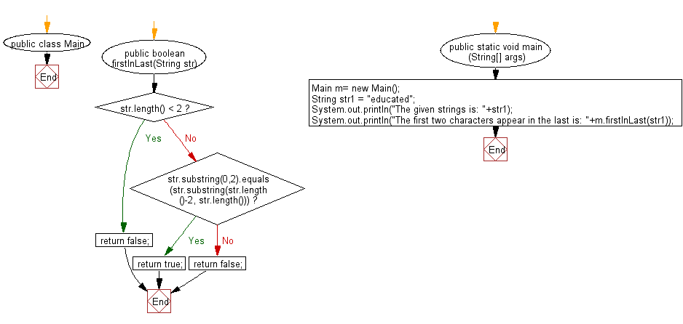

**public** **class** Program_63 {

**public** **boolean** firstInLast(String str)

{

**if** (str.length() < 2)

**return** **false**;

**else** **if** (str.substring(0,2).equals(str.substring(str.length()-2, str.length())))

**return** **true**;

**else**

**return** **false**;

}

**public** **static** **void** main(String[] args) {

// **TODO** Auto-generated method stub

Program_63 m= **new** Program_63();

String str1 = "educated";

System.***out***.println("The given strings is: "+str1);

System.***out***.println("The first two characters appear in the last is: "+m.firstInLast(str1));

}

}

**Output:**

The given strings is: educated

The first two characters appear in the last is: true

**64. Write a Java program to read a string and if a substring of length two appears at both its beginning and end, return a string without the substring at the beginning otherwise, return the original string unchanged.**

**Flowchart:**

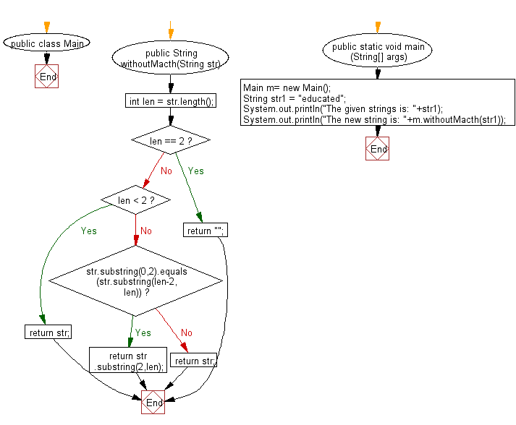

**public** **class** Program_64 {

**public** String withoutMacth(String str)

{

**int** len = str.length();

**if** (len == 2)

**return** "";

**if** (len < 2)

**return** str;

**else**

{

**if** (str.substring(0,2).equals(str.substring(len-2, len)))

**return** str.substring(2,len);

**else** **return** str;

}

}

**public** **static** **void** main(String[] args) {

// **TODO** Auto-generated method stub

Program_64 m= **new** Program_64();

String str1 = "educated";

System.***out***.println("The given strings is: "+str1);

System.***out***.println("The new string is: "+m.withoutMacth(str1));

}

}

**Output:**

The given strings is: educated

The new string is: ucated

**65. Write a Java program to read a string and if the first or last characters are 't', return the string without those 't' otherwise return the string unchanged**

**Flowchart:**

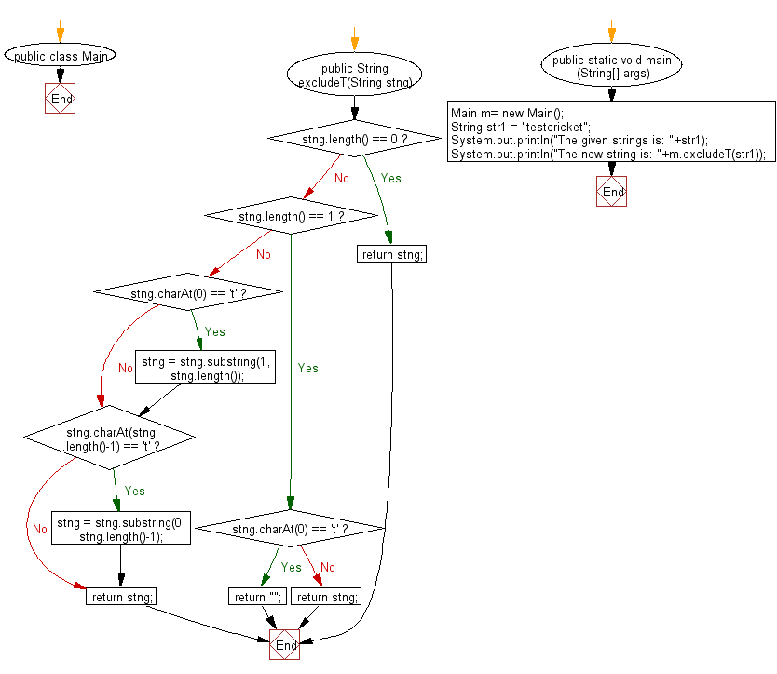

**public** **class** Program_65 {

**public** String excludeT(String stng)

{

**if** (stng.length() == 0)

**return** stng;

**if** (stng.length() == 1)

{

**if** (stng.charAt(0) == 't')

**return** "";

**else**

**return** stng;

}

**if** (stng.charAt(0) == 't')

stng = stng.substring(1,stng.length());

**if** (stng.charAt(stng.length()-1) == 't')

stng = stng.substring(0,stng.length()-1);

**return** stng;

}

**public** **static** **void** main(String[] args) {

// **TODO** Auto-generated method stub

Program_65 m = **new** Program_65();

String str1 = "testcricket";

System.***out***.println("The given strings is: "+str1);

System.***out***.println("The new string is: "+m.excludeT(str1));

}

}

**Output:**

The given strings is: testcricket

The new string is: estcricke

**66. Write a Java program to read a string and return the string without the first two characters.Except keep the first char if it is 'g' and keep the second char if it is 'h'.**

**Flowchart:**

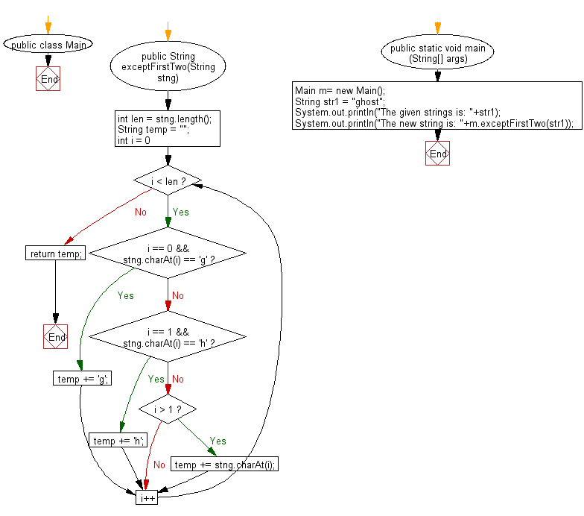

**public** **class** Program_66 {

**public** String exceptFirstTwo(String stng)

{

**int** len = stng.length();

String temp = "";

**for** (**int** i = 0; i < len; i++)

{

**if** (i == 0 && stng.charAt(i) == 'g')

temp += 'g';

**else** **if** (i == 1 && stng.charAt(i) == 'h')

temp += 'h';

**else** **if** (i > 1)

temp += stng.charAt(i);

}

**return** temp;

}

**public** **static** **void** main(String[] args) {

// **TODO** Auto-generated method stub

Program_66 m = **new** Program_66();

String str1 = "ghost";

System.***out***.println("The given strings is: "+str1);

System.***out***.println("The new string is: "+m.exceptFirstTwo(str1));

}

}

**Output:**

The given strings is: ghost

The new string is: ghost

**67. Write a Java program to read a string and if one or both of the first tow characters is 'x', return without those 'x',otherwise return the string unchanged.**

**Flowchart:**

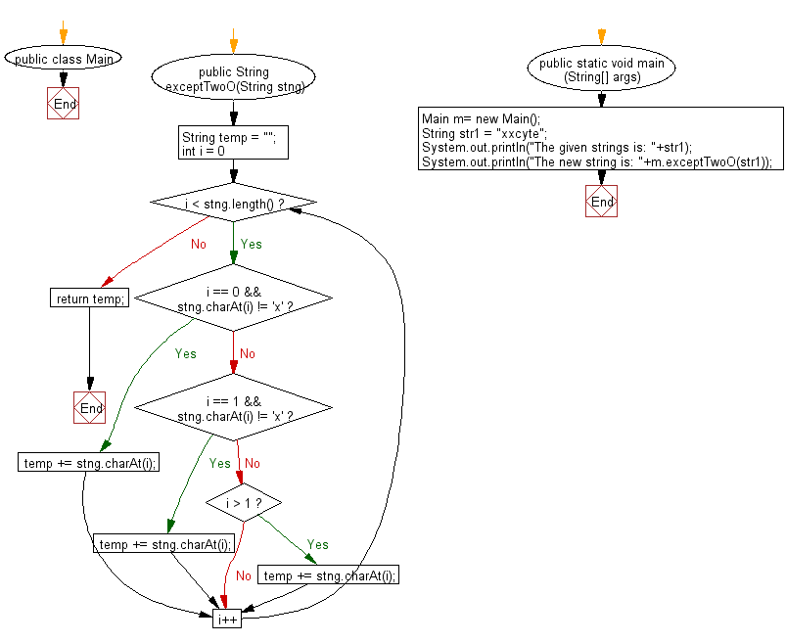

**public** **class** Program_67 {

**public** String exceptTwoO(String stng)

{

String temp = "";

**for** (**int** i = 0; i < stng.length(); i++)

{

**if** (i == 0 && stng.charAt(i) != 'x')

temp += stng.charAt(i);

**else** **if** (i == 1 && stng.charAt(i) != 'x')

temp += stng.charAt(i);

**else** **if** (i > 1)

temp += stng.charAt(i);

}

**return** temp;

}

**public** **static** **void** main(String[] args) {

// **TODO** Auto-generated method stub

Program_67 m= **new** Program_67();

String str1 = "xxcyte";

System.***out***.println("The given strings is: "+str1);

System.***out***.println("The new string is: "+m.exceptTwoO(str1));

}

}

**Output:**

The given strings is: xxcyte

The new string is: cyte

**68. Write a Java program to read a string and returns after remove the # and its immediate left and right characters.**

**Flowchart:**

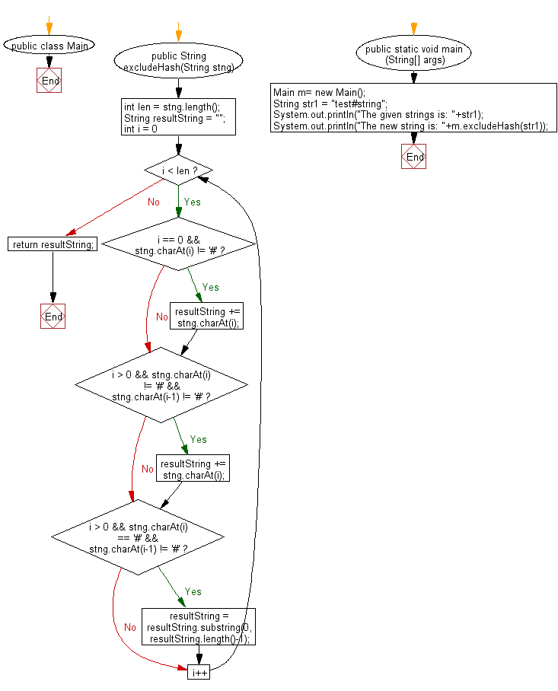

**public** **class** Program_68 {

**public** String excludeHash(String stng)

{

**int** len = stng.length();

String resultString = "";

**for** (**int** i = 0; i < len; i++)

{

**if** (i == 0 && stng.charAt(i) != '#')

resultString += stng.charAt(i);

**if** (i > 0 && stng.charAt(i) != '#' && stng.charAt(i-1) != '#')

resultString += stng.charAt(i);

**if** (i > 0 && stng.charAt(i) == '#' && stng.charAt(i-1) != '#')

resultString = resultString.substring(0,resultString.length()-1);

}

**return** resultString;

}

**public** **static** **void** main(String[] args) {

// **TODO** Auto-generated method stub

Program_68 m= **new** Program_68();

String str1 = "test#string";

System.***out***.println("The given strings is: "+str1);

System.***out***.println("The new string is: "+m.excludeHash(str1));

}

}

**Output:**

The given strings is: test#string

The new string is: testring

**69. Write a Java program to return the substring that is between the first and last appearance of the substring 'toast' in the given string,or return the empty string if substirng 'toast' does not exists.**

**Flowchart:**

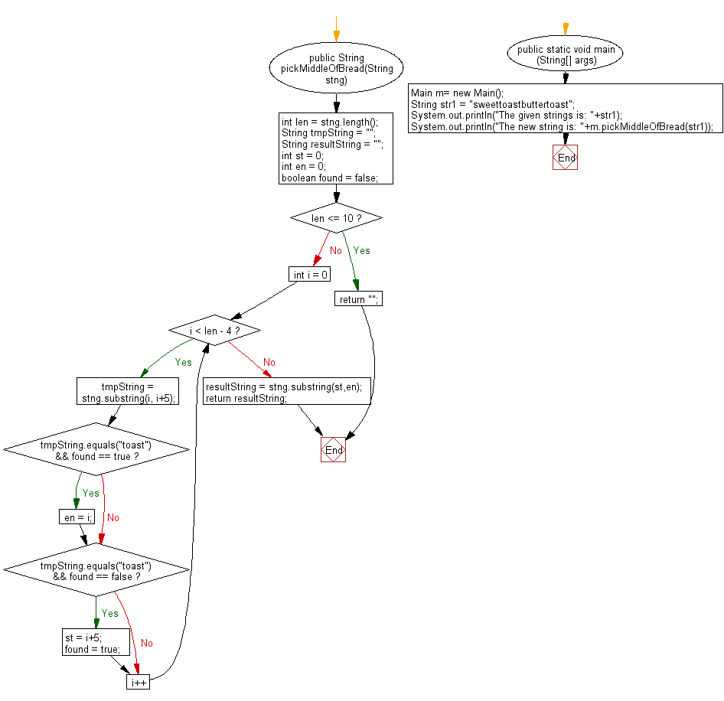

**public** **class** Program_69 {

**public** String pickMiddleOfBread(String stng)

{

**int** len = stng.length();

String tmpString = "";

String resultString = "";

**int** st = 0;

**int** en = 0;

**boolean** found = **false**;

**if** (len <= 10)

**return** "";

**for** (**int** i = 0; i < len - 4; i++)

{

tmpString = stng.substring(i, i+5);

**if** (tmpString.equals("toast") && found == **true**)

en = i;

**if** (tmpString.equals("toast") && found == **false**)

{

st = i+5;

found = **true**;

}

}

resultString = stng.substring(st,en);

**return** resultString;

}

**public** **static** **void** main(String[] args) {

// **TODO** Auto-generated method stub

Program_69 m= **new** Program_69();

String str1 = "sweettoastbuttertoast";

System.***out***.println("The given strings is: "+str1);

System.***out***.println("The new string is: "+m.pickMiddleOfBread(str1));

}

}

**Output:**

The given strings is: sweettoastbuttertoast

The new string is: butter

**70. Write a Java program to check whether a string is pq-balanced or not.A String is pq-balanced if for all the p's in the string atleast one 'q' must exists right of the p's.But 'q' before the 'p' makes the pq-balanced false.**

**Flowchart:**

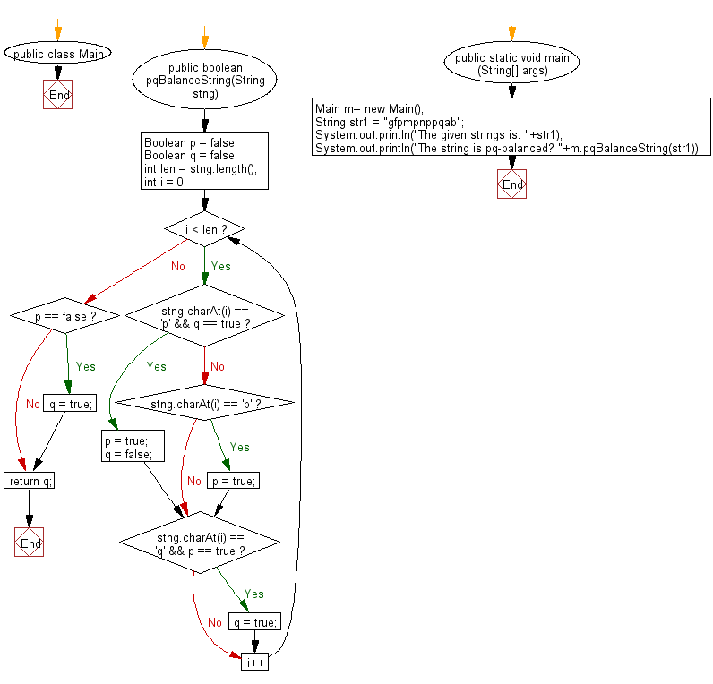

**public** **class** Program_70 {

**public** **boolean** pqBalanceString(String stng)

{

Boolean p = **false**;

Boolean q = **false**;

**int** len = stng.length();

**for** (**int** i = 0; i < len; i++)

{

**if** (stng.charAt(i) == 'p' && q == **true**)

{

p = **true**;

q = **false**;

}

**else** **if** (stng.charAt(i) == 'p')

{

p = **true**;

}

**if** (stng.charAt(i) == 'q' && p == **true**)

q = **true**;

}

**if** (p == **false**)

q = **true**;

**return** q;

}

**public** **static** **void** main(String[] args) {

// **TODO** Auto-generated method stub

Program_70 m= **new** Program_70();

String str1 = "gfpmpnppqab";

System.***out***.println("The given strings is: "+str1);

System.***out***.println("The string is pq-balanced? "+m.pqBalanceString(str1));

}

}

**Output:**

The given strings is: gfpmpnppqab

The string is pq-balanced? true

**71. Write a Java program to return true when either of the two given strings appear at the end of the other string ignoring case sensitivity.**

**Flowchart:**

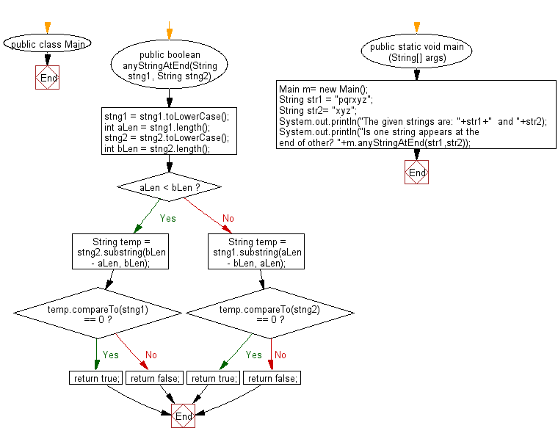

**public** **class** Program_71 {

**public** **boolean** anyStringAtEnd(String stng1, String stng2)

{

stng1 = stng1.toLowerCase();

**int** aLen = stng1.length();

stng2 = stng2.toLowerCase();

**int** bLen = stng2.length();

**if** (aLen < bLen)

{

String temp = stng2.substring(bLen - aLen, bLen);

**if** (temp.compareTo(stng1) == 0)

**return** **true**;

**else**

**return** **false**;

} **else**

{

String temp = stng1.substring(aLen - bLen, aLen);

**if** (temp.compareTo(stng2) == 0)

**return** **true**;

**else**

**return** **false**;

}

}

**public** **static** **void** main(String[] args) {

// **TODO** Auto-generated method stub

Program_71 m= **new** Program_71();

String str1 = "pqrxyz";

String str2= "xyz";

System.***out***.println("The given strings are: "+str1+" and "+str2);

System.***out***.println("Is one string appears at the end of other? "+m.anyStringAtEnd(str1,str2));

}

}

**Output:**

The given strings are: pqrxyz and xyz

Is one string appears at the end of other? true

**72. Write a Java program to return true if a given string contain the string 'pop', but the middle 'o' also may other character.**

**Flowchart:**

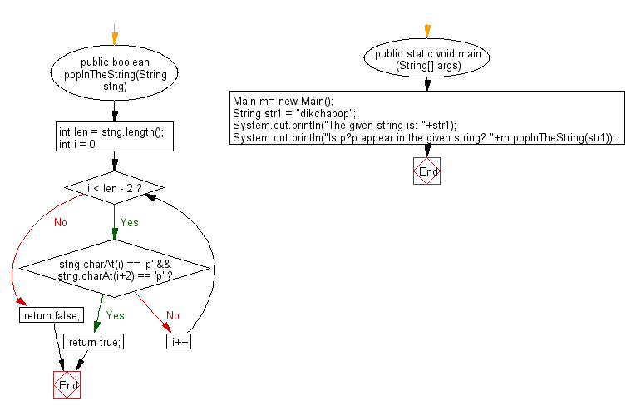

**public** **class** Program_72 {

**public** **boolean** popInTheString(String stng)

{

**int** len = stng.length();

**for** (**int** i = 0; i < len - 2; i++)

{

**if** (stng.charAt(i) == 'p' && stng.charAt(i+2) == 'p')

**return** **true**;

}

**return** **false**;

}

**public** **static** **void** main(String[] args) {

// **TODO** Auto-generated method stub

Program_72 m= **new** Program_72();

String str1 = "dikchapop";

System.***out***.println("The given string is: "+str1);

System.***out***.println("Is p?p appear in the given string? "+m.popInTheString(str1));

}

}

**Output:**

The given string is: dikchapop

Is p?p appear in the given string? true

**73. Write a Java program to return true if the given string contains an appearance of 'abc' but not directly a period(.) and followed by.**

**Flowchart:**

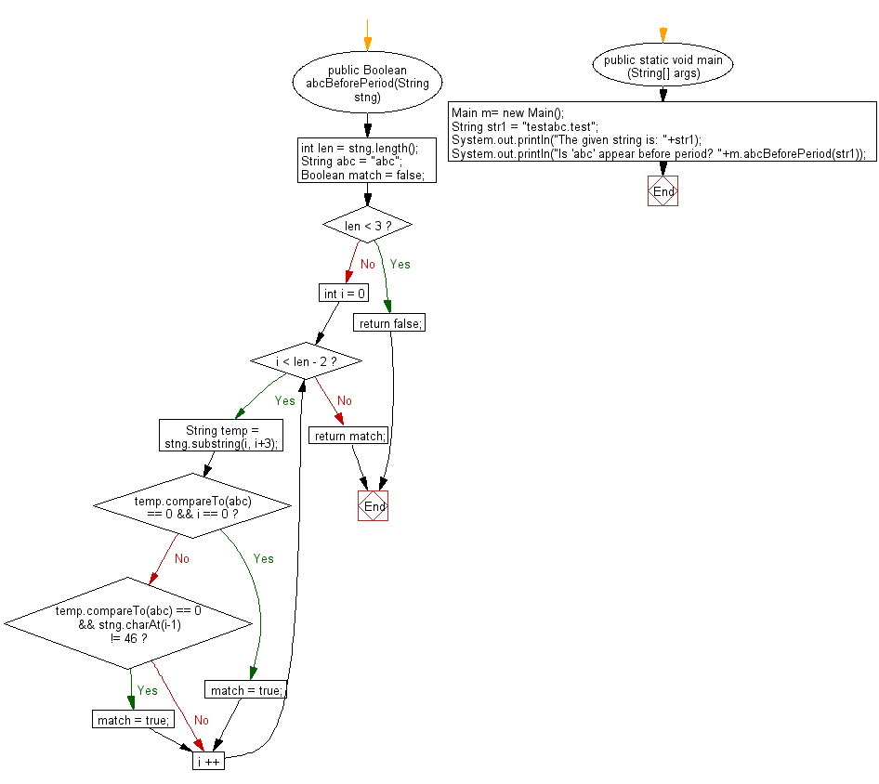

**public** **class** Program_73 {

**public** Boolean abcBeforePeriod(String stng)

{

**int** len = stng.length();

String abc = "abc";

Boolean match = **false**;

**if** (len < 3)

**return** **false**;

**for** (**int** i = 0; i < len - 2; i ++)

{

String temp = stng.substring(i, i+3);

**if** (temp.compareTo(abc) == 0 && i == 0)

match = **true**;

**else** **if**(temp.compareTo(abc) == 0 && stng.charAt(i-1) != 46)

match = **true**;

}

**return** match;

}

**public** **static** **void** main(String[] args) {

// **TODO** Auto-generated method stub

Program_73 m= **new** Program_73();

String str1 = "testabc.test";

System.***out***.println("The given string is: "+str1);

System.***out***.println("Is 'abc' appear before period? "+m.abcBeforePeriod(str1));

}

}

**Output:**

The given string is: testabc.test

Is 'abc' appear before period? true

**74. Write a Java program to return whether a prefix string made of the first N specific characters of the string appear somewhere else in the string.**

**Flowchart:**

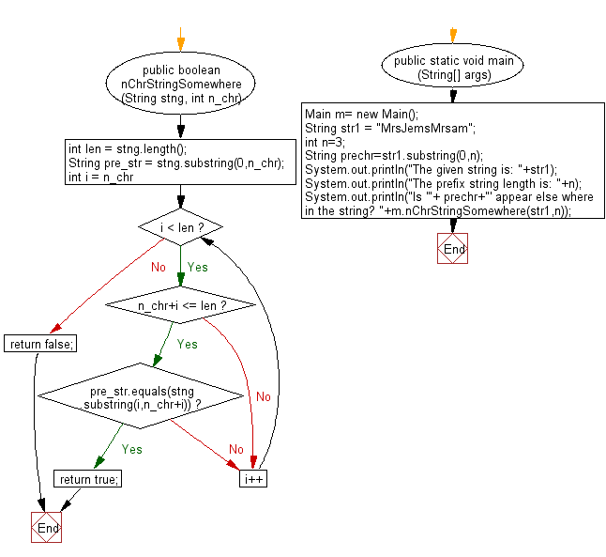

**public** **class** Program_74 {

**public** **boolean** nChrStringSomewhere (String stng, **int** n_chr)

{

**int** len = stng.length();

String pre_str = stng.substring(0,n_chr);

**for** (**int** i = n_chr; i < len; i++)

{

**if**(n_chr+i <= len)

{

**if** (pre_str.equals(stng.substring(i,n_chr+i)))

**return** **true**;

}

}

**return** **false**;

}

**public** **static** **void** main(String[] args) {

// **TODO** Auto-generated method stub

Program_74 m= **new** Program_74();

String str1 = "MrsJemsMrsam";

**int** n=3;

String prechr=str1.substring(0,n);

System.***out***.println("The given string is: "+str1);

System.***out***.println("The prefix string length is: "+n);

System.***out***.println("Is '"+ prechr+"' appear else where in the string? "+m.nChrStringSomewhere(str1,n));

}

}

**Output:**

The given string is: MrsJemsMrsam

The prefix string length is: 3

Is 'Mrs' appear else where in the string? true

**75. Write a Java program to check whether a string 'abc' in the middle of a given string. Here middle means the number of character to the left and right of the substring 'abc' must differ by at most one.**

**Flowchart:**

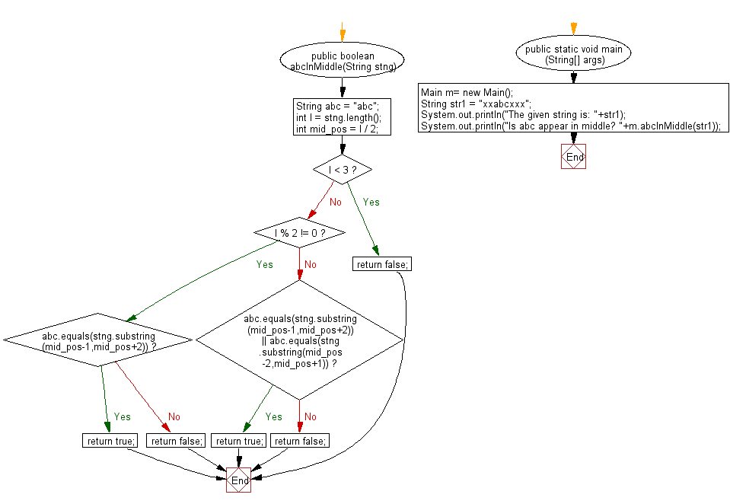

**public** **class** Program_75 {

**public** **boolean** abcInMiddle(String stng)

{

String abc = "abc";

**int** l = stng.length();

**int** mid_pos = l / 2;

**if** (l < 3)

**return** **false**;

**if** (l % 2 != 0)

{

**if** (abc.equals(stng.substring(mid_pos-1,mid_pos+2)))

{

**return** **true**;

} **else**

{

**return** **false**;

}

}

**else** **if** (abc.equals(stng.substring(mid_pos-1,mid_pos+2)) || abc.equals(stng.substring(mid_pos-2,mid_pos+1)))

{

**return** **true**;

}

**else**

**return** **false**;

}

**public** **static** **void** main(String[] args) {

// **TODO** Auto-generated method stub

Program_75 m= **new** Program_75();

String str1 = "xxabcxxx";

System.***out***.println("The given string is: "+str1);

System.***out***.println("Is abc appear in middle? "+m.abcInMiddle(str1));

}

}

**Output:**

The given string is: xxabcxxx

Is abc appear in middle? true

**76. Write a Java program to count how many times the substring 'life' present at anywhere in a given string. Counting can also happen for the substring 'li?e', any character instead of 'f'.**

**Flowchart:**

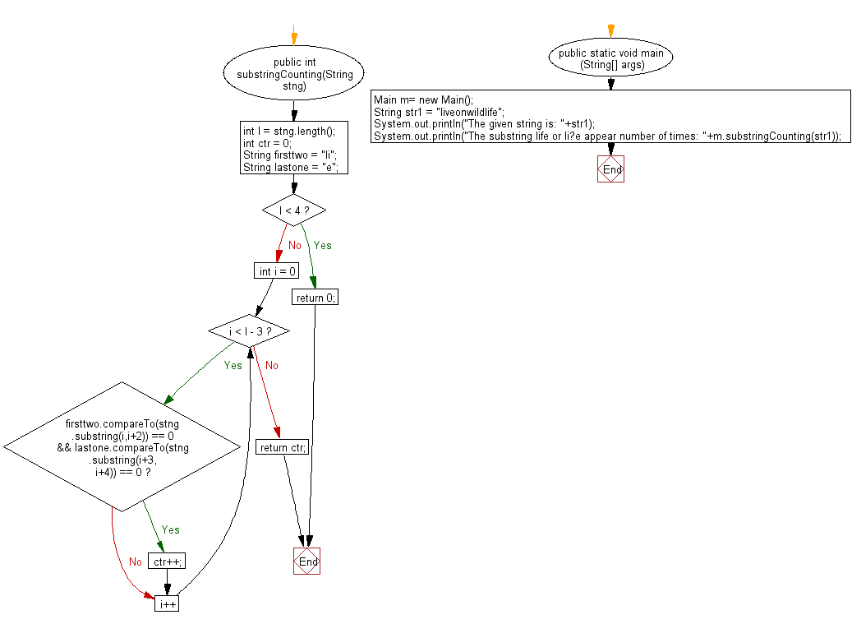

**public** **class** Program_76 {

**public** **int** substringCounting(String stng)

{

**int** l = stng.length();

**int** ctr = 0;

String firsttwo = "li";

String lastone = "e";

**if** (l < 4)

**return** 0;

**for** (**int** i = 0; i < l - 3; i++)

{

**if** (firsttwo.compareTo(stng.substring(i,i+2)) == 0 && lastone.compareTo(stng.substring(i+3, i+4)) == 0)

ctr++;

}

**return** ctr;

}

**public** **static** **void** main(String[] args) {

// **TODO** Auto-generated method stub

Program_76 m= **new** Program_76();

String str1 = "liveonwildlife";

System.***out***.println("The given string is: "+str1);

System.***out***.println("The substring life or li?e appear number of times: "+m.substringCounting(str1));

}

}

**Output:**

The given string is: liveonwildlife

The substring life or li?e appear number of times: 2

**77. Write a Java program to add a string with specific number of times seperated by a substring.**

**Flowchart:**

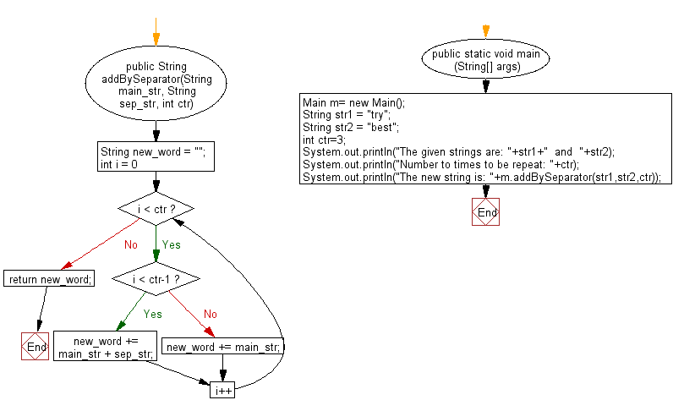

**public** **class** Program_77 {

**public** String addBySeparator(String main_str, String sep_str, **int** ctr)

{

String new_word = "";

**for** (**int** i = 0; i < ctr; i++)

{

**if** (i < ctr-1)

new_word += main_str + sep_str;

**else**

new_word += main_str;

}

**return** new_word;

}

**public** **static** **void** main(String[] args) {

// **TODO** Auto-generated method stub

Program_77 m= **new** Program_77();

String str1 = "try";

String str2 = "best";

**int** ctr=3;

System.***out***.println("The given strings are: "+str1+" and "+str2);

System.***out***.println("Number to times to be repeat: "+ctr);

System.***out***.println("The new string is: "+m.addBySeparator(str1,str2,ctr));

}

}

**Output:**

The given strings are: try and best

Number to times to be repeat: 3

The new string is: trybesttrybesttry

**78. Write a Java program to repeat a specific number of characters for specific number of times from the last of a string.**

**Flowchart:**

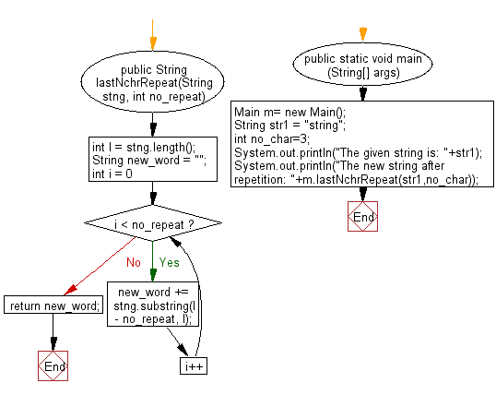

**public** **class** Program_78 {

**public** String lastNchrRepeat(String stng, **int** no_repeat)

{

**int** l = stng.length();

String new_word = "";

**for** (**int** i = 0; i < no_repeat; i++)

{

new_word += stng.substring(l - no_repeat, l);

}

**return** new_word;

}

**public** **static** **void** main(String[] args) {

// **TODO** Auto-generated method stub

Program_78 m= **new** Program_78();

String str1 = "string";

**int** no_char=3;

System.***out***.println("The given string is: "+str1);

System.***out***.println("The new string after repetition: "+m.lastNchrRepeat(str1,no_char));

}

}

**Output:**

The given string is: string

The new string after repetition: inginging

**79. Write a Java program to return the given string after removing the 2nd character from the substring of length three, starting with 'z' and ending with 'g'.**

**Flowchart:**

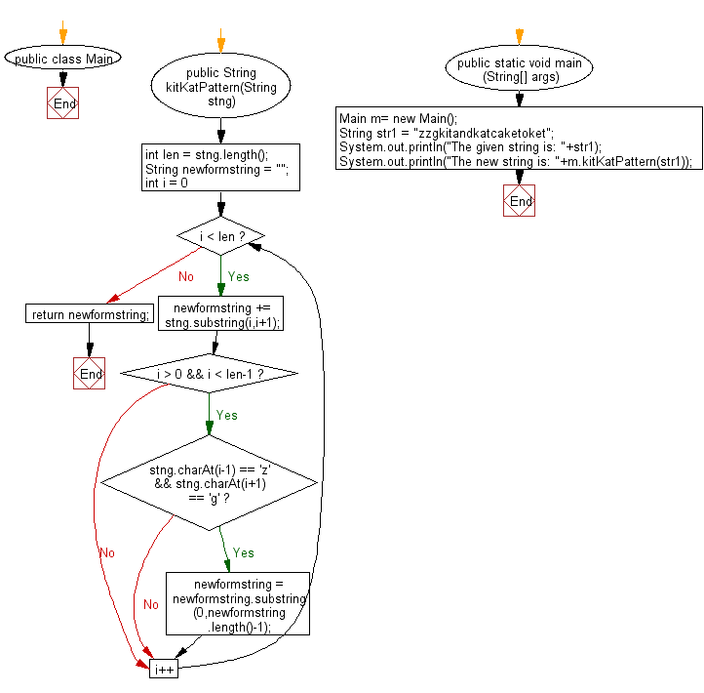

**public** **class** Program_79 {

**public** String kitKatPattern(String stng)

{

**int** len = stng.length();

String newformstring = "";

**for** (**int** i = 0; i < len; i++)

{

newformstring += stng.substring(i,i+1);

**if** (i > 0 && i < len-1)

{

**if** (stng.charAt(i-1) == 'z' && stng.charAt(i+1) == 'g')

newformstring = newformstring.substring(0,newformstring.length()-1);

}

}

**return** newformstring;

}

**public** **static** **void** main(String[] args) {

// **TODO** Auto-generated method stub

Program_79 m= **new** Program_79();

String str1 = "zzgkitandkatcaketoket";

System.***out***.println("The given string is: "+str1);

System.***out***.println("The new string is: "+m.kitKatPattern(str1));

}

}

**Output:**

The given string is: zzgkitandkatcaketoket

The new string is: zgkitandkatcaketoket

**80. Write a Java program to check whether the character immediately before and after of # is same in a given string.**

**Flowchart:**

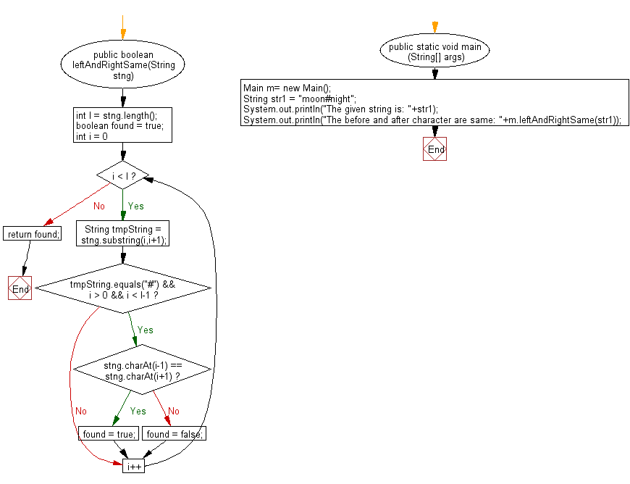

**public** **class** Program_80 {

**public** **boolean** leftAndRightSame(String stng)

{

**int** l = stng.length();

**boolean** found = **true**;

**for** (**int** i = 0; i < l; i++)

{

String tmpString = stng.substring(i,i+1);

**if** (tmpString.equals("#") && i > 0 && i < l-1)

{

**if** (stng.charAt(i-1) == stng.charAt(i+1))

found = **true**;

**else**

found = **false**;

}

}

**return** found;

}

**public** **static** **void** main(String[] args) {

// **TODO** Auto-generated method stub

Program_80 m= **new** Program_80();

String str1 = "moon#night";

System.***out***.println("The given string is: "+str1);

System.***out***.println("The before and after character are same: "+m.leftAndRightSame(str1));

}

}

**Output:**

The given string is: moon#night

The before and after character are same: true

**81. Write a Java program to check whether the string 'red' and 'blue' appear in same number of times in a given string.**

**Flowchart:**

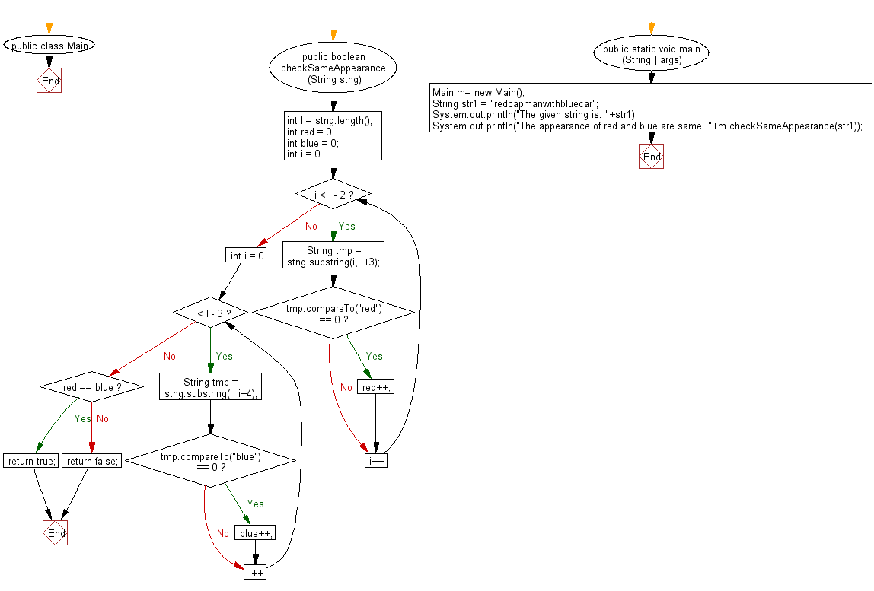

**public** **class** Program_81 {

**public** **boolean** checkSameAppearance(String stng)

{

**int** l = stng.length();

**int** red = 0;

**int** blue = 0;

**for** (**int** i = 0; i < l - 2; i++)

{

String tmp = stng.substring(i, i+3);

**if** (tmp.compareTo("red") == 0)

red++;

}

**for** (**int** i = 0; i < l - 3; i++)

{

String tmp = stng.substring(i, i+4);

**if** (tmp.compareTo("blue") == 0)

blue++;

}

**if** (red == blue)

**return** **true**;

**else**

**return** **false**;

}

**public** **static** **void** main(String[] args) {

// **TODO** Auto-generated method stub

Program_81 m = **new** Program_81();

String str1 = "redcapmanwithbluecar";

System.***out***.println("The given string is: "+str1);

System.***out***.println("The appearance of red and blue are same: "+m.checkSameAppearance(str1));

}

}

**Output:**

The given string is: redcapmanwithbluecar

The appearance of red and blue are same: true

**82. Write a Java program to repeat every character twice in the original string.**

**Flowchart:**

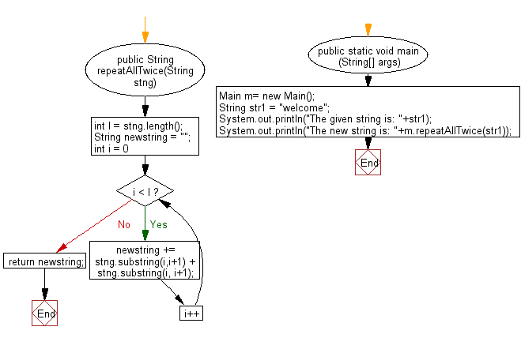

**public** **class** Program_82 {

**public** String repeatAllTwice(String stng)

{

**int** l = stng.length();

String newstring = "";

**for** (**int** i = 0; i < l; i++)

{

newstring += stng.substring(i,i+1) + stng.substring(i, i+1);

}

**return** newstring;

}

**public** **static** **void** main(String[] args) {

// **TODO** Auto-generated method stub

Program_82 m= **new** Program_82();

String str1 = "welcome";

System.***out***.println("The given string is: "+str1);

System.***out***.println("The new string is: "+m.repeatAllTwice(str1));

}

}

**Output:**

The given string is: welcome

The new string is: wweellccoommee

**83. Write a Java program to make a new string from two given string in such a way that, each character of two string will come respectively.**

**Flowchart:**

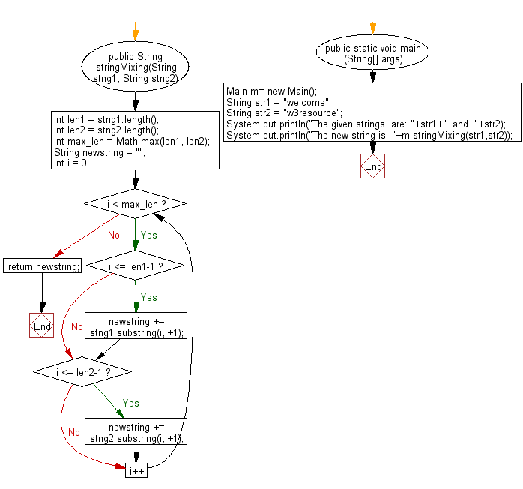

**public** **class** Program_83 {

**public** String stringMixing(String stng1, String stng2)

{

**int** len1 = stng1.length();

**int** len2 = stng2.length();

**int** max_len = Math.*max*(len1, len2);

String newstring = "";

**for** (**int** i = 0; i < max_len; i++)

{

**if** (i <= len1-1)

newstring += stng1.substring(i,i+1);

**if** (i <= len2-1)

newstring += stng2.substring(i,i+1);

}

**return** newstring;

}

**public** **static** **void** main(String[] args) {

// **TODO** Auto-generated method stub

Program_83 m= **new** Program_83();

String str1 = "welcome";

String str2 = "w3resource";

System.***out***.println("The given strings are: "+str1+" and "+str2);

System.***out***.println("The new string is: "+m.stringMixing(str1,str2));

}

}

**Output:**

The given strings are: welcome and w3resource

The new string is: wwe3lrceosmoeurce

**84. Write a Java program to make a new string made of p number of characters from the first of a given string and followed by p-1 number characters till the p is greater than zero.**

**Flowchart:**

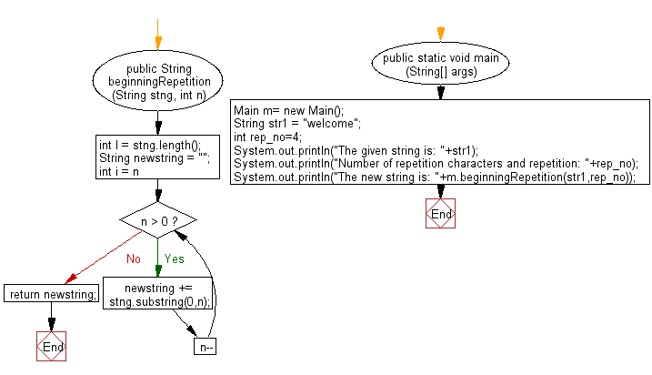

**public** **class** Program_84 {

**public** String beginningRepetition(String stng, **int** n)

{

**int** l = stng.length();

String newstring = "";

**for** (**int** i = n; n > 0; n--)

{

newstring += stng.substring(0,n);

}

**return** newstring;

}

**public** **static** **void** main(String[] args) {

// **TODO** Auto-generated method stub

Program_84 m= **new** Program_84();

String str1 = "welcome";

**int** rep_no=4;

System.***out***.println("The given string is: "+str1);

System.***out***.println("Number of repetition characters and repetition: "+rep_no);

System.***out***.println("The new string is: "+m.beginningRepetition(str1,rep_no));

}

}

**Output:**

The given string is: welcome

Number of repetition characters and repetition: 4

The new string is: welcwelwew

**85. Write a Java program to make a new string with each character of just before and after of t-string whichever it appears in m-string. Assume that m-string and non-empty t-string has given.**

**Flowchart:**

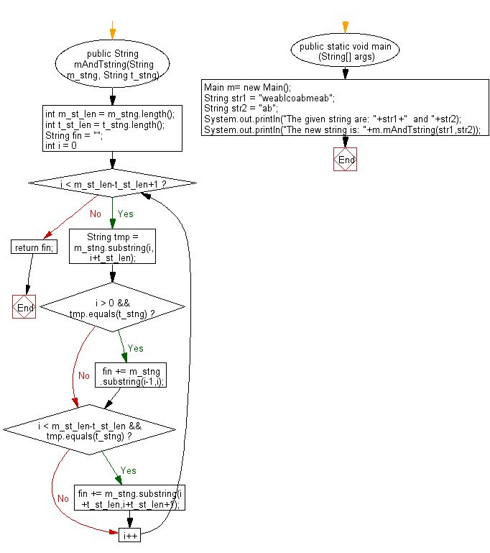

**public** **class** Program_85 {

**public** String mAndTstring(String m_stng, String t_stng)

{

**int** m_st_len = m_stng.length();

**int** t_st_len = t_stng.length();

String fin = "";

**for** (**int** i = 0; i < m_st_len-t_st_len+1; i++)

{

String tmp = m_stng.substring(i,i+t_st_len);

**if** (i > 0 && tmp.equals(t_stng))

fin += m_stng.substring(i-1,i);

**if** (i < m_st_len-t_st_len && tmp.equals(t_stng))

fin += m_stng.substring(i+t_st_len,i+t_st_len+1);

}

**return** fin;

}

**public** **static** **void** main(String[] args) {

// **TODO** Auto-generated method stub

Program_85 m= **new** Program_85();

String str1 = "weablcoabmeab";

String str2 = "ab";

System.***out***.println("The given string are: "+str1+" and "+str2);

System.***out***.println("The new string is: "+m.mAndTstring(str1,str2));

}

}

**Output:**

The given string are: weablcoabmeab and ab

The new string is: elome

**86. Write a Java program to return the number of triples in the given string. A triple is a character appearing three times in a row in a string.**

**Flowchart:**

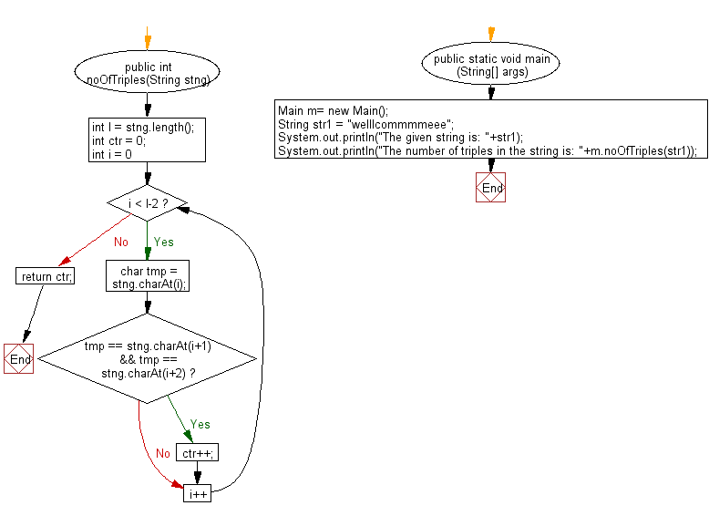

**public** **class** Program_86 {

**public** **int** noOfTriples(String stng)

{

**int** l = stng.length();

**int** ctr = 0;

**for** (**int** i = 0; i < l-2; i++)

{

**char** tmp = stng.charAt(i);

**if** (tmp == stng.charAt(i+1) && tmp == stng.charAt(i+2))

ctr++;

}

**return** ctr;

}

**public** **static** **void** main(String[] args) {

// **TODO** Auto-generated method stub

Program_86 m= **new** Program_86();

String str1 = "welllcommmmeee";

System.***out***.println("The given string is: "+str1);

System.***out***.println("The number of triples in the string is: "+m.noOfTriples(str1));

}

}

**Output:**

The given string is: welllcommmmeee

The number of triples in the string is: 4

**87. Write a Java program to check whether a z is happy or not. A 'z' is happy when there is another 'z' immediately to its left or right.Return true if all the z's in the given string are happy.**

**Flowchart:**

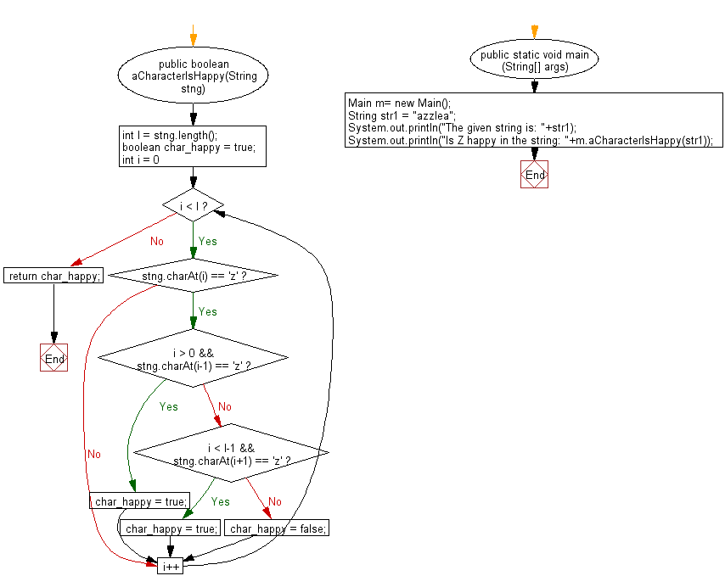

**public** **class** Program_87 {

**public** **boolean** aCharacterIsHappy(String stng)

{

**int** l = stng.length();

**boolean** char_happy = **true**;

**for** (**int** i = 0; i < l; i++)

{

**if** (stng.charAt(i) == 'z')

{

**if** (i > 0 && stng.charAt(i-1) == 'z')

char_happy = **true**;

**else** **if** (i < l-1 && stng.charAt(i+1) == 'z')

char_happy = **true**;

**else**

char_happy = **false**;

}

}

**return** char_happy;

}

**public** **static** **void** main(String[] args) {

// **TODO** Auto-generated method stub

Program_87 m= **new** Program_87();

String str1 = "azzlea";

System.***out***.println("The given string is: "+str1);

System.***out***.println("Is Z happy in the string: "+m.aCharacterIsHappy(str1));

}

}

**Output:**

The given string is: azzlea

Is Z happy in the string: true

**88. Write a Java program to return a string where every appearance of the lowercase word 'is' has been replaced with 'is not'.**

**Flowchart:**

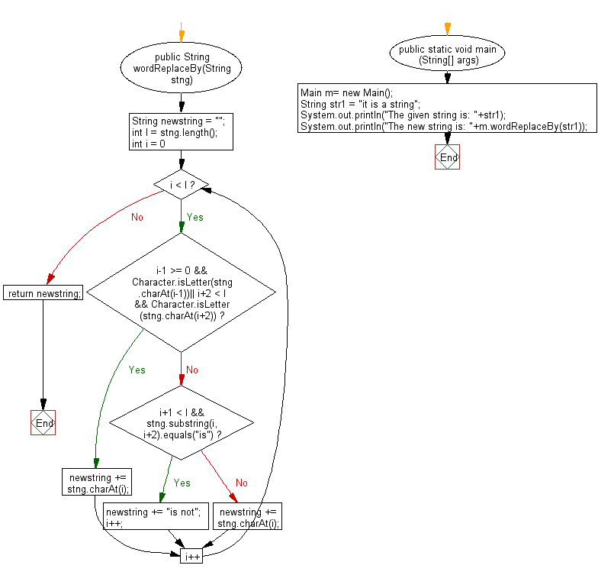

**public** **class** Program_88 {

**public** String wordReplaceBy(String stng)

{

String newstring = "";

**int** l = stng.length();

**for**(**int** i = 0; i < l; i++)

{

**if**(i-1 >= 0 && Character.*isLetter*(stng.charAt(i-1))|| i+2 < l && Character.*isLetter*(stng.charAt(i+2)))

{

newstring += stng.charAt(i);

}

**else** **if**(i+1 < l && stng.substring(i, i+2).equals("is"))

{

newstring += "is not";

i++;

}

**else** newstring += stng.charAt(i);

}

**return** newstring;

}

**public** **static** **void** main(String[] args) {

// **TODO** Auto-generated method stub

Program_88 m= **new** Program_88 ();

String str1 = "it is a string";

System.***out***.println("The given string is: "+str1);

System.***out***.println("The new string is: "+m.wordReplaceBy(str1));

}

}

**Output:**

The given string is: it is a string

The new string is: it is not a string

**89. Write a Java program to return the sum of the numbers (may form more than one digits), appearing in the string.**

**Flowchart:**

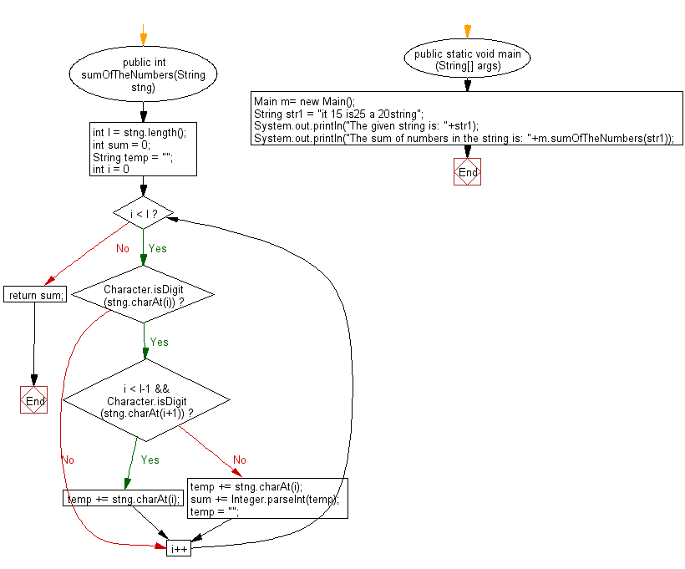

**public** **class** Program_89 {

**public** **int** sumOfTheNumbers(String stng)

{

**int** l = stng.length();

**int** sum = 0;

String temp = "";

**for** (**int** i = 0; i < l; i++)

{

**if** (Character.*isDigit*(stng.charAt(i)))

{

**if** (i < l-1 && Character.*isDigit*(stng.charAt(i+1)))

{

temp += stng.charAt(i);

}

**else**

{

temp += stng.charAt(i);

sum += Integer.*parseInt*(temp);

temp = "";

}

}

}

**return** sum;

}

**public** **static** **void** main(String[] args) {

// **TODO** Auto-generated method stub

Program_89 m= **new** Program_89();

String str1 = "it 15 is25 a 20string";

System.***out***.println("The given string is: "+str1);

System.***out***.println("The sum of numbers in the string is: "+m.sumOfTheNumbers(str1));

}

}

**Output:**

The given string is: it 15 is25 a 20string

The sum of numbers in the string is: 60

**90. Write a Java program to return true if the number of appearances of 'the' and 'is' anywhere in the string is equal.**

**Flowchart:**

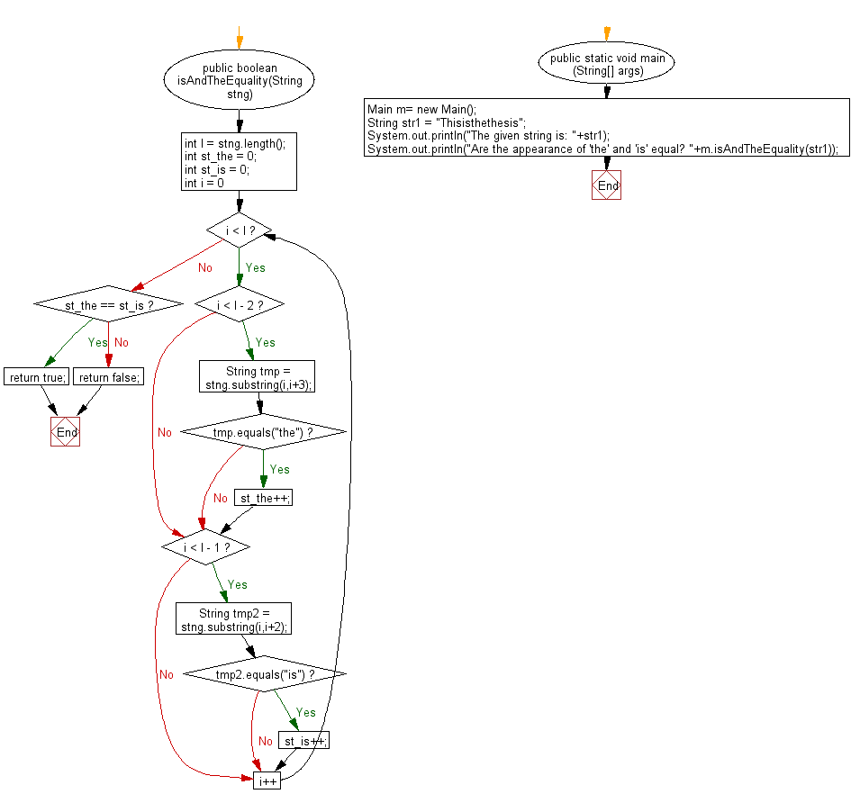

**public** **class** Program_90 {

**public** **boolean** isAndTheEquality(String stng)

{

**int** l = stng.length();

**int** st_the = 0;

**int** st_is = 0;

**for** (**int** i = 0; i < l; i++)

{

**if** (i < l - 2)

{

String tmp = stng.substring(i,i+3);

**if** (tmp.equals("the"))

st_the++;

}

**if** (i < l - 1)

{

String tmp2 = stng.substring(i,i+2);

**if** (tmp2.equals("is"))

st_is++;

}

}

**if** (st_the == st_is)

**return** **true**;

**else**

**return** **false**;

}

**public** **static** **void** main(String[] args) {

// **TODO** Auto-generated method stub

Program_90 m= **new** Program_90();

String str1 = "Thisisthethesis";

System.***out***.println("The given string is: "+str1);

System.***out***.println("Are the appearance of 'the' and 'is' equal? "+m.isAndTheEquality(str1));

}

}

**Output:**

The given string is: Thisisthethesis

Are the appearance of 'the' and 'is' equal? false

**91. Write a Java program to count the number of words ending in 'm' or 'n' (not case sensitive).**

**Flowchart:**

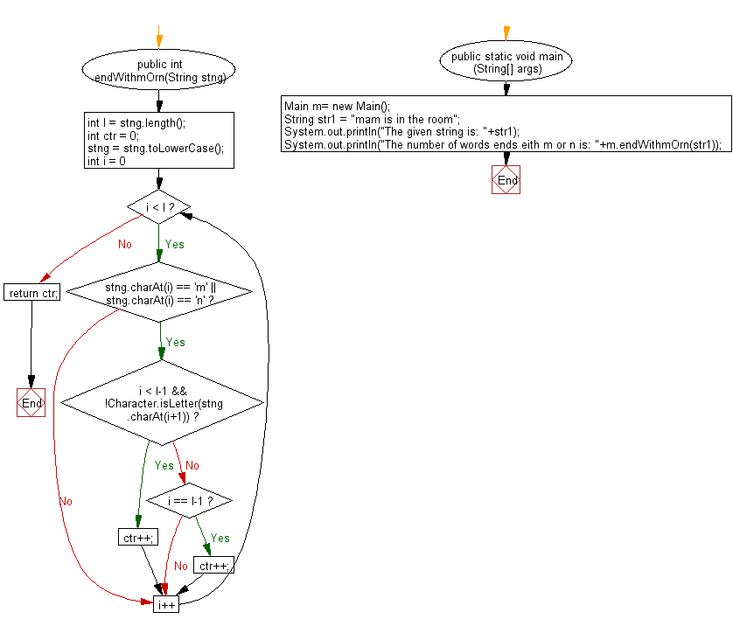

**public** **class** Program_91 {

**public** **int** endWithmOrn(String stng)

{

**int** l = stng.length();

**int** ctr = 0;

stng = stng.toLowerCase();

**for** (**int** i = 0; i < l; i++)

{

**if** (stng.charAt(i) == 'm' || stng.charAt(i) == 'n')

{

**if** (i < l-1 && !Character.*isLetter*(stng.charAt(i+1)))

ctr++;

**else** **if** (i == l-1)

ctr++;

}

}

**return** ctr;

}

**public** **static** **void** main(String[] args) {

// **TODO** Auto-generated method stub

Program_91 m= **new** Program_91();

String str1 = "mam is in the room";

System.***out***.println("The given string is: "+str1);

System.***out***.println("The number of words ends eith m or n is: "+m.endWithmOrn(str1));

}

}

**Output:**

The given string is: mam is in the room

The number of words ends eith m or n is: 3

**92. Write a Java program to return a substring after removing the all instances of remove string as given from the given main string.**

**Flowchart:**

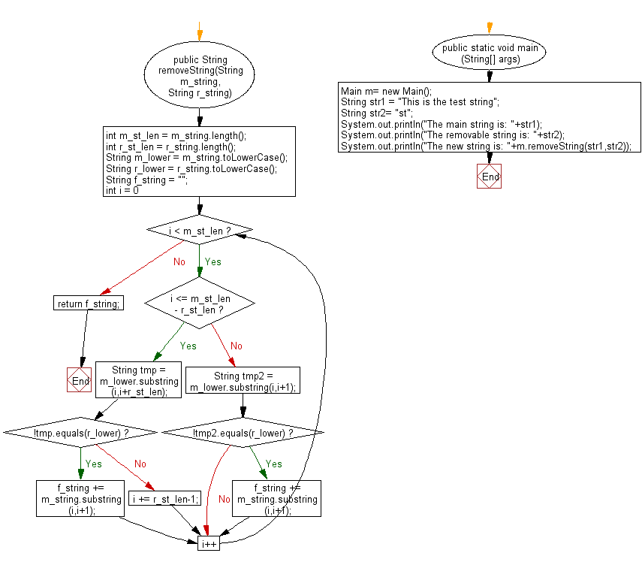

**public** **class** Program_92 {

**public** String removeString(String m_string, String r_string)

{

**int** m_st_len = m_string.length();

**int** r_st_len = r_string.length();

String m_lower = m_string.toLowerCase();

String r_lower = r_string.toLowerCase();

String f_string = "";

**for** (**int** i = 0; i < m_st_len; i++)

{

**if** (i <= m_st_len - r_st_len)

{

String tmp = m_lower.substring(i,i+r_st_len);

**if** (!tmp.equals(r_lower))

f_string += m_string.substring(i,i+1);

**else**

{

i += r_st_len-1;

}

}

**else**

{

String tmp2 = m_lower.substring(i,i+1);

**if** (!tmp2.equals(r_lower))

f_string += m_string.substring(i,i+1);

}

}

**return** f_string;

}

**public** **static** **void** main(String[] args) {

// **TODO** Auto-generated method stub

Program_92 m= **new** Program_92();

String str1 = "This is the test string";

String str2= "st";

System.***out***.println("The main string is: "+str1);

System.***out***.println("The removable string is: "+str2);

System.***out***.println("The new string is: "+m.removeString(str1,str2));

}

}

**Output:**

The main string is: This is the test string

The removable string is: st

The new string is: This is the te ring

**93. Write a Java program to find the longest substring appears at both ends of a given string.**

**Flowchart:**

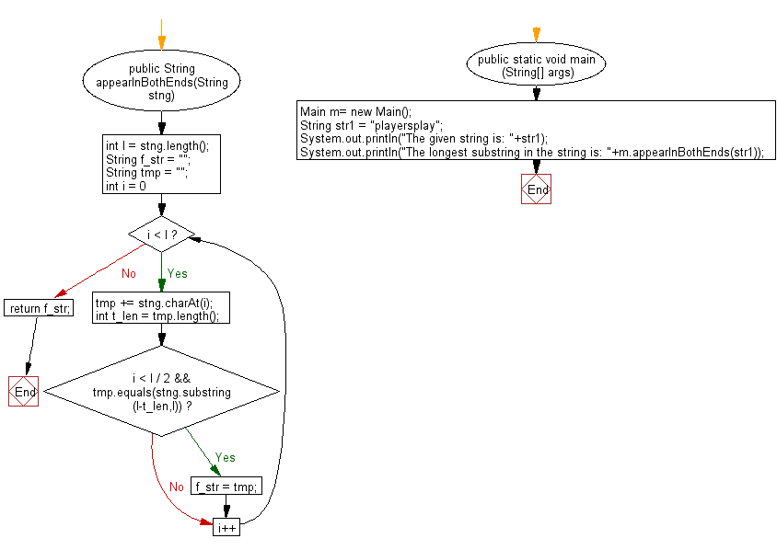

**public** **class** Program_93 {

**public** String appearInBothEnds(String stng)

{

**int** l = stng.length();

String f_str = "";

String tmp = "";

**for** (**int** i = 0; i < l; i++)

{

tmp += stng.charAt(i);

**int** t_len = tmp.length();

**if** (i < l / 2 && tmp.equals(stng.substring(l-t_len,l)))

f_str = tmp;

}

**return** f_str;

}

**public** **static** **void** main(String[] args) {

// **TODO** Auto-generated method stub

Program_93 m= **new** Program_93();

String str1 = "playersplay";

System.***out***.println("The given string is: "+str1);

System.***out***.println("The longest substring in the string is: "+m.appearInBothEnds(str1));

}

}

**Output:**

The given string is: playersplay

The longest substring in the string is: play

**94. Write a Java program to find the longest mirror image string at the both ends of a given string.**

**Flowchart:**

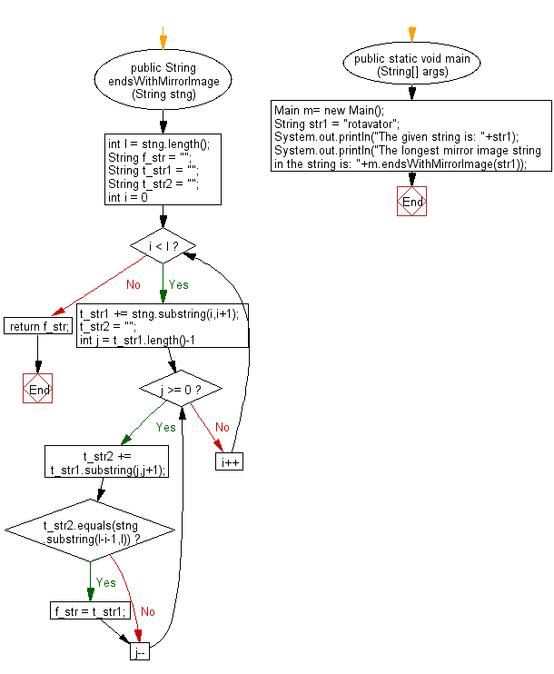

**public** **class** Program_94 {

**public** String endsWithMirrorImage(String stng)

{

**int** l = stng.length();

String f_str = "";

String t_str1 = "";

String t_str2 = "";

**for** (**int** i = 0; i < l; i++)

{

t_str1 += stng.substring(i,i+1);

t_str2 = "";

**for** (**int** j = t_str1.length()-1; j >= 0; j--)

{

t_str2 += t_str1.substring(j,j+1);

**if** (t_str2.equals(stng.substring(l-i-1,l)))

f_str = t_str1;

}

}

**return** f_str;

}

**public** **static** **void** main(String[] args) {

// **TODO** Auto-generated method stub

Program_94 m= **new** Program_94();

String str1 = "rotavator";

System.***out***.println("The given string is: "+str1);

System.***out***.println("The longest mirror image string in the string is: "+m.endsWithMirrorImage(str1));

}

}

**Output:**

The given string is: rotavator

The longest mirror image string in the string is: rotavator

**95.Write a Java program to return the sum of the digits present in the given string. If there is no digits the sum return is 0.**

**Flowchart:**

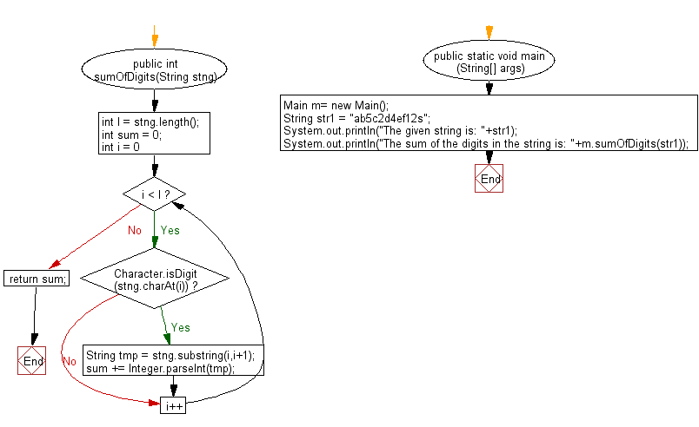

**public** **class** Program_95 {

**public** **int** sumOfDigits(String stng)

{

**int** l = stng.length();

**int** sum = 0;

**for** (**int** i = 0; i < l; i++)

{

**if** (Character.*isDigit*(stng.charAt(i)))

{

String tmp = stng.substring(i,i+1);

sum += Integer.*parseInt*(tmp);

}

}

**return** sum;

}

**public** **static** **void** main(String[] args) {

// **TODO** Auto-generated method stub

Program_95 m= **new** Program_95();

String str1 = "ab5c2d4ef12s";

System.***out***.println("The given string is: "+str1);

System.***out***.println("The sum of the digits in the string is: "+m.sumOfDigits(str1));

}

}

**Output:**

The given string is: ab5c2d4ef12s

The sum of the digits in the string is: 14

**96.Write a Java program to return the string after removing all 'z' (except the very first and last) from a given string.**

**Flowchart:**

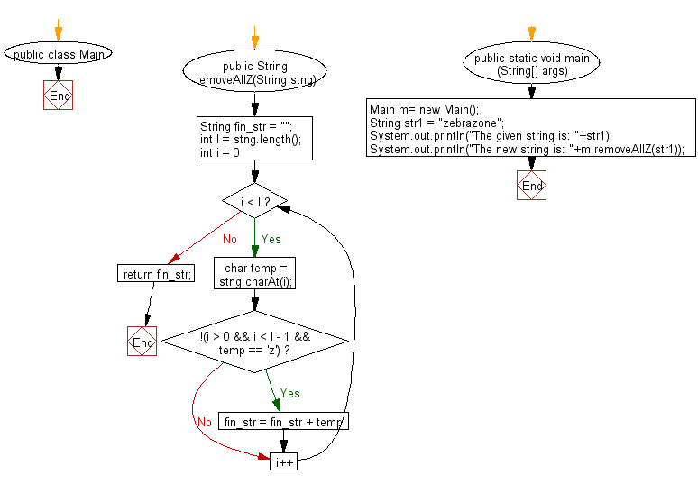

**public** **class** Program_96 {

**public** String removeAllZ(String stng)

{

String fin_str = "";

**int** l = stng.length();

**for** (**int** i = 0; i < l; i++)

{

**char** temp = stng.charAt(i);

**if** (!(i > 0 && i < l - 1 && temp == 'z'))

fin_str = fin_str + temp;

}

**return** fin_str;

}

**public** **static** **void** main(String[] args) {

// **TODO** Auto-generated method stub

Program_96 m= **new** Program_96();

String str1 = "zebrazone";

System.***out***.println("The given string is: "+str1);

System.***out***.println("The new string is: "+m.removeAllZ(str1));

}

}

**Output:**

The given string is: zebrazone

The new string is: zebraone

**97.Write a Java program to return a string with the characters of the index position 0,1,2, 5,6,7, ... from a given string.**

**Flowchart:**

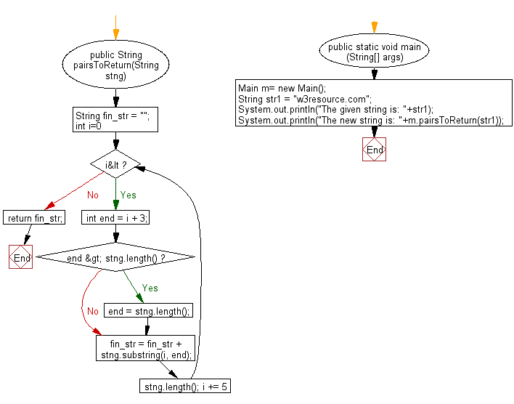

**public** **class** Program_97 {

**public** String pairsToReturn(String stng)

{

String fin_str = "";

**for** (**int** i=0; i<stng.length(); i += 5)

{

**int** end = i + 3;

**if** (end > stng.length())

{

end = stng.length();

}

fin_str = fin_str + stng.substring(i, end);

}

**return** fin_str;

}

**public** **static** **void** main(String[] args) {

// **TODO** Auto-generated method stub

Program_97 m= **new** Program_97();

String str1 = "w3resource.com";

System.***out***.println("The given string is: "+str1);

System.***out***.println("The new string is: "+m.pairsToReturn(str1));

}

}

**Output:**

The given string is: w3resource.com

The new string is: w3rour.co

**98. Write a Java program to check whether the first instance of 'z' is immediately followed by another 'z' in a given string**.

**Flowchart:**

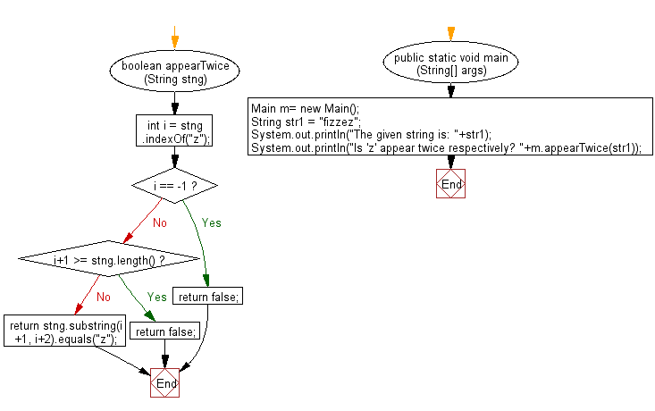

**public** **class** Program_98 {

**boolean** appearTwice(String stng)

{

**int** i = stng.indexOf("z");

**if** (i == -1) **return** **false**;

**if** (i+1 >= stng.length()) **return** **false**;

**return** stng.substring(i+1, i+2).equals("z");

}

**public** **static** **void** main(String[] args) {

// **TODO** Auto-generated method stub

Program_98 m= **new** Program_98();

String str1 = "fizzez";

System.***out***.println("The given string is: "+str1);

System.***out***.println("Is 'z' appear twice respectively? "+m.appearTwice(str1));

}

}

**Output:**

The given string is: fizzez

Is 'z' appear twice respectively? true

**99.Write a Java program to return a new string using every characters of even positions from a given string.**

**public** **class** Program_99 {

**public** String makeWithEvenCharacters(String stng)

{

**int** len = stng.length();

String fin_str = "";

**for** (**int** i = 0; i < len; i = i + 2)

{

fin_str += stng.charAt(i);

}

**return** fin_str;

}

**public** **static** **void** main(String[] args) {

// **TODO** Auto-generated method stub

Program_99 m= **new** Program_99();

String str1 = "w3resource.com";

System.***out***.println("The given string is: "+str1);

System.***out***.println("The new string is: "+m.makeWithEvenCharacters(str1));

}

}

**Output:**

The given string is: w3resource.com

The new string is: wrsuc.o

**100.Write a Java program to check if a given string contains another string. Return true or false**.

**Flowchart:**

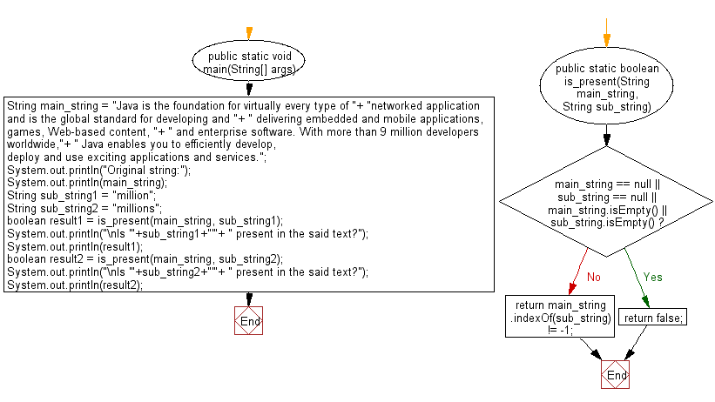

**public** **class** Program_100 {

**public** **static** **void** main(String[] args) {

// **TODO** Auto-generated method stub

String main_string = "Java is the foundation for virtually every type of "+

"networked application and is the global standard for developing and "+

" delivering embedded and mobile applications, games, Web-based content, "+

" and enterprise software. With more than 9 million developers worldwide,"+

" Java enables you to efficiently develop, deploy and use exciting applications and services.";

System.***out***.println("Original string:");

System.***out***.println(main_string);

String sub_string1 = "million";

String sub_string2 = "millions";

**boolean** result1 = *is_present*(main_string, sub_string1);

System.***out***.println("\nIs '"+sub_string1+"'"+ " present in the said text?");

System.***out***.println(result1);

**boolean** result2 = *is_present*(main_string, sub_string2);

System.***out***.println("\nIs '"+sub_string2+"'"+ " present in the said text?");

System.***out***.println(result2);

}

**public** **static** **boolean** is_present(String main_string, String sub_string) {

**if** (main_string == **null** || sub_string == **null** || main_string.isEmpty() || sub_string.isEmpty()) {

**return** **false**;

}

**return** main_string.indexOf(sub_string) != -1;

}

}

**Output:**

Original string:

Java is the foundation for virtually every type of networked application and is the global standard for developing and delivering embedded and mobile applications, games, Web-based content, and enterprise software. With more than 9 million developers worldwide, Java enables you to efficiently develop, deploy and use exciting applications and services.

Is 'million' present in the said text?

true

Is 'millions' present in the said text?

false

**101. Write a Java program to test if a given string contains only digits.**

**Flowchart:**

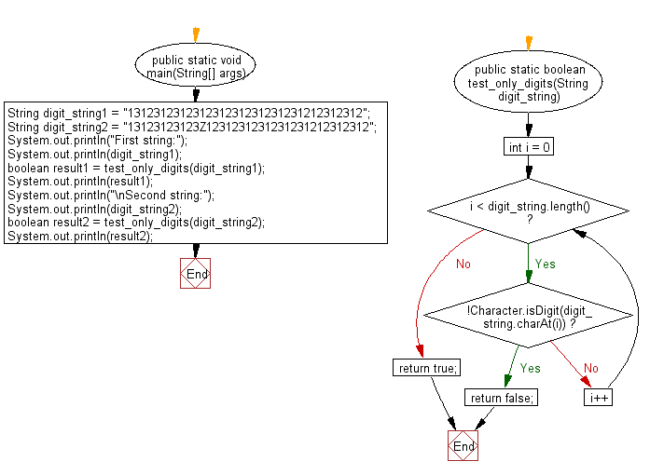

**public** **class** Program_101 {

**public** **static** **void** main(String[] args) {

// **TODO** Auto-generated method stub

String digit_string1 = "131231231231231231231231231212312312";

String digit_string2 = "13123123123Z1231231231231231212312312";

System.***out***.println("First string:");

System.***out***.println(digit_string1);

**boolean** result1 = *test_only_digits*(digit_string1);

System.***out***.println(result1);

System.***out***.println("\nSecond string:");

System.***out***.println(digit_string2);

**boolean** result2 = *test_only_digits*(digit_string2);

System.***out***.println(result2);

}

**public** **static** **boolean** test_only_digits(String digit_string) {

**for** (**int** i = 0; i < digit_string.length(); i++) {

**if** (!Character.*isDigit*(digit_string.charAt(i))) {

**return** **false**;

}

}

**return** **true**;

}

}

**Output:**

First string:

131231231231231231231231231212312312

true

Second string:

13123123123Z1231231231231231212312312

false

**102. Write a Java program to convert a given String to int, long, float and double.**

**Flowchart:**

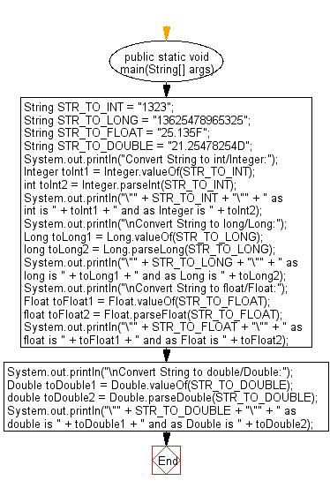

**public** **class** Program_102 {

**public** **static** **void** main(String[] args) {

// **TODO** Auto-generated method stub

String STR_TO_INT = "1323";

String STR_TO_LONG = "13625478965325";

String STR_TO_FLOAT = "25.135F";

String STR_TO_DOUBLE = "21.25478254D";

System.***out***.println("Convert String to int/Integer:");

Integer toInt1 = Integer.*valueOf*(STR_TO_INT);

**int** toInt2 = Integer.*parseInt*(STR_TO_INT);

System.***out***.println("\"" + STR_TO_INT + "\"" + " as int is "

+ toInt1 + " and as Integer is " + toInt2);

System.***out***.println("\nConvert String to long/Long:");

Long toLong1 = Long.*valueOf*(STR_TO_LONG);

**long** toLong2 = Long.*parseLong*(STR_TO_LONG);

System.***out***.println("\"" + STR_TO_LONG + "\"" + " as long is "

+ toLong1 + " and as Long is " + toLong2);

System.***out***.println("\nConvert String to float/Float:");

Float toFloat1 = Float.*valueOf*(STR_TO_FLOAT);

**float** toFloat2 = Float.*parseFloat*(STR_TO_FLOAT);

System.***out***.println("\"" + STR_TO_FLOAT + "\"" + " as float is "

+ toFloat1 + " and as Float is " + toFloat2);

System.***out***.println("\nConvert String to double/Double:");

Double toDouble1 = Double.*valueOf*(STR_TO_DOUBLE);

**double** toDouble2 = Double.*parseDouble*(STR_TO_DOUBLE);

System.***out***.println("\"" + STR_TO_DOUBLE + "\"" + " as double is "

+ toDouble1 + " and as Double is " + toDouble2);

}

}

**Output:**

Convert String to int/Integer:

"1323" as int is 1323 and as Integer is 1323

Convert String to long/Long:

"13625478965325" as long is 13625478965325 and as Long is 13625478965325

Convert String to float/Float:

"25.135F" as float is 25.135 and as Float is 25.135

Convert String to double/Double:

"21.25478254D" as double is 21.25478254 and as Double is 21.25478254

**103. Write a Java program to remove a specified character from a given string.**

**Flowchart:**

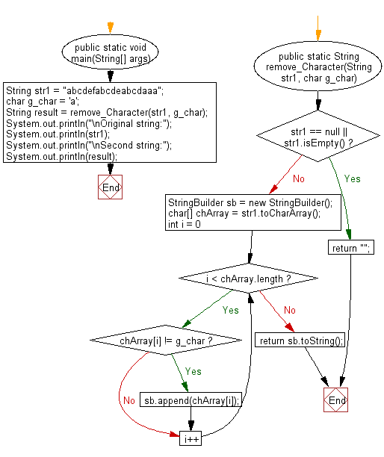

**public** **class** Program_103 {

**public** **static** **void** main(String[] args) {

// **TODO** Auto-generated method stub

String str1 = "abcdefabcdeabcdaaa";

**char** g_char = 'a';

String result = *remove_Character*(str1, g_char);

System.***out***.println("\nOriginal string:");

System.***out***.println(str1);

System.***out***.println("\nSecond string:");

System.***out***.println(result);

}

**public** **static** String remove_Character(String str1, **char** g_char) {

**if** (str1 == **null** || str1.isEmpty()) {

**return** "";

}

StringBuilder sb = **new** StringBuilder();

**char**[] chArray = str1.toCharArray();

**for** (**int** i = 0; i < chArray.length; i++) {

**if** (chArray[i] != g_char) {

sb.append(chArray[i]);

}

}

**return** sb.toString();

}

}

**Output:**

Original string:

abcdefabcdeabcdaaa

Second string:

bcdefbcdebcd

**104. Write a Java program to sort in ascending and descending order by length of the given array of strings.**

**Flowchart:**

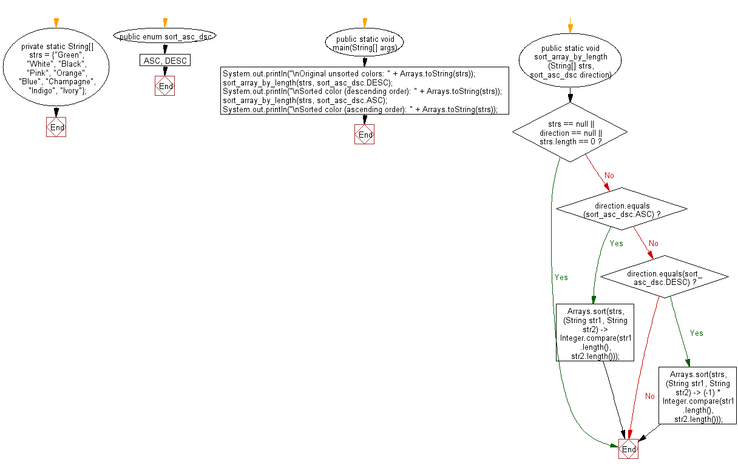

**import** java.util.Arrays;

**public** **class** Program_104 {

**private** **static** String[] *strs* = {"Green", "White", "Black", "Pink", "Orange", "Blue", "Champagne", "Indigo", "Ivory"};

**public** **enum** sort_asc_dsc{

***ASC***, ***DESC***

}

**public** **static** **void** main(String[] args) {

// **TODO** Auto-generated method stub

System.***out***.println("\nOriginal unsorted colors: " + Arrays.*toString*(*strs*));

*sort_array_by_length*(*strs*, sort_asc_dsc.***DESC***);

System.***out***.println("\nSorted color (descending order): " + Arrays.*toString*(*strs*));

*sort_array_by_length*(*strs*, sort_asc_dsc.***ASC***);

System.***out***.println("\nSorted color (ascending order): " + Arrays.*toString*(*strs*));

}

**public** **static** **void** sort_array_by_length(String[] strs, sort_asc_dsc direction) {

**if** (strs == **null** || direction == **null** || strs.length == 0) {

**return**;

}

**if** (direction.equals(sort_asc_dsc.***ASC***)) {

Arrays.*sort*(strs, (String str1, String str2)

-> Integer.*compare*(str1.length(), str2.length()));

} **else** **if** (direction.equals(sort_asc_dsc.***DESC***)) {

Arrays.*sort*(strs, (String str1, String str2)

-> (-1) * Integer.*compare*(str1.length(), str2.length()));

}

}

}

**Output:**

Original unsorted colors: [Green, White, Black, Pink, Orange, Blue, Champagne, Indigo, Ivory]

Sorted color (descending order): [Champagne, Orange, Indigo, Green, White, Black, Ivory, Pink, Blue]

Sorted color (ascending order): [Pink, Blue, Green, White, Black, Ivory, Orange, Indigo, Champagne]

**105. Write a Java program to count the occurrences of a given string in another given string.**

**Flowchart:**

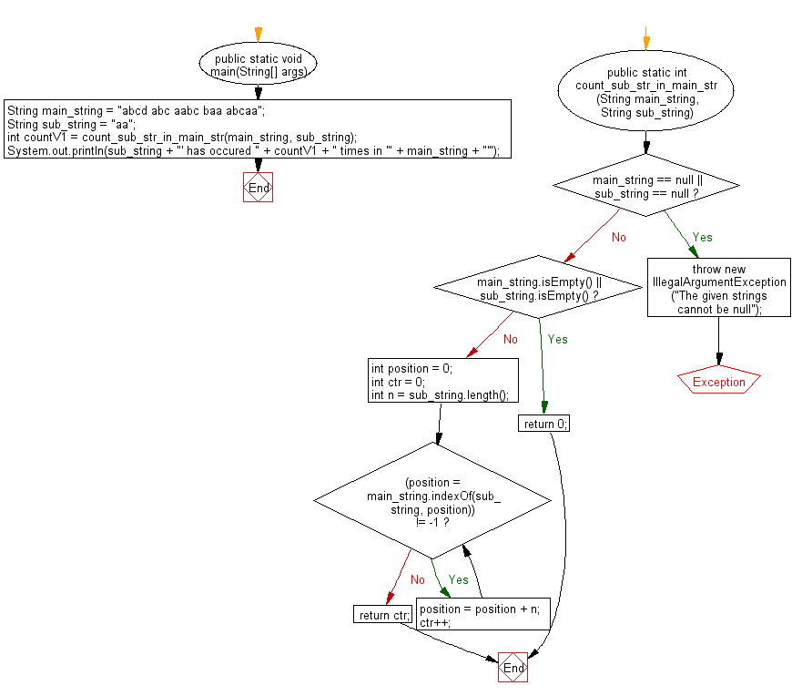

**public** **class** Program_105 {

**public** **static** **void** main(String[] args) {

// **TODO** Auto-generated method stub

String main_string = "abcd abc aabc baa abcaa";

String sub_string = "aa";

**int** countV1 = *count_sub_str_in_main_str*(main_string, sub_string);

System.***out***.println(sub_string + "' has occured " + countV1 + " times in '" + main_string + "'");

}

**public** **static** **int** count_sub_str_in_main_str(String main_string, String sub_string) {

**if** (main_string == **null** || sub_string == **null**) {

**throw** **new** IllegalArgumentException("The given strings cannot be null");

}

**if** (main_string.isEmpty() || sub_string.isEmpty()) {

**return** 0;

}

**int** position = 0;

**int** ctr = 0;

**int** n = sub_string.length();

**while** ((position = main_string.indexOf(sub_string, position)) != -1) {

position = position + n;

ctr++;

}

**return** ctr;

}

}

**Output:**

aa' has occured 3 times in 'abcd abc aabc baa abcaa'

**106. Write a Java program to concatenate a given string with itself of a given number of times**.

**Flowchart:**

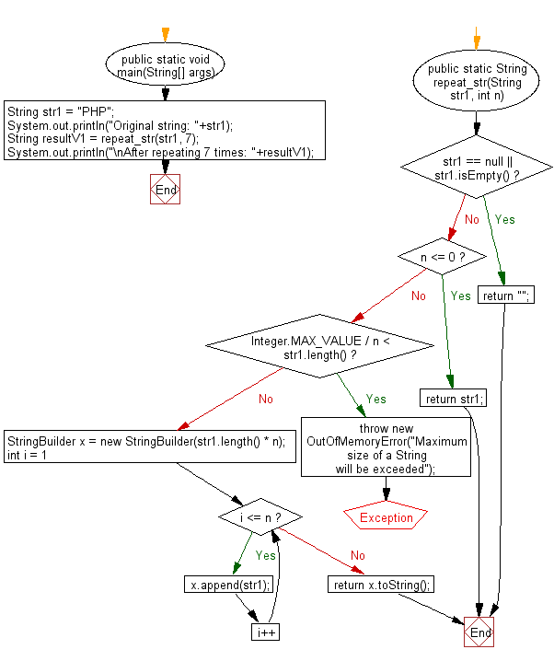

**public** **class** Program_106 {

**public** **static** **void** main(String[] args) {

// **TODO** Auto-generated method stub

String str1 = "PHP";

System.***out***.println("Original string: "+str1);

String resultV1 = *repeat_str*(str1, 7);

System.***out***.println("\nAfter repeating 7 times: "+resultV1);

}

**public** **static** String repeat_str(String str1, **int** n) {

**if** (str1 == **null** || str1.isEmpty()) {

**return** "";

}

**if** (n <= 0) {

**return** str1;

}

**if** (Integer.***MAX_VALUE*** / n < str1.length()) {

**throw** **new** OutOfMemoryError("Maximum size of a String will be exceeded");

}

StringBuilder x = **new** StringBuilder(str1.length() * n);

**for** (**int** i = 1; i <= n; i++) {

x.append(str1);

}

**return** x.toString();

}

}

**Output:**

Original string: PHP

After repeating 7 times: PHPPHPPHPPHPPHPPHPPHP

**107. Write a Java program to counts occurrences of a certain character in a given string.**

**Flowchart:**

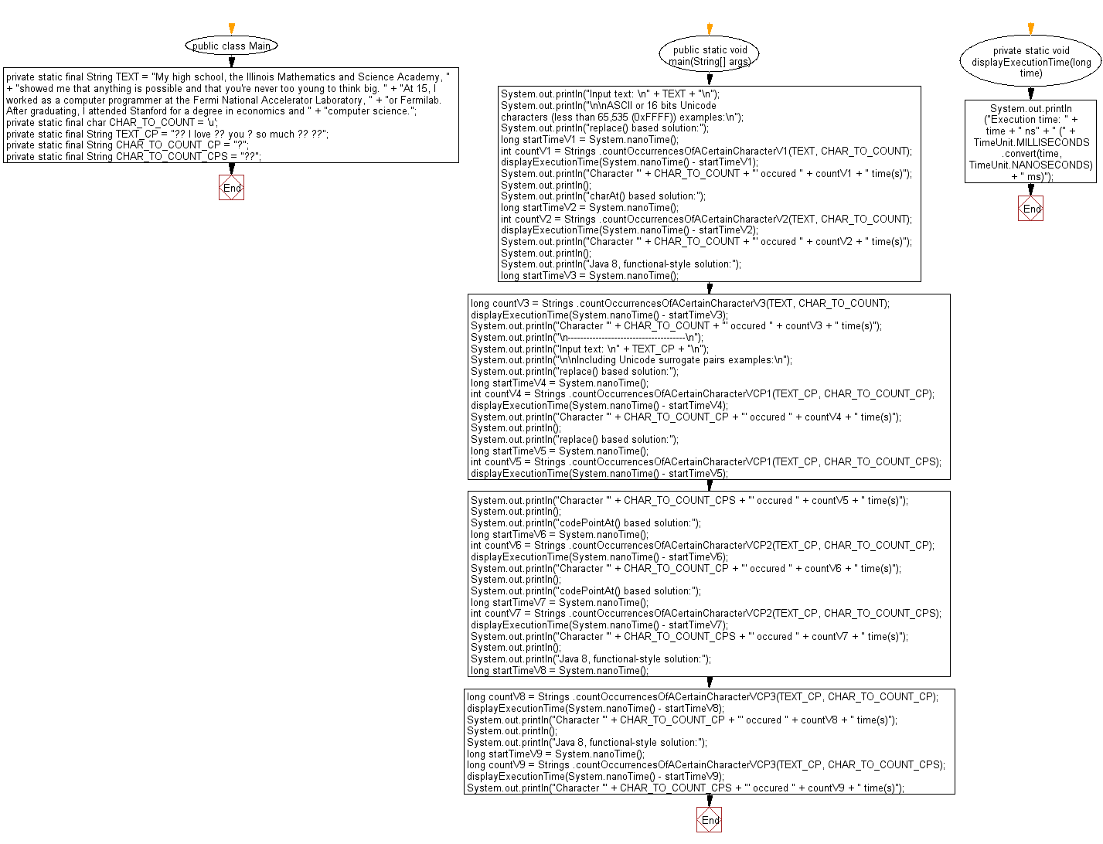

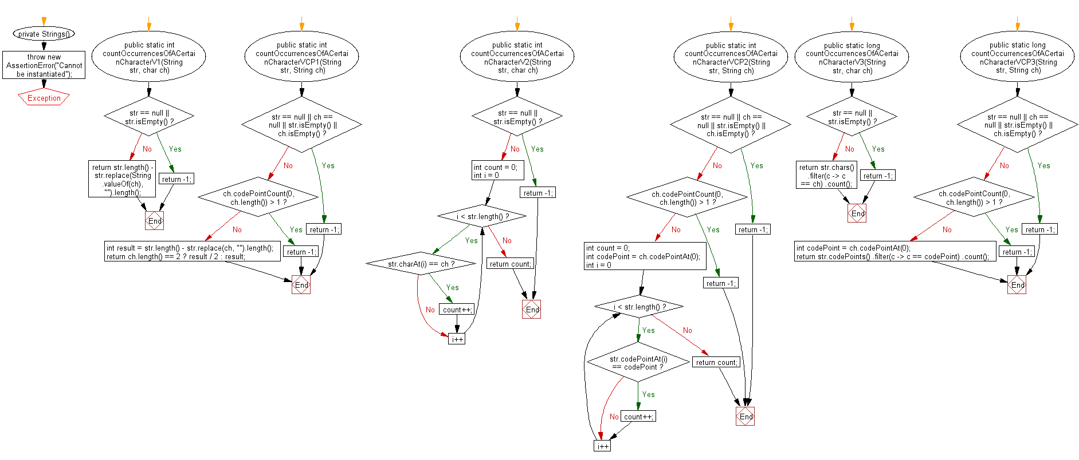

Main.java:

**import** java.util.concurrent.TimeUnit;

**public** **class** Program_107 {

**private** **static** **final** String ***TEXT*** = "My high school, the Illinois Mathematics and Science Academy, "

+ "showed me that anything is possible and that you're never too young to think big. "

+ "At 15, I worked as a computer programmer at the Fermi National Accelerator Laboratory, "

+ "or Fermilab. After graduating, I attended Stanford for a degree in economics and "

+ "computer science.";

**private** **static** **final** **char** ***CHAR_TO_COUNT*** = 'u';

**private** **static** **final** String ***TEXT_CP*** = "😍 I love 💕 you Ӝ so much 💕 😍";

**private** **static** **final** String ***CHAR_TO_COUNT_CP*** = "Ӝ"; // unicode: \u04DC, Code Point: 1244

**private** **static** **final** String ***CHAR_TO_COUNT_CPS*** = "💕"; // unicode: \uD83D\uDC95, Code Point: 128149

**public** **static** **void** main(String[] args) {

// **TODO** Auto-generated method stub

System.***out***.println("Input text: \n" + ***TEXT*** + "\n");

System.***out***.println("\n\nASCII or 16 bits Unicode characters (less than 65,535 (0xFFFF)) examples:\n");

System.***out***.println("replace() based solution:");

**long** startTimeV1 = System.*nanoTime*();

**int** countV1 = Strings

.*countOccurrencesOfACertainCharacterV1*(***TEXT***, ***CHAR_TO_COUNT***);

*displayExecutionTime*(System.*nanoTime*() - startTimeV1);

System.***out***.println("Character '" + ***CHAR_TO_COUNT*** + "' occured " + countV1 + " time(s)");

System.***out***.println();

System.***out***.println("charAt() based solution:");

**long** startTimeV2 = System.*nanoTime*();

**int** countV2 = Strings

.*countOccurrencesOfACertainCharacterV2*(***TEXT***, ***CHAR_TO_COUNT***);

*displayExecutionTime*(System.*nanoTime*() - startTimeV2);

System.***out***.println("Character '" + ***CHAR_TO_COUNT*** + "' occured " + countV2 + " time(s)");

System.***out***.println();

System.***out***.println("Java 8, functional-style solution:");

**long** startTimeV3 = System.*nanoTime*();

**long** countV3 = Strings

.*countOccurrencesOfACertainCharacterV3*(***TEXT***, ***CHAR_TO_COUNT***);

*displayExecutionTime*(System.*nanoTime*() - startTimeV3);

System.***out***.println("Character '" + ***CHAR_TO_COUNT*** + "' occured " + countV3 + " time(s)");

System.***out***.println("\n--------------------------------------\n");

System.***out***.println("Input text: \n" + ***TEXT_CP*** + "\n");

System.***out***.println("\n\nIncluding Unicode surrogate pairs examples:\n");

System.***out***.println("replace() based solution:");

**long** startTimeV4 = System.*nanoTime*();

**int** countV4 = Strings

.*countOccurrencesOfACertainCharacterVCP1*(***TEXT_CP***, ***CHAR_TO_COUNT_CP***);

*displayExecutionTime*(System.*nanoTime*() - startTimeV4);

System.***out***.println("Character '" + ***CHAR_TO_COUNT_CP*** + "' occured " + countV4 + " time(s)");

System.***out***.println();

System.***out***.println("replace() based solution:");

**long** startTimeV5 = System.*nanoTime*();

**int** countV5 = Strings

.*countOccurrencesOfACertainCharacterVCP1*(***TEXT_CP***, ***CHAR_TO_COUNT_CPS***);

*displayExecutionTime*(System.*nanoTime*() - startTimeV5);

System.***out***.println("Character '" + ***CHAR_TO_COUNT_CPS*** + "' occured " + countV5 + " time(s)");

System.***out***.println();

System.***out***.println("codePointAt() based solution:");

**long** startTimeV6 = System.*nanoTime*();

**int** countV6 = Strings

.*countOccurrencesOfACertainCharacterVCP2*(***TEXT_CP***, ***CHAR_TO_COUNT_CP***);

*displayExecutionTime*(System.*nanoTime*() - startTimeV6);

System.***out***.println("Character '" + ***CHAR_TO_COUNT_CP*** + "' occured " + countV6 + " time(s)");

System.***out***.println();

System.***out***.println("codePointAt() based solution:");

**long** startTimeV7 = System.*nanoTime*();

**int** countV7 = Strings

.*countOccurrencesOfACertainCharacterVCP2*(***TEXT_CP***, ***CHAR_TO_COUNT_CPS***);

*displayExecutionTime*(System.*nanoTime*() - startTimeV7);

System.***out***.println("Character '" + ***CHAR_TO_COUNT_CPS*** + "' occured " + countV7 + " time(s)");

System.***out***.println();

System.***out***.println("Java 8, functional-style solution:");

**long** startTimeV8 = System.*nanoTime*();

**long** countV8 = Strings

.*countOccurrencesOfACertainCharacterVCP3*(***TEXT_CP***, ***CHAR_TO_COUNT_CP***);

*displayExecutionTime*(System.*nanoTime*() - startTimeV8);

System.***out***.println("Character '" + ***CHAR_TO_COUNT_CP*** + "' occured " + countV8 + " time(s)");

System.***out***.println();

System.***out***.println("Java 8, functional-style solution:");

**long** startTimeV9 = System.*nanoTime*();

**long** countV9 = Strings

.*countOccurrencesOfACertainCharacterVCP3*(***TEXT_CP***, ***CHAR_TO_COUNT_CPS***);

*displayExecutionTime*(System.*nanoTime*() - startTimeV9);

System.***out***.println("Character '" + ***CHAR_TO_COUNT_CPS*** + "' occured " + countV9 + " time(s)");

}

**private** **static** **void** displayExecutionTime(**long** time) {

System.***out***.println("Execution time: " + time + " ns" + " ("

+ TimeUnit.***MILLISECONDS***.convert(time, TimeUnit.***NANOSECONDS***) + " ms)");

}

}

Strings.java:

public final class Strings {

private Strings() {

throw new AssertionError("Cannot be instantiated");

}

public static int countOccurrencesOfACertainCharacterV1(String str, char ch) {

if (str == null || str.isEmpty()) {

// or throw IllegalArgumentException

return -1;

}

return str.length() - str.replace(String.*valueOf*(ch), "").length();

}

public static int countOccurrencesOfACertainCharacterVCP1(String str, String ch) {

if (str == null || ch == null || str.isEmpty() || ch.isEmpty()) {

// or throw IllegalArgumentException

return -1;

}

if (ch.codePointCount(0, ch.length()) > 1) {

**return** -1; // there is more than 1 Unicode character in the given String

}

**int** result = str.length() - str.replace(ch, "").length();

// if ch.length() return 2 then this is a Unicode surrogate pair

**return** ch.length() == 2 ? result / 2 : result;

}

**public** **static** **int** countOccurrencesOfACertainCharacterV2(String str, **char** ch) {

**if** (str == **null** || str.isEmpty()) {

// or throw IllegalArgumentException

**return** -1;

}

**int** count = 0;

**for** (**int** i = 0; i < str.length(); i++) {

**if** (str.charAt(i) == ch) {

count++;

}

}

**return** count;

}

**public** **static** **int** countOccurrencesOfACertainCharacterVCP2(String str, String ch) {

**if** (str == **null** || ch == **null** || str.isEmpty() || ch.isEmpty()) {

// or throw IllegalArgumentException

**return** -1;

}

**if** (ch.codePointCount(0, ch.length()) > 1) {

**return** -1; // there is more than 1 Unicode character in the given String

}

**int** count = 0;

**int** codePoint = ch.codePointAt(0);

**for** (**int** i = 0; i < str.length(); i++) {

**if** (str.codePointAt(i) == codePoint) {

count++;

}

}

**return** count;

}

**public** **static** **long** countOccurrencesOfACertainCharacterV3(String str, **char** ch) {

**if** (str == **null** || str.isEmpty()) {

// or throw IllegalArgumentException

**return** -1;

}

**return** str.chars()

.filter(c -> c == ch)

.count();

}

**public** **static** **long** countOccurrencesOfACertainCharacterVCP3(String str, String ch) {

**if** (str == **null** || ch == **null** || str.isEmpty() || ch.isEmpty()) {

// or throw IllegalArgumentException

**return** -1;

}

**if** (ch.codePointCount(0, ch.length()) > 1) {

**return** -1; // there is more than 1 Unicode character in the given String

}

**int** codePoint = ch.codePointAt(0);

**return** str.codePoints()

.filter(c -> c == codePoint)

.count();

}

}

**Output:**

Input text:

My high school, the Illinois Mathematics and Science Academy, showed me that anything is possible and that you're never too young to think big. At 15, I worked as a computer programmer at the Fermi National Accelerator Laboratory, or Fermilab. After graduating, I attended Stanford for a degree in economics and computer science.

ASCII or 16 bits Unicode characters (less than 65,535 (0xFFFF)) examples:

replace() based solution:

Execution time: 1339842 ns (1 ms)

Character 'u' occured 5 time(s)

charAt() based solution:

Execution time: 43621 ns (0 ms)

Character 'u' occured 5 time(s)

Java 8, functional-style solution:

Execution time: 8851166 ns (8 ms)

Character 'u' occured 5 time(s)

--------------------------------------

Input text:

😍 I love 💕 you Ӝ so much 💕 😍

Including Unicode surrogate pairs examples:

replace() based solution:

Execution time: 63720 ns (0 ms)

Character 'Ӝ' occured 1 time(s)

replace() based solution:

Execution time: 69708 ns (0 ms)

Character '💕' occured 2 time(s)

codePointAt() based solution:

Execution time: 73557 ns (0 ms)

Character 'Ӝ' occured 1 time(s)

codePointAt() based solution:

Execution time: 51746 ns (0 ms)

Character '💕' occured 2 time(s)

Java 8, functional-style solution:

Execution time: 915181 ns (0 ms)

Character 'Ӝ' occured 1 time(s)

Java 8, functional-style solution:

Execution time: 54312 ns (0 ms)

Character '💕' occured 2 time(s)

108. Program to Perform String Matching Using String Library

Flow Chart

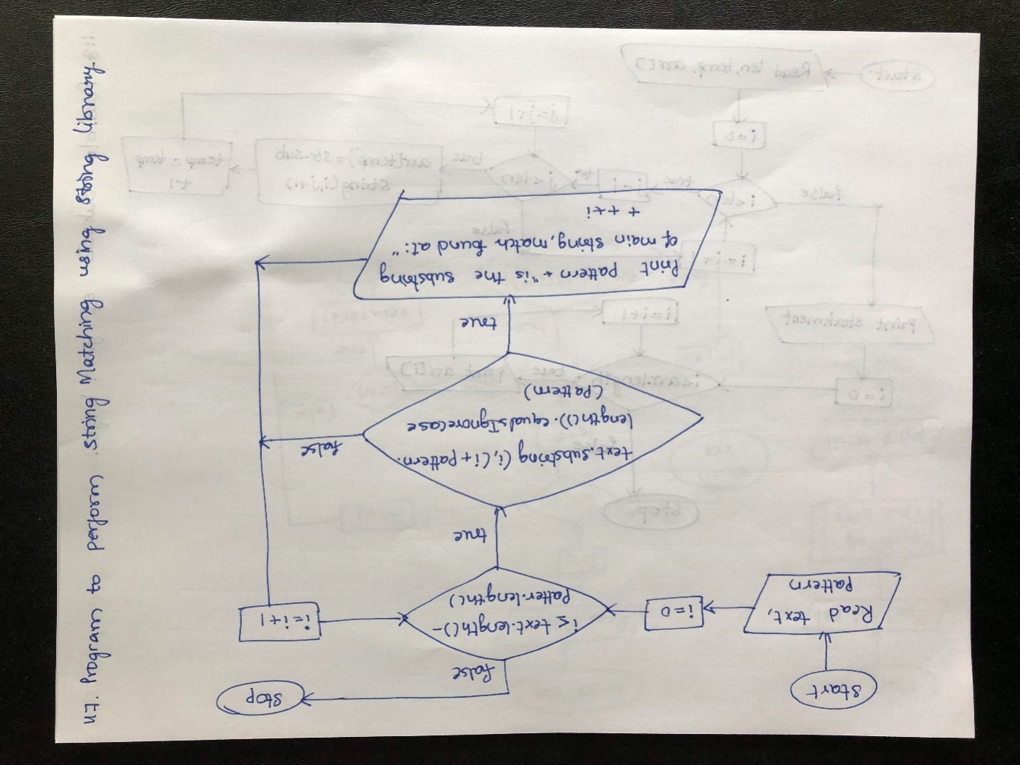

Algorithm

step 1: START

step 2: Read text,pattern and goto step 3

step 3: Check condition for forloop.If true,goto step 4 else goto step 6

step 4: Check if condition.If true,goto step 5 else goto step 6

step 5: Pre Increment i value and print the pattern in statement pattern + " is substring of main string, match found at: "+ ++i. Repeat step 3

step 6: Close Scanner object and goto step 7

step 7: STOP

Program

**import** java.util.Scanner;  
  
**public class** StringMatching {  
**public static void** main(String[] args)  
 {  
 Scanner sc = **new** Scanner(System.***in***);  
 System.***out***.println(**"Enter the main string: "**);  
 String text = sc.nextLine();  
 System.***out***.println(**"Enter the pattern string: "**);  
 String pattern = sc.nextLine();  
**for** (**int** i = 0; i <= (text.length() - pattern.length()); i++)  
 {  
**if** (text.substring(i, (i + pattern.length())).equalsIgnoreCase(  
 pattern))  
 {  
 System.***out***.println(pattern  
 + **" is substring of main string, match found at: "**+ ++i);  
 }  
 }  
sc.close();  
 }  
  
}

I/P

Enter the main string:

welcome

Enter the pattern string:

Come

O/P

come is substring of main string, match found at: 4

109. Program to Find All Possible Subsets of given Length in String

Flow Chart

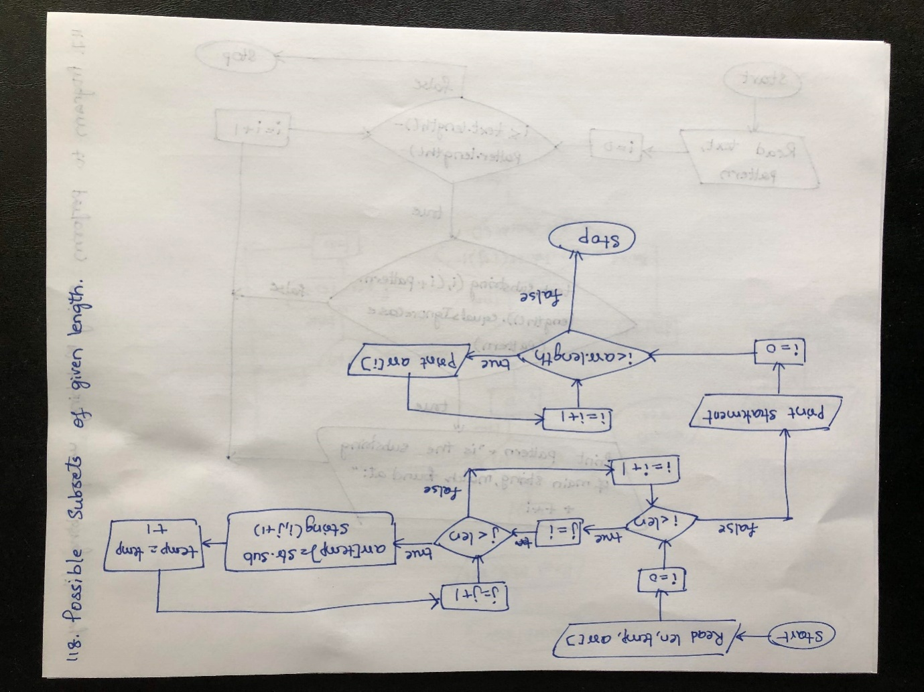

Algorithm

step 1: START

step 2: Read str value to "Fun",len value to str.length, temp to 0.Goto step 3

step 3: Create a string array arr with length of value len*(len+1)/2.

step 4: Check for loop condition.If true,goto step 5 else goto step 8

step 5: Check for loop condition.If true,goto step 6 else goto step 4

step 6: Assign arr[temp] to str.substring(i,j+1) and goto seep 7

step 7: Increment the value of temp and repeat step 5

step 8: Print the statement and goto step 9

step 9: Check for loop condition.If true goto step 10 else goto step 11

step 10: Print the arr[i] values and repeat step 9

step 11: STOP

Program

**public class** PossibleSubsets {  
**public static void** main(String[] args) {  
  
 String str = **"FUN"**;  
**int** len = str.length();  
**int** temp = 0;  
*//Total possible subsets for string of size n is n*(n+1)/2*String arr[] = **new** String[len*(len+1)/2];  
  
*//This loop maintains the starting character***for**(**int** i = 0; i < len; i++) {  
*//This loop adds the next character every iteration for the subset to form and add it to the array***for**(**int** j = i; j < len; j++) {  
 arr[temp] = str.substring(i, j+1);  
 temp++;  
 }  
 }  
  
*//This loop prints all the subsets formed from the string.*System.***out***.println(**"All subsets for given string are: "**);  
**for**(**int** i = 0; i <arr.**length**; i++) {  
 System.***out***.println(arr[i]);  
 }  
 }  
  
}

O/P

All subsets for given string are:

F

FU

FUN

U

UN

N

110. Java Program to Sort Word in String

Flow Chart

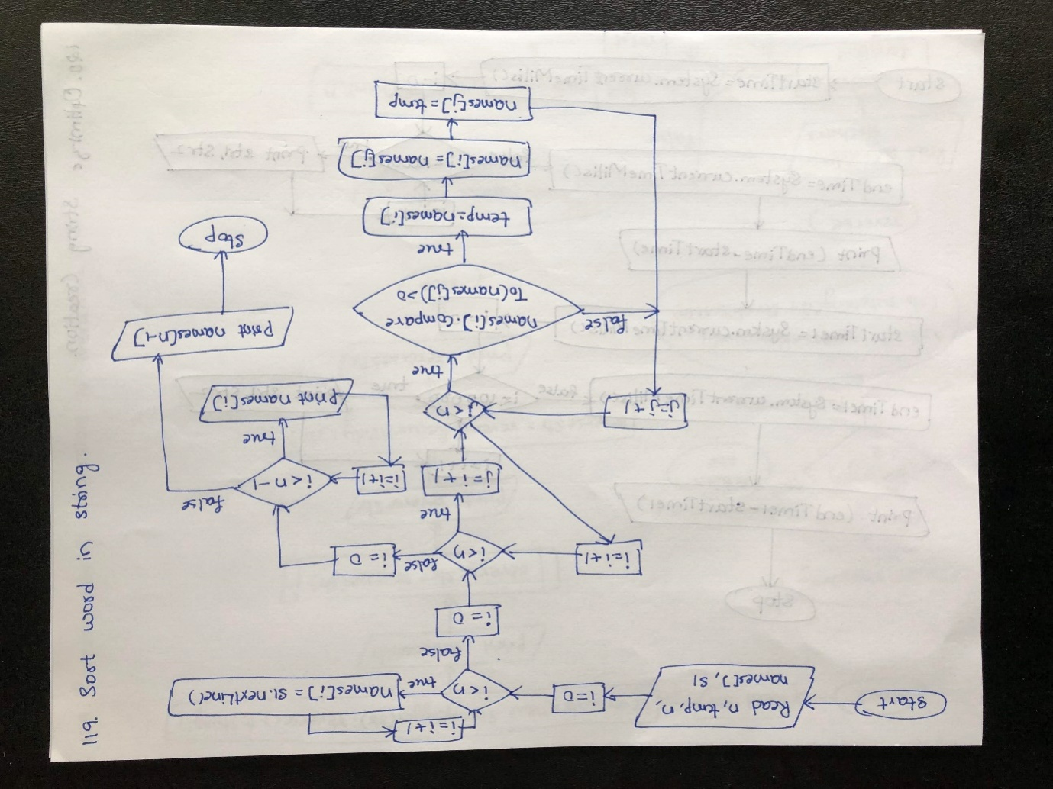

Algorithm

step 1: START

step 2: Read n,temp and goto step 3

step 3: Check for loop condition.If true,goto step 4 else goto step 5

step 4: Read names[i] values and repeat step 3

step 5: Check for loop condition.If true,goto step 6 else goto step 11

step 6: Check for loop condition.If true goto step 7 else repeat step 5

step 7: Check if condition.If true goto step 8 else repeat step 6

step 8: Assign names[i] to temp

step 9: Assign names[j] to names[i]

step 10: Assign temp to names[j] and repeat step 6

step 11: Print the statement and goto sep 12

step 12: Check for loop condition.If true,goto step 13 else goto step 14

step 13: Print names[i] value and repeat step 12

step 14: Print the values of names[n-1] and goto step 15

step 15: STOP

Program

**import** java.util.Scanner;  
  
**public class** AlphabeticalOrder {  
**public static void** main(String[] args)  
 {  
**int** n;  
 String temp;  
 Scanner s = **new** Scanner(System.***in***);  
 System.***out***.print(**"Enter number of names you want to enter:"**);  
 n = s.nextInt();  
 String names[] = **new** String[n];  
 Scanner s1 = **new** Scanner(System.***in***);  
 System.***out***.println(**"Enter all the names:"**);  
**for**(**int** i = 0; i < n; i++)  
 {  
 names[i] = s1.nextLine();  
 }  
**for** (**int** i = 0; i < n; i++)  
 {  
**for** (**int** j = i + 1; j < n; j++)  
 {  
**if** (names[i].compareTo(names[j])>0)  
 {  
 temp = names[i];  
 names[i] = names[j];  
 names[j] = temp;  
 }  
 }  
 }  
 System.***out***.print(**"Names in Sorted Order:"**);  
**for** (**int** i = 0; i < n - 1; i++)  
 {  
 System.***out***.print(names[i] + **","**);  
 }  
 System.***out***.print(names[n - 1]);  
 }  
  
}

I/P

Enter number of names you want to enter:2

Enter all the names:

hari

giri

O/P

Names in Sorted Order:giri,hari

111. Java Program to Optimize String Creation

Flow Chart

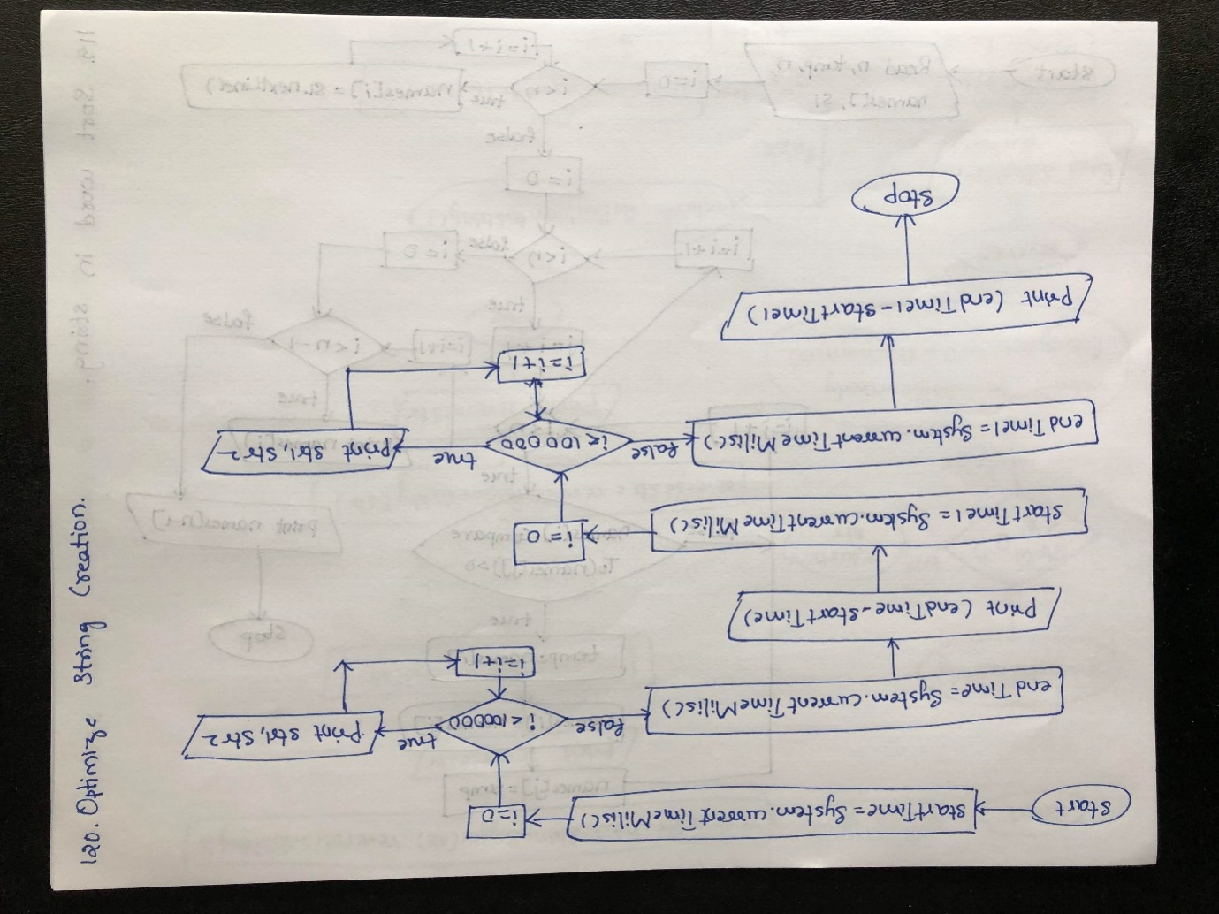

Algorithm

step 1: START

step 2: Assign System.currentTimeMillis() value to startTime

step 3: Check for loop condition.If true goto step 4 else goto step 5

step 4: Assign "India" to str1 and str2.Repeat step 3

step 5: Assign System.currentTimeMillis() value to endTime

step 6: Print the endTime and startTime values in the statement ("Time taken to create literal String : " + (endTime - startTime) + " ms"

step 7: Assign System.currentTimeMillis() value to startTime1 and goto step 8

step 8: Check for loop condition.If true,goto step 9 else goto step 10

step 9: Assign "India" to str1 and str2 and repeat step 8

step 10: Assign System.currentTimeMillis() value to endTime1

step 11: Print endTime1-startTime1 value in the statement ("Time taken to create Object String : " + (endTime1 - startTime1) + " ms".Goto step 12

step 12: STOP

Program

**public class** OptimizeString{  
**public static void** main(String[] args) {  
**long** startTime = System.*currentTimeMillis*();  
  
**for** (**int** i = 0; i <100000; i++) {  
 String str1 = **"India"**;  
 String str2= **"India"**;  
 }  
**long** endTime = System.*currentTimeMillis*();  
 System.***out***.println(**"Time taken to create literal String : "** + (endTime - startTime) + **" ms"**);  
**long** startTime1 = System.*currentTimeMillis*();  
  
**for** (**int** i = 0; i <100000; i++) {  
 String str1 = **new** String(**"India"**);  
 String str2 = **new** String(**"India"**);  
 }  
**long** endTime1 = System.*currentTimeMillis*();  
 System.***out***.println(**"Time taken to create Object String : "** + (endTime1 - startTime1) + **" ms"**);  
 }  
  
}

O/P

Time taken to create literal String : 0 ms

Time taken to create Object String : 15 ms

112. Program to Find out Match Part of One String with the Part of Another String

Flow Chart

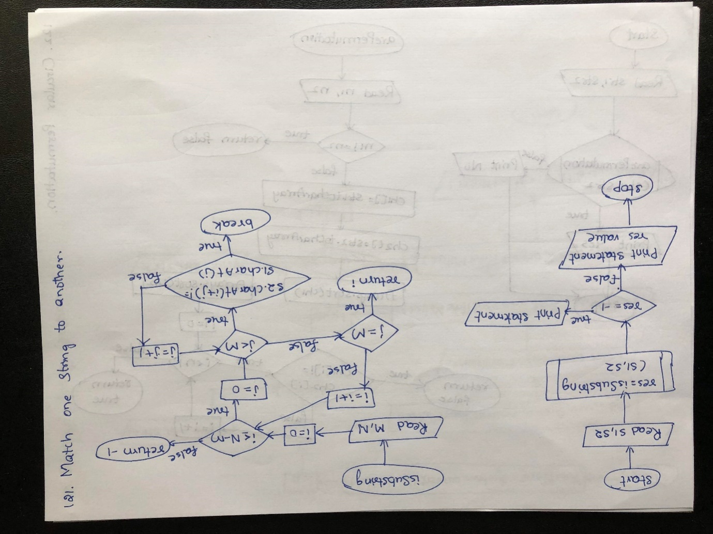

Algorithm

step 1: START

step 2: Assign "for" value to s1 and "geeksforgeeks" value to s2

step 3: Call isSubstring method with s1,s2 as arguments and goto step 4

step 4: Enter isSubstring method

step 5: Assign s1.length to M and s2.length to N

step 6: Check for loop condition.If true,goto step 7 else goto step 12

step 7: Check for loop condition.If true goto step 8 else goto step 10

step 8: Check if condition.If true,goto step 9 else repeat step 7

step 9: Break the for loop and goto step 10

step 10: Check if condition.If true,goto step 11 els repeat step 6

step 11: Return i value to step 13

step 12: Return -1 to step 13

step 13: Return from method and assign the value to res

step 14: Check if condition.If true,goto step 15 else goto step 16

step 15: Print the statement "Not present" and goto step 17

step 16: Print res value in the statement ("Present at index "+ res. Goto step 17

step 17: STOP

Program

**public class** MatchPartOneString {  
*// Returns true if s1 is substring of s2***static int** isSubstring(String s1, String s2)  
 {  
**int** M = s1.length();  
**int** N = s2.length();  
  
*/* A loop to slide pat[] one by one */***for** (**int** i = 0; i <= N - M; i++) {  
**int** j;  
  
*/* For current index i, check for  
 pattern match */***for** (j = 0; j < M; j++)  
**if** (s2.charAt(i + j) != s1.charAt(j))  
**break**;  
  
**if** (j == M)  
**return** i;  
 }  
  
**return** -1;  
 }  
  
*/* Driver program to test above function */***public static void** main(String args[])  
 {  
 String s1 = **"for"**;  
 String s2 = **"geeksforgeeks"**;  
  
**int** res = *isSubstring*(s1, s2);  
  
**if** (res == -1)  
 System.***out***.println(**"Not present"**);  
**else**System.***out***.println(**"Present at index "**+ res);  
 }  
  
}

O/P

Present at index 5

113. Program to Determine if One String is a Circular Permutation of Another String

Flow Chart

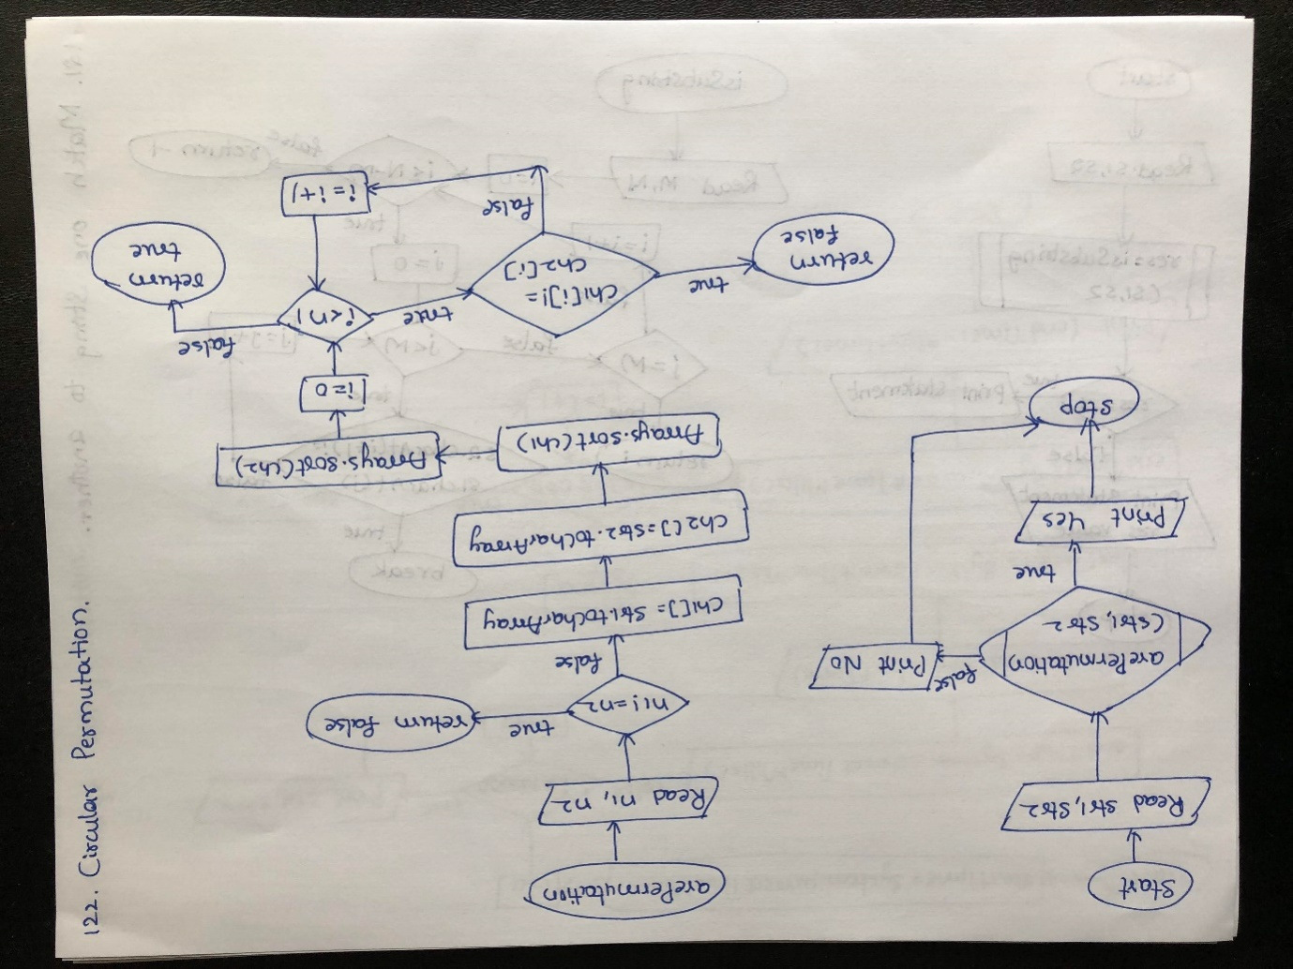

Algorithm

step 1: START

step 2: Assign "test" value to str1 and "ttew" value to str2

step 3:: Call arePermutation method with str1,str2 as arguments and goto step 4

step 4: Enter arePermutation method

step 5: Assign str1.length to n1 and str2.length to n2

step 6: Check if statement condition.If true,goto step 7 else goto step 8

step 7: Return false to step 15

step 8: Assign str1.toCharArray() to ch1 array

atep 9: Assign str2.toCharArray() to ch2 array

step 10: Sort the ch1 and ch2 arrays using Arrays.sort

step 11: Check for loop condition.If true,goto step 12 else goto step 14

step 12: Check if statement condition.If true,goto step 13 else repeat step 11

step 13: Return false to step 15

step 14: Return true to statement 15

step 15: Return from method and check if condition.If true goto step 16 else goto step 17

step 16: Print "Yes" and goto step 18

step 17: Print "No" and goto step 18

step 18: STOP

Program

**import** java.util.Arrays;  
  
**public class** CircularPermutation {  
*/* function to check whether two strings are  
Permutation of each other */***static boolean**arePermutation(String str1, String str2)  
 {  
*// Get lenghts of both strings***int** n1 = str1.length();  
**int** n2 = str2.length();  
  
*// If length of both strings is not same,  
 // then they cannot be Permutation***if** (n1 != n2)  
**return false**;  
**char** ch1[] = str1.toCharArray();  
**char** ch2[] = str2.toCharArray();  
  
*// Sort both strings*Arrays.*sort*(ch1);  
Arrays.*sort*(ch2);  
  
*// Compare sorted strings***for** (**int** i = 0; i < n1; i++)  
**if** (ch1[i] != ch2[i])  
**return false**;  
  
**return true**;  
 }  
  
*/* Driver program to test to print printDups*/***public static void** main(String[] args)  
 {  
 String str1 = **"test"**;  
 String str2 = **"ttew"**;  
**if** (*arePermutation*(str1, str2))  
 System.***out***.println(**"Yes"**);  
**else**System.***out***.println(**"No"**);  
  
 }  
  
}

O/P

No

114. Program to Find Every Occurrence of a Word

Flow Chart

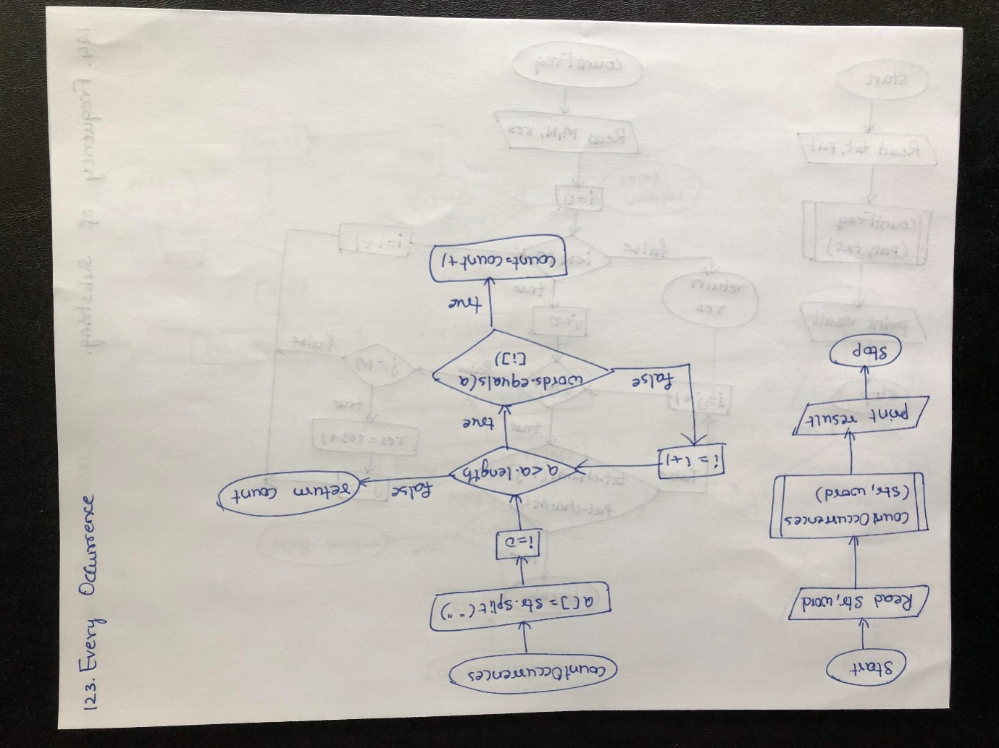

Algorithm

step 1: START

step 2: Assign the value "GeeksforGeeks A computer science portal for geeks " to str and "portal" to word

step 3: Call countOccurrences method with str,word as arguments and goto step 4

step 4: Enter into the method

step 5: Assign str.split("") to array a and 0 to count

step 6: Check for loop condition.If true,goto step 7 else goto step 9

step 7: Check if statement condition.If true,goto step 8 else repeat step 6

step 8: Increment count value by 1 and repeat step 6

step 9: Return count value to step 10

step 10: Return from the method and pritn the value and goto step 11

step 11: STOP

Program

**public class** EveryOccurrence {  
**static int** countOccurences(String str, String word)  
 {  
*// split the string by spaces in a*String a[] = str.split(**" "**);  
  
*// search for pattern in a***int** count = 0;  
**for** (**int** i = 0; i < a.**length**; i++)  
 {  
*// if match found increase count***if** (word.equals(a[i]))  
 count++;  
 }  
  
**return** count;  
 }  
  
*// Driver code***public static void** main(String args[])  
 {  
 String str = **"GeeksforGeeks A computer science portal for geeks "**;  
 String word = **"portal"**;  
 System.***out***.println(*countOccurences*(str, word));  
 }  
  
}

O/P

1

115. Program to Find the Frequency of Substring in the Given String

Flow Chart

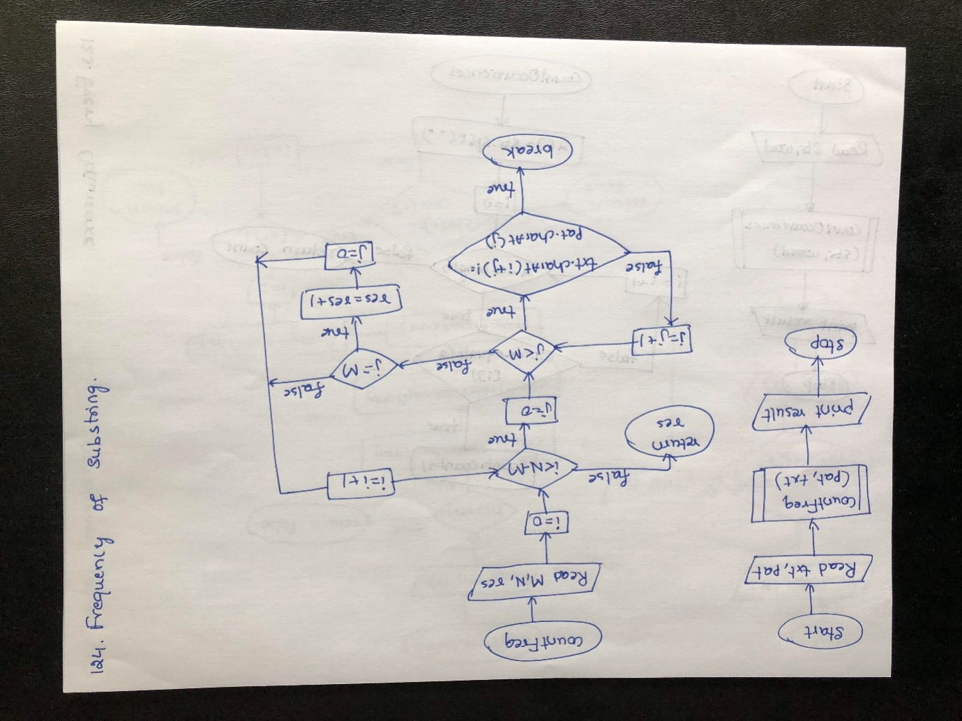

Algorithm

step 1: START

step 2: Assign "dhimanman" to txt and "man" to pat

step 3: Call countFreq method with pat,txt as arguments and goto step 4

step 4: Enter the method and goto step 5

step 5: Assign pat.length to M and txt.length to N and 0 to res

step 6: Check for loop condition.If true,goto step 7 else goto step 13

step 7: Check for loop condition.If true,goto step 8 else repeat step 6

step 8: Check if statement condiion.If true,goto step 9 else repeat step 7

step 9: Break the for loop and goto step 10

step 10: Check if statement condition.If true,goto step 11 else repeat step 6

step 11: Increment res value by 1

step 12: Assign 0 to j and repeat step 6

step 13: Return res to step 14

step 14: Return from method and print the value.

step 15: STOP

Program

**public class** FrequencyOfSubstring {  
**static int** countFreq(String pat, String txt) {  
**int** M = pat.length();  
**int** N = txt.length();  
**int** res = 0;  
  
*/* A loop to slide pat[] one by one */***for** (**int** i = 0; i <= N - M; i++) {  
*/* For current index i, check for  
 pattern match */***int** j;  
**for** (j = 0; j < M; j++) {  
**if** (txt.charAt(i + j) != pat.charAt(j)) {  
**break**;  
 }  
 }  
  
*// if pat[0...M-1] = txt[i, i+1, ...i+M-1]***if** (j == M) {  
 res++;  
 j = 0;  
 }  
 }  
**return** res;  
 }  
  
*/* Driver program to test above function */***static public void** main(String[] args) {  
 String txt = **"dhimanman"**;  
 String pat = **"man"**;  
 System.***out***.println(*countFreq*(pat, txt));  
 }  
  
}

O/P

2

116. Program to Find the Frequency of Every Word in a Given String

Program

**import** java.util.HashMap;  
  
**public class** FrequencyOfEachWord {  
**public static void** main(String[] args) {  
 String str = **"aaddrfshdsklhio"**;  
**char**[] arr = str.toCharArray();  
 HashMap<Character,Integer>hMap = **new** HashMap<>();  
**for**(**int** i= 0 ; i<arr.**length**; i++) {  
**if**(hMap.containsKey(arr[i])) {  
**int** count = hMap.get(arr[i]);  
hMap.put(arr[i],count+1);  
 } **else** {  
hMap.put(arr[i],1);  
 }  
 }  
 System.***out***.println(hMap);  
 }  
}

O/P

{a=2, r=1, s=2, d=3, f=1, h=2, i=1, k=1, l=1, o=1}

**117. Program to Remove a Particular Character from a String**

**Flow Chart**

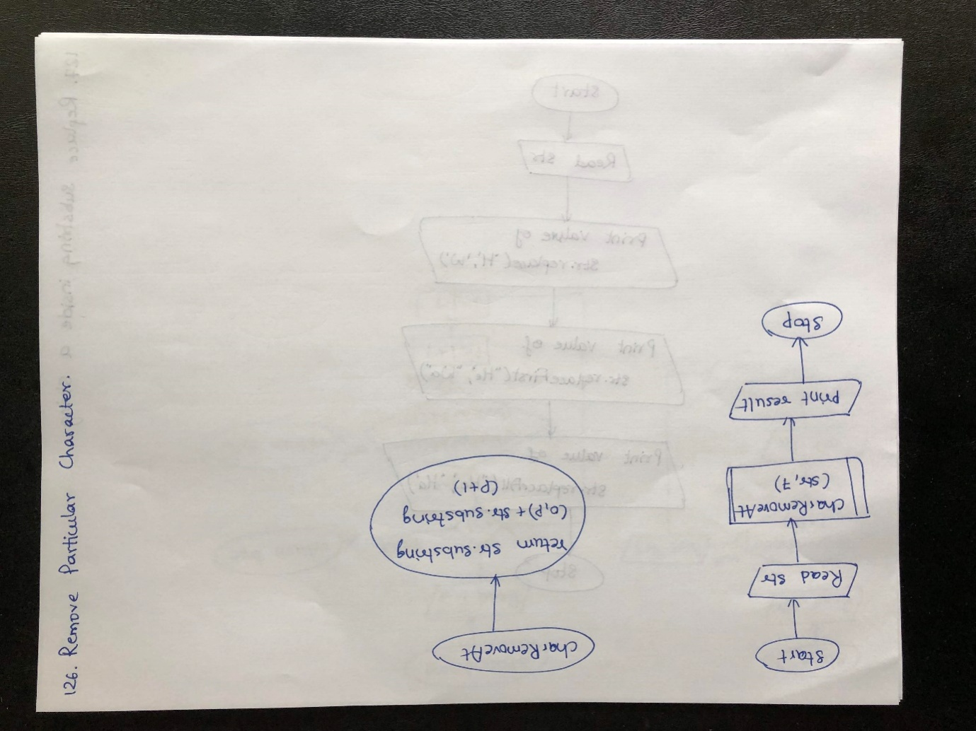

Algorithm

step 1: START

step 2: Assign "India is my country" value to str

step 3: Call charRemove method with str,7 as arguments and goto step 4

step 4: Return str.substring(0, p) + str.substring(p + 1) value to step 5

step 5: Return from method and print the value obtained from method

step 6: STOP

Program

**public class** RemoveParticularChar {  
**public static void** main(String[] args) {  
 String str = **"India is my country"**;  
 System.***out***.println(*charRemoveAt*(str, 7));  
 }  
**public static** String charRemoveAt(String str, **int** p) {  
**return** str.substring(0, p) + str.substring(p + 1);  
 }  
  
}

O/P

India i my country

**118. Java Program to Replace a Substring Inside a String by Another One**

Flow Chart

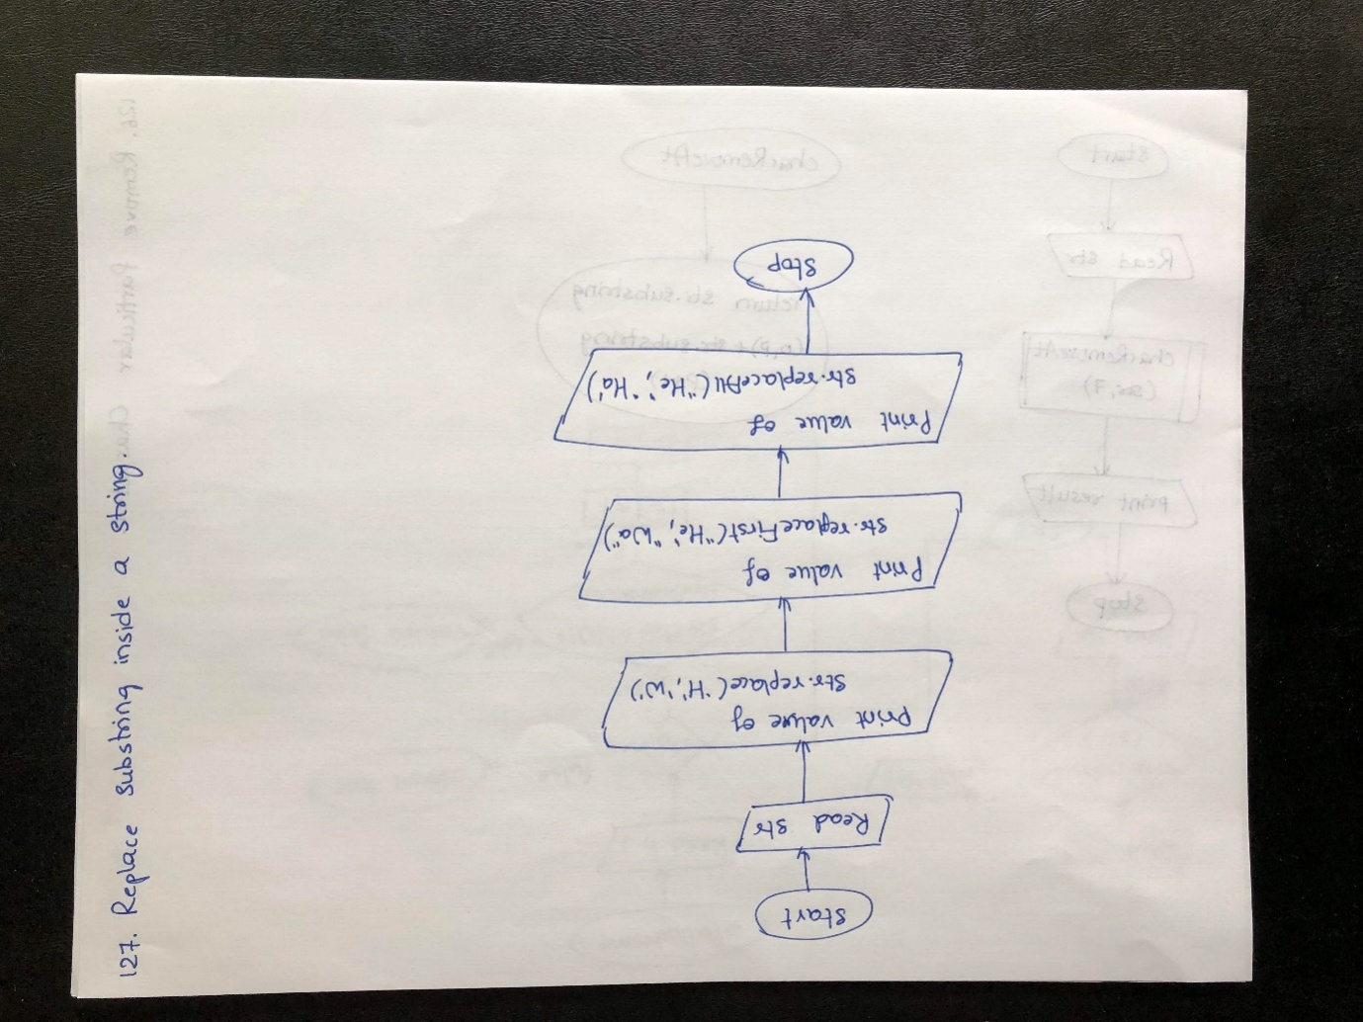

Algorithm

step 1: START

step 2: Assign "Hello World" to str

step 3: Print the result of str.replace('H','W')

step 4: Print the result of str.replaceFirst('He','Wa')

step 5: Print the result of str.replaceAll('He','Ha')

step 6: STOP

Program

**public class** ReplaceSubstringInsideAnother {  
**public static void** main(String args[]) {  
 String str=**"Hello World"**;  
 System.***out***.println( str.replace( **'H'**,**'W'** ) );  
 System.***out***.println( str.replaceFirst(**"He"**, **"Wa"**) );  
 System.***out***.println( str.replaceAll(**"He"**, **"Ha"**) );  
 }  
  
}

O/P

Wello World

Wallo World

Hallo World

**119. Java Program to Search a Word Inside a String**

Flow Chart

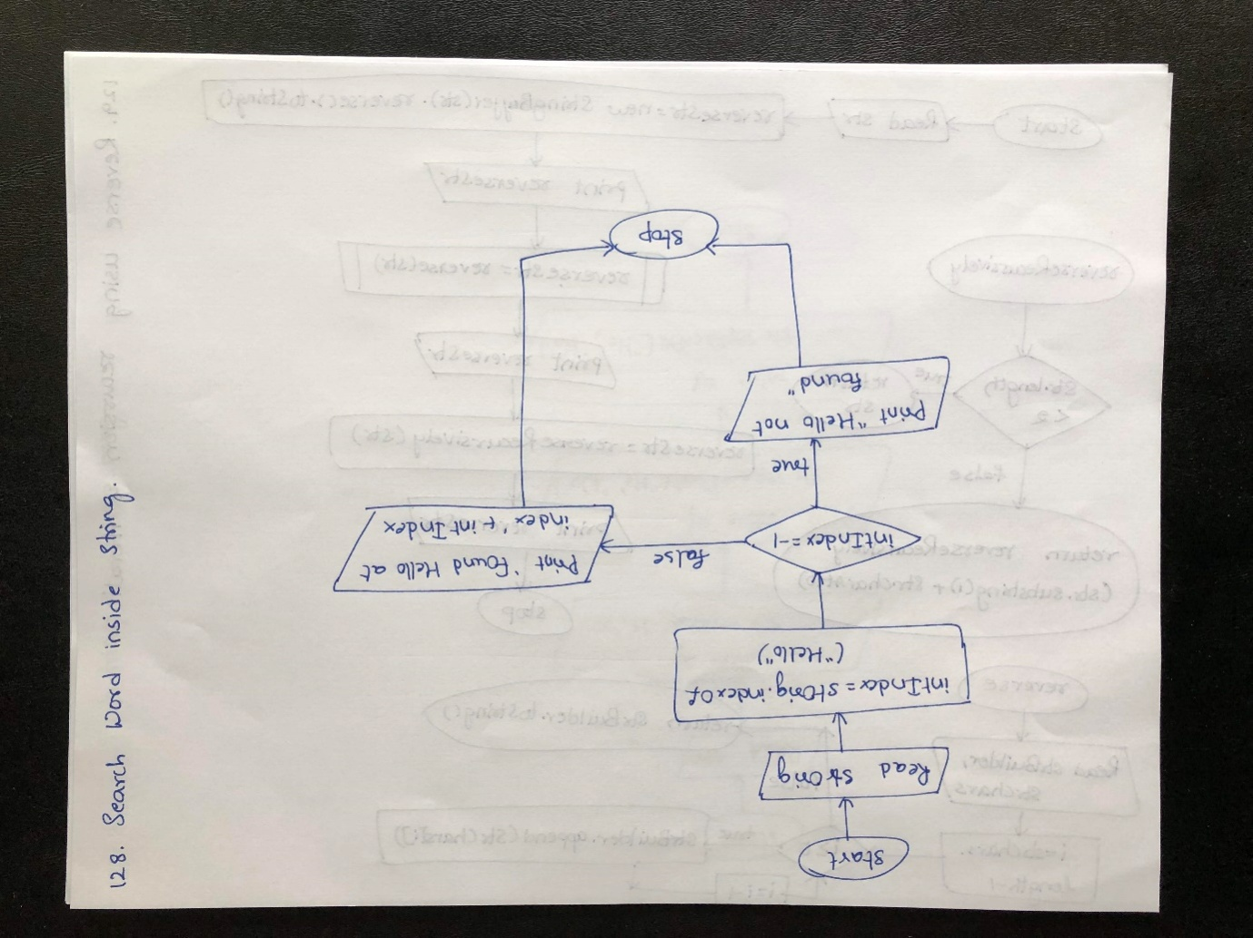

Algorithm

step 1: START

step 2: Assign "Hello readers" to strOrig

step 3: Assign index of strOrig using strOrig.indexOf("Hello") to intIdex

step 4: Check if condition.If true,goto step 5 else goto step 6

step 5: Print the statement and goto step 7

step 6: Print intIndex values using the statement and goto step 7

step 7: STOP

Program

**public class** SearchWordInsideString {  
**public static void** main(String[] args) {  
 String strOrig = **"Hello readers"**;  
**int** intIndex = strOrig.indexOf(**"Hello"**);  
**if**(intIndex == - 1) {  
 System.***out***.println(**"Hello not found"**);  
 } **else** {  
 System.***out***.println(**"Found Hello at index "**+ intIndex);  
 }  
 }  
}

O/P

Found Hello at index 0

**120. Java Program to Reverse the String Using Both Recursion and Iteration**

Flow Chart

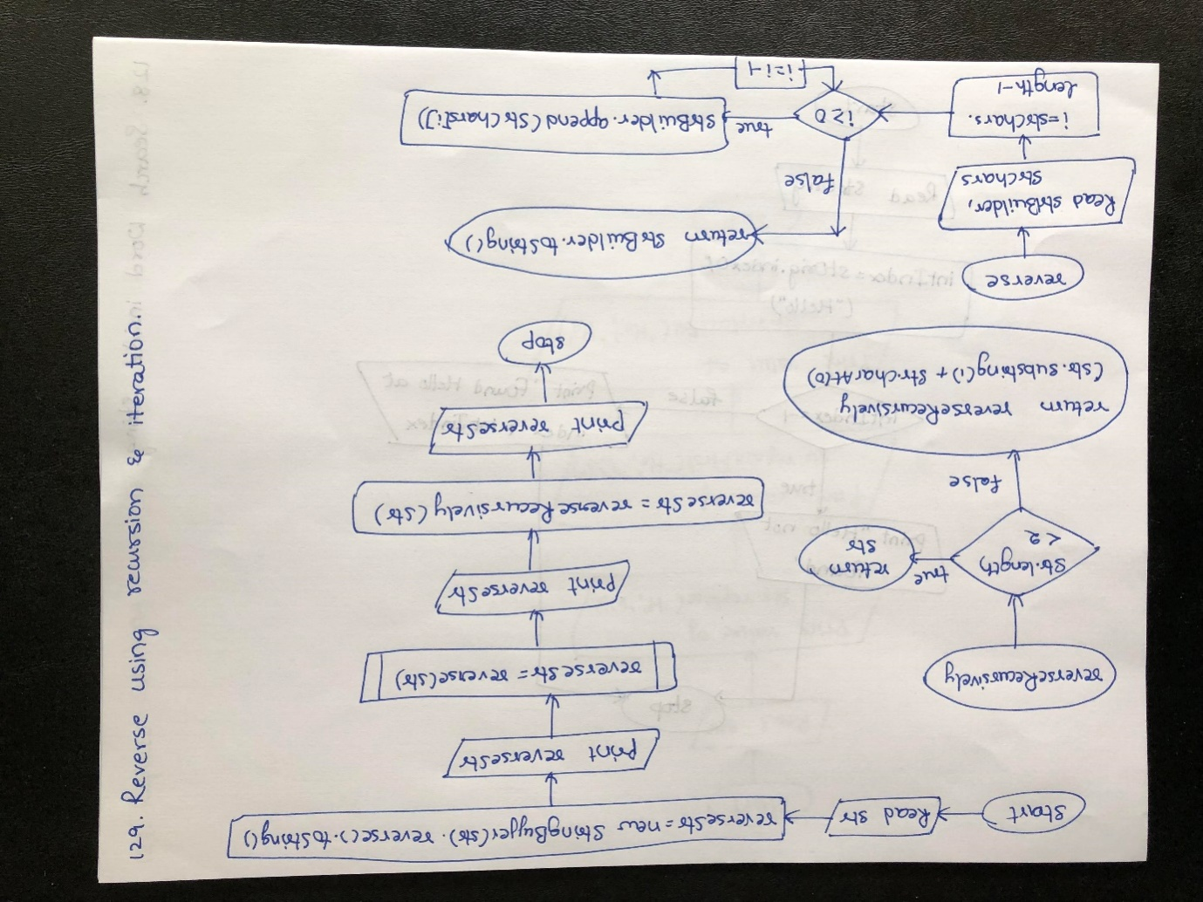

Algorithm

step 1: START

step 2: Assign "Sony is going to introduce Internet TV soon" to str

step 3: Print str value

step 4: Reverse str value using reverse method of StringBuffer and assign to reverseStr

step 5: Print the reverseStr value

step 6: Call reverse method with str as argument

step 7: Enter into reverse method and goto step 8

step 8: Create strBuilder object of StringBuffer

step 9: Convert str to Character array using toCharArray method and assign to strChars

step 10: Check for loop condition.If true,goto step 11 else goto step 12

step 11: Append the strChars[i] with string builder and repeat step 10

step 12: Return strBuilder.toString() value to step 13

step 13: Return from reverse method and assign the value to reverseStr

step 14: Call reverseRecurtively method with str as arguments

step 15: Enter the method and check if condition.If true goto step 16 else goto step 17

step 15: Return str to step 17

step 16: Call the reverseRecursively method using recursion with str.substring method and concat with str.CharAt(0) and return the result value to step 17

step 17: Return from reverseRecursively method and assign the value to reverseStr

step 18: Print the reverseStr and goto step 19

step 19: STOP

Program

**import** java.io.FileNotFoundException;  
**import** java.io.IOException;  
  
**public class** ReverseIterationRecursion {  
**public static void** main(String args[]) **throws** FileNotFoundException, IOException {  
  
*//original string*String str = **"Sony is going to introduce Internet TV soon"**;  
 System.***out***.println(**"Original String: "** + str);  
  
*//reversed string using Stringbuffer*String reverseStr = **new** StringBuffer(str).reverse().toString();  
 System.***out***.println(**"Reverse String in Java using StringBuffer: "** + reverseStr);  
  
*//iterative method to reverse String in Java*reverseStr = *reverse*(str);  
 System.***out***.println(**"Reverse String in Java using Iteration: "** + reverseStr);  
  
*//recursive method to reverse String in Java*reverseStr = *reverseRecursively*(str);  
 System.***out***.println(**"Reverse String in Java using Recursion: "** + reverseStr);  
  
 }  
  
**public static** String reverse(String str) {  
 StringBuilder strBuilder = **new** StringBuilder();  
**char**[] strChars = str.toCharArray();  
  
**for** (**int** i = strChars.**length**- 1; i >= 0; i--) {  
strBuilder.append(strChars[i]);  
 }  
  
**return** strBuilder.toString();  
 }  
  
**public static** String reverseRecursively(String str) {  
  
*//base case to handle one char string and empty string***if** (str.length() <2) {  
**return** str;  
 }  
  
**return** *reverseRecursively*(str.substring(1)) + str.charAt(0);  
  
 }  
  
}

O/P

Original String: Sony is going to introduce Internet TV soon

Reverse String in Java using StringBuffer: noos VT tenretnIecudortniotgniogsiynoS

Reverse String in Java using Iteration: noos VT tenretnIecudortniotgniogsiynoS

Reverse String in Java using Recursion: noos VT tenretnIecudortniotgniogsiynoS

**121. Java Program to Remove all Characters in Second String which are Present in First String**

Flow Chart

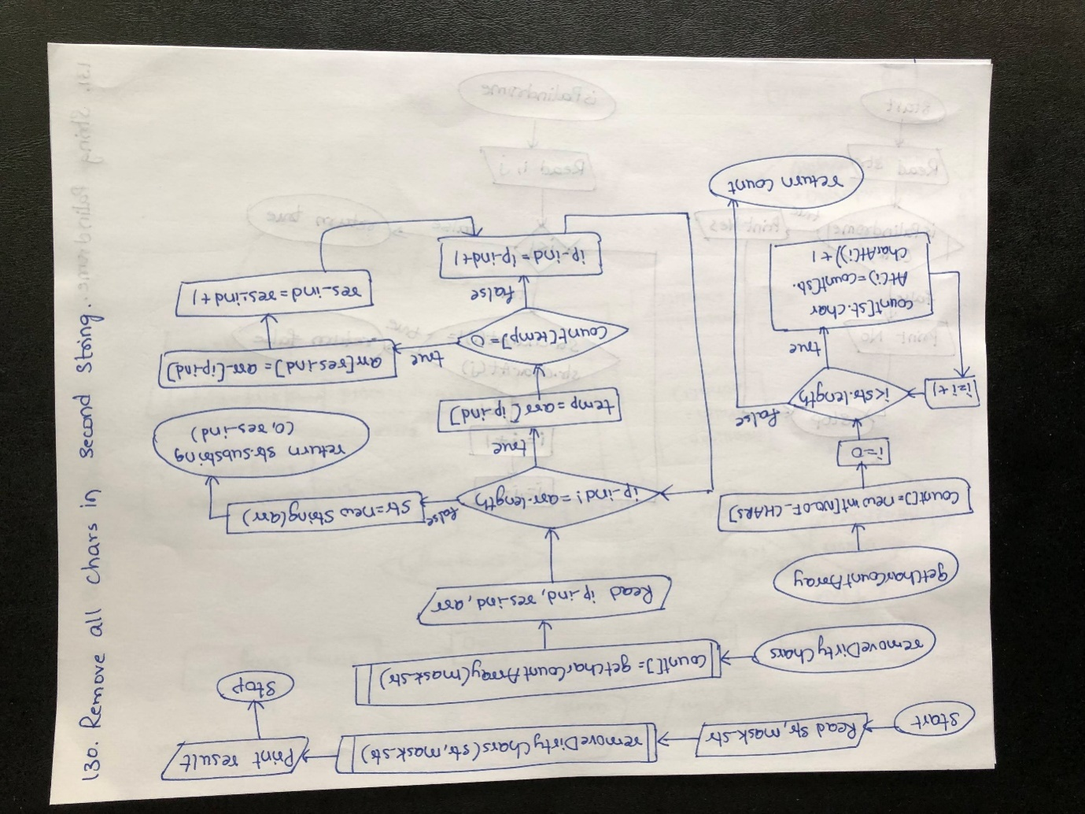

Algorithm:

step 1: START

step 2: Assign "geeksforgeeks" to str and "mask" to mask_str

step 3: Call removeDirtyChars method with str,mask_str as arguments.

step 4: Enter the method and call getCharCountArray method with mask_str as arguments

step 5: Enter the method and Initialize count array

step 6: Check for loop condition.If true,goto step 7 else goto step 8

step 7: Increment the value of count[str.charAt(i)] and repeat step 6

step 8: Return count to step 9

step 9: Return from method and assign the result to count array

step 10: Check while loop condition.If true,goto step 11 else goto step 15

step 11: Check if condition.If true goto step 12 else goto step 14

step 12: Assign arr[ip_ind] to arr[res_ind]

step 13: Increment res_ind value by 1 and goto step 14

step 14: Increment the ip_ind value by 1 and repeat step 10

step 15: Create str with arr length

step 16: Return str.substring(0,res_ind) and goto step 17

step 17: Return from removeDirtyChars method and print the result.

step 18: STOP

Program

**public class** RemoveCharSecond {  
**static final int *NO_OF_CHARS*** = 256;  
  
*/* Returns an array of size 256 containg count  
 of characters in the passed char array */***static int**[] getCharCountArray(String str)  
 {  
**int** count[] = **new int**[***NO_OF_CHARS***];  
**for** (**int** i = 0; i<str.length(); i++)  
 count[str.charAt(i)]++;  
  
**return** count;  
 }  
  
*/* removeDirtyChars takes two string as arguments: First  
 string (str) is the one from where function removes dirty  
 characters. Second string is the string which contain all  
 dirty characters which need to be removed from first string */***static** String removeDirtyChars(String str, String mask_str)  
 {  
**int** count[] = *getCharCountArray*(mask_str);  
**int** ip_ind = 0, res_ind = 0;  
  
**char** arr[] = str.toCharArray();  
  
**while** (ip_ind != arr.**length**)  
 {  
**char** temp = arr[ip_ind];  
**if**(count[temp] == 0)  
 {  
 arr[res_ind] = arr[ip_ind];  
res_ind ++;  
 }  
ip_ind++;  
  
 }  
  
 str = **new** String(arr);  
  
*/* After above step string is ngring.  
 Removing extra "iittg" after string*/***return** str.substring(0, res_ind);  
  
 }  
  
*// Driver Method***public static void** main(String[] args)  
 {  
 String str = **"geeksforgeeks"**;  
 String mask_str = **"mask"**;  
 System.***out***.println(*removeDirtyChars*(str, mask_str));  
 }  
  
}

O/P

Geeforgee

**122. Java Program to Test Whether String is Palindrome**

Flow Chart

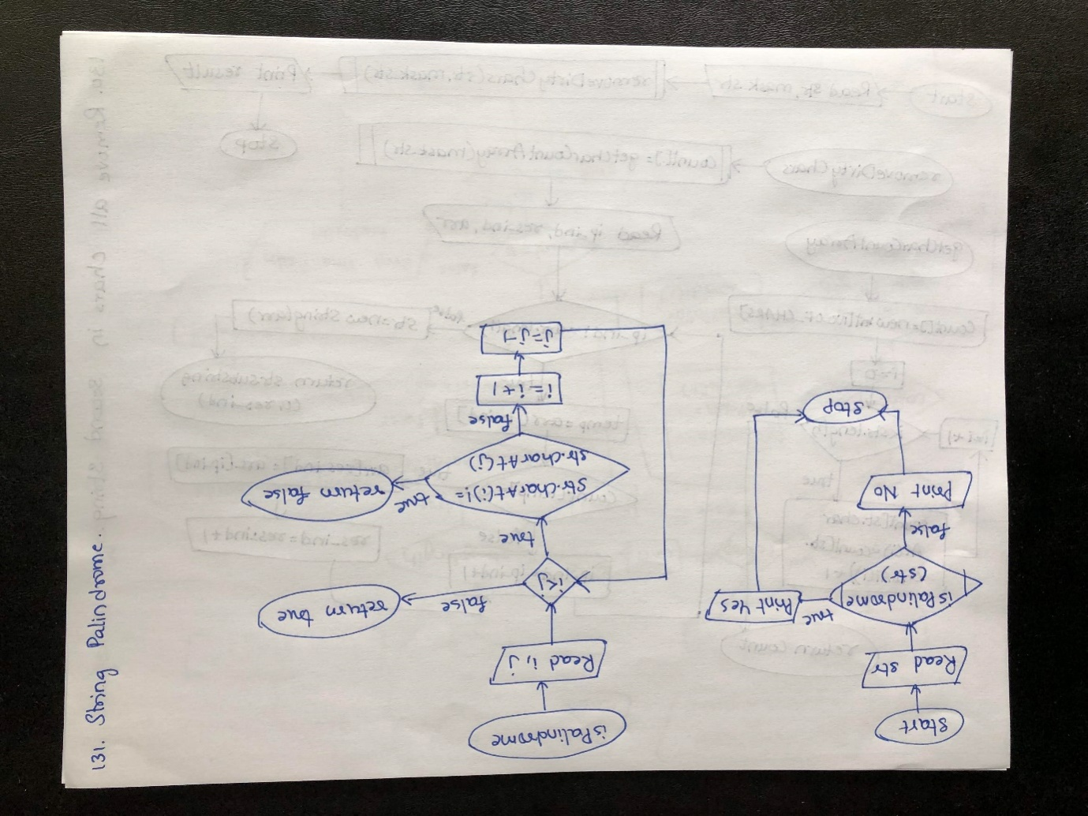

Algorithm

step 1: START

step 2: Assign "geeks" for str

step 3: Call isPalindrome method and goto step 4

step 4: Enter into the method and initialize 0 to i,str.length-1 to j

step 5: Check while loop condition.If true,goto step 6 else goto step 10

step 6: Check if condition.If true,goto step 7 else goto step 8

step 7: Return false to step 11

step 8: Inrement i value by 1

step 9: Decrement j value by 1 and repeat step 5

step 10: Return true to step 11

step 11: Return from method and check the if condition.If true,goto step 12 else goto step 13

step 12: Print "Yes" and goto step 14

step 13: Print "No" and goto step 14

step 14: STOP  
Program

**public class** PalindromeOrNot {  
*// Function that returns true if  
 // str is a palindrome***static boolean**isPalindrome(String str)  
 {  
  
*// Pointers pointing to the beginning  
 // and the end of the string***int** i = 0, j = str.length() - 1;  
  
*// While there are characters toc compare***while** (i < j) {  
  
*// If there is a mismatch***if** (str.charAt(i) != str.charAt(j))  
**return false**;  
  
*// Increment first pointer and  
 // decrement the other*i++;  
 j--;  
 }  
  
*// Given string is a palindrome***return true**;  
 }  
  
*// Driver code***public static void** main(String[] args)  
 {  
 String str = **"geeks"**;  
  
**if** (*isPalindrome*(str))  
 System.***out***.print(**"Yes"**);  
**else**System.***out***.print(**"No"**);  
 }  
  
}

O/P

No

**123. Java Program to Find the Longest Common Subsequence**

Flow Chart

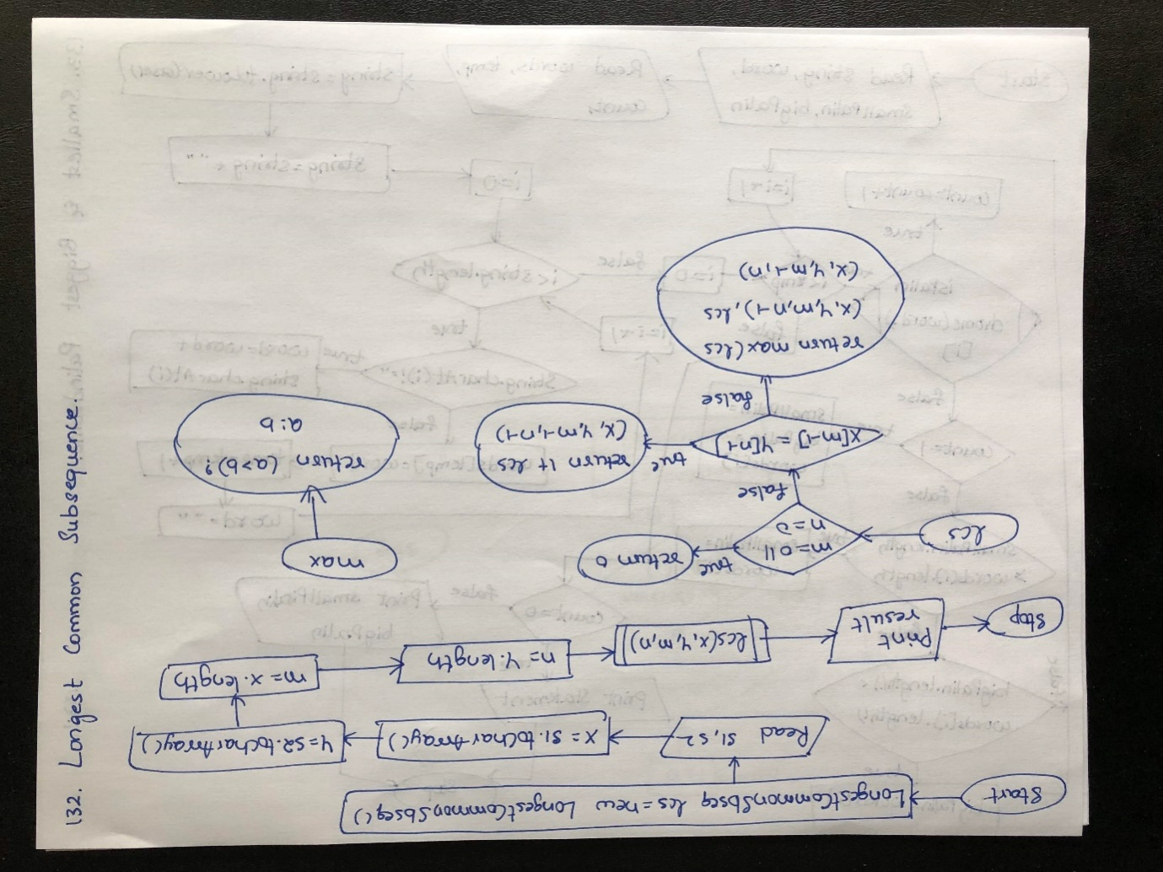

Algorithm

step 1: START

step 2: Create an object lcs for the class

step 3: Assign "AGGTAB" to s1 and "GXTXAYB" to s2

step 4: Create character arrays X and Y and assign s1.toCharArray(),s2.toCharArray() values

step 5: Assign X.length to m and Y.length to n

step 6: Call lcs method with X,Y,m,n as aguments

step 7: Enter into the method and check if condition.If true,goto step 8 else goto step 9

step 8: Return 0 to step 15

step 9: Check if condition.If true,goto step 10 else goto step 11

step 10: Call lcs method with X,Y,m-1,n-1 arguments and repeat step 7 and return the result by adding 1 to step 15

step 11: Call max method with X,Y,m,n-1 arguments

step 12: Enter max method and check the condition.Return the result to step 13

step 13: Return from method and call the lcs method with X,Y,m-1,n arguments and repea step 7

step 14: Return the result of calling max and lcs methods to step 15

step 15: Return from lcs method and print the result

step 16: STOP

Program

**public class** LongestCommonSbseq {  
*/* Returns length of LCS for X[0..m-1], Y[0..n-1] */***int** lcs(**char**[] X, **char**[] Y, **int** m, **int** n)  
 {  
**if** (m == 0 || n == 0)  
**return** 0;  
**if** (X[m - 1] == Y[n - 1])  
**return** 1 + lcs(X, Y, m - 1, n - 1);  
**else  
 return** max(lcs(X, Y, m, n - 1), lcs(X, Y, m - 1, n));  
 }  
  
*/* Utility function to get max of 2 integers */***int** max(**int** a, **int** b)  
 {  
**return** (a > b) ? a : b;  
 }  
  
**public static void** main(String[] args)  
 {  
LongestCommonSbseqlcs = **new** LongestCommonSbseq();  
 String s1 = **"AGGTAB"**;  
 String s2 = **"GXTXAYB"**;  
  
**char**[] X = s1.toCharArray();  
**char**[] Y = s2.toCharArray();  
**int** m = X.**length**;  
**int** n = Y.**length**;  
  
 System.***out***.println(**"Length of LCS is"**+ **" "** + lcs.lcs(X, Y, m, n));  
 }  
  
}

O/P

Length of LCS is 4

**124. Java Program To Print Smallest and Biggest Possible Word which is Palindrome in a given String**

Flow Chart

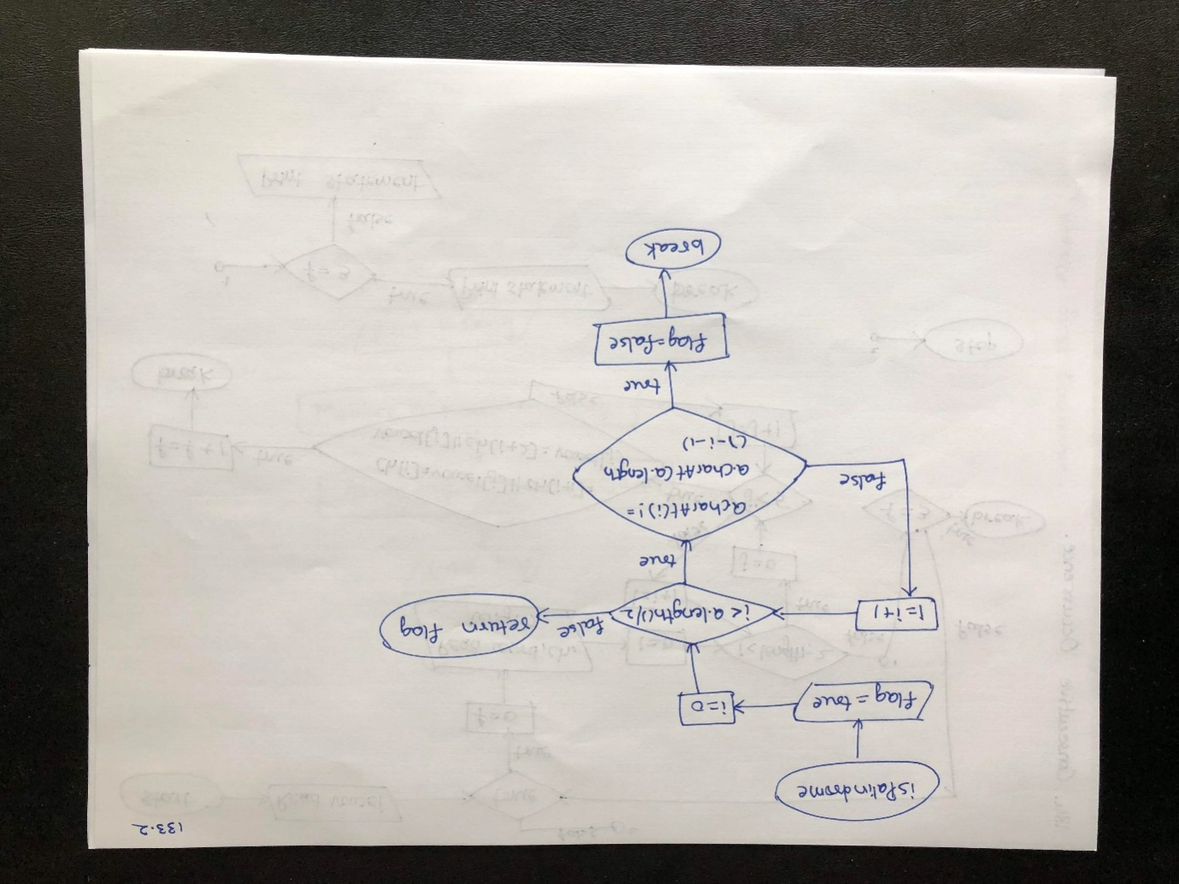

Algorithm

step 1: START

step 2: Assign "Wow you own kayak" to string

step 3: Read word,smallPalin,bigPalin,words

step 4: Convert string to lower case and concat "" to string

step 5: Check for loop condition.If true,goto step 6 else goto step

step 6: Check if condition.If true,goto step 7 else goto step 8

step 7: Concat word and string.charAt(i) to word and repeat step 5

step 8: Assign word to words[temp]

step 9: Increment temp value by 1

step 10: Assign "" to word and repeat step 5

step 11: Check for loop condition.If true,goto step 12 else goto step

step 12: Call isPalindromw method

step 13: Enter method and assign true to flag

step 14: Check for loop condition.If true,goto step 15 else goto step 18

step 15: Check if condition.If true,goto step 16 else repeat step 14

step 16: Assign false to flag

step 17: Break the for loop and goto step 19

step 18: Return flag to step 19

step 19: Return from method and check if condition using the result from method.If true,goto step 20 else goto sttep

step 20: Increment count value by 1

step 21: Check if condition.If true,goto step 22 else goto step 23

step 22: IntializesmallPalin,bigPalin to words[i] and repeat step 14

step 23: Check if condition.If true,goto step 24 else goto step 25

step 24: Assign words[i] to smallPalin and goto step 25

step 25: Check if condition.If true,goto step 26 else repeat step 14

step 26: Assign words[i] to bigPalin and repeat step 14

step 27: Check if condition.If true,goto step 28 else goto step 28

step 28: Print the statement and goto step 30

step 29: Print smallPalin and bigPalin and goto step 30

step 30: STOP

Program

**public class** SmallestBiggestPalindrome {  
*//isPalindrome() checks whether a string is palindrome or not***public static boolean**isPalindrome(String a){  
**boolean**flag = **true**;  
*//Iterate the string forward and backward and compare one character at a time  
 //till middle of the string is reached***for**(**int** i = 0; i < a.length()/2; i++){  
**if**(a.charAt(i) != a.charAt(a.length()-i-1)){  
 flag = **false**;  
**break**;  
 }  
 }  
**return** flag;  
 }  
  
**public static void** main(String[] args){  
 String string = **"Wow you own kayak"**;  
 String word = **""**, smallPalin = **""**, bigPalin=**""**;  
 String[] words = **new** String[100];  
**int** temp = 0, count = 0;  
  
*//Converts the given string into lowercase*string = string.toLowerCase();  
  
*//Add extra space after string to get the last word in the given string*string = string + **" "**;  
  
**for**(**int** i = 0; i <string.length(); i++){  
*//Split the string into words***if**(string.charAt(i) != **' '**){  
 word = word + string.charAt(i);  
 }  
**else**{  
*//Add word to array words*words[temp] = word;  
*//Increment temp*temp++;  
*//Make word an empty string*word = **""**;  
 }  
 }  
  
*//Determine the smallest and biggest palindromes in a given string***for**(**int** i = 0; i< temp; i++){  
**if**(*isPalindrome*(words[i])){  
  
 count++;  
*//When first palindromic word is found***if**(count == 1)  
*//Initialize smallPalin and bigPalin with first palindromic word*smallPalin = bigPalin = words[i];  
  
*//Compare smallPalin and bigPalin with each palindromic words***else**{  
*//If length of smallPalin is greater than next palindromic word  
 //Store that word in smallPalin***if**(smallPalin.length() > words[i].length())  
smallPalin = words[i];  
  
*//If length of bigPalin is less than next palindromic word  
 //Store that word in bigPalin***if**(bigPalin.length() < words[i].length())  
bigPalin = words[i];  
 }  
 }  
 }  
  
**if**(count == 0)  
 System.***out***.println(**"No palindrome is present in the given string"**);  
**else**{  
 System.***out***.println(**"Smallest palindromic word: "** + smallPalin);  
 System.***out***.println(**"Biggest palindromic word: "** + bigPalin);  
 }  
 }  
  
}

O/P

Smallest palindromic word: wow

Biggest palindromic word: kayak

**125. Java Program to Find the Consecutive Occurrence of any Vowel in a String**

Flow Chart

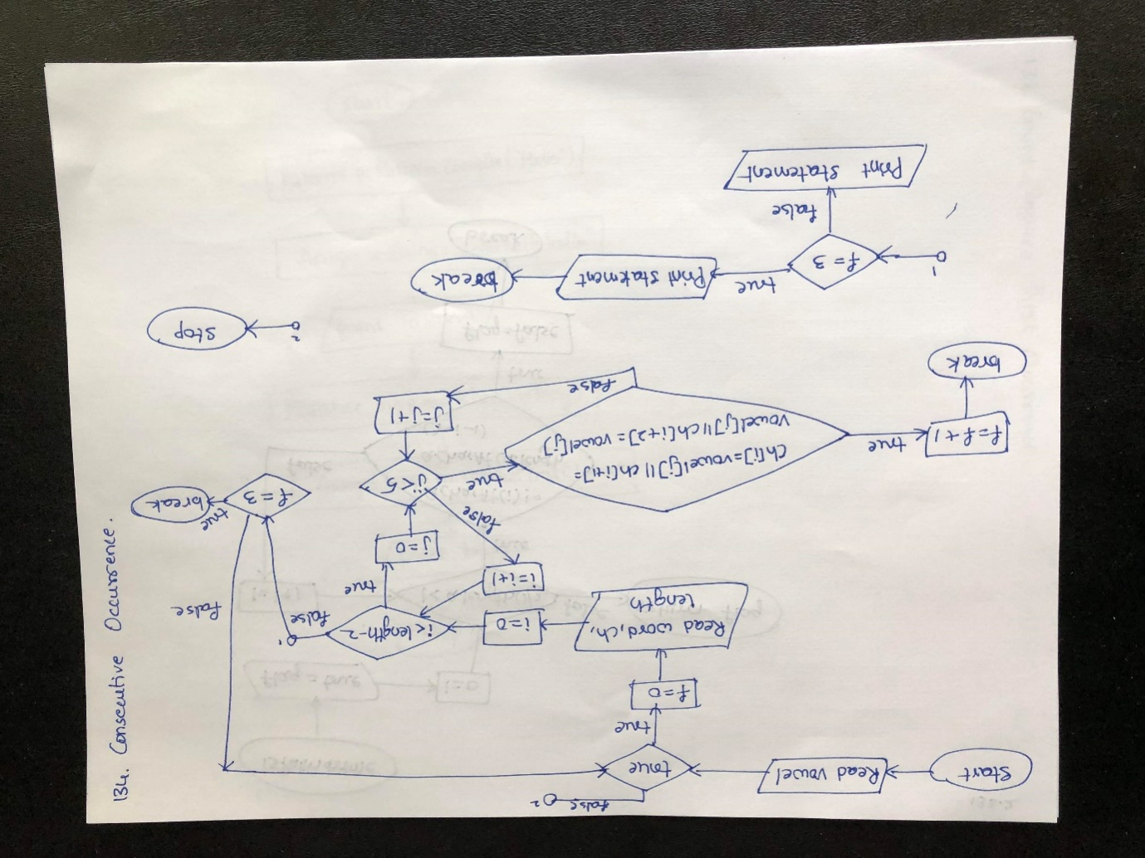

Algorithm

step 1: START

step 2: Initialize vowel

step 3: Check while condition.If true,goto step 4 else goto step 18

step 4: Read word,length,ch

step 5: Check for loop condition.If true,goto step 6 else goto step 12

step 6: Check for loop condition.If true,goto step 7 else goto step 10

step 7: Check if condition.If true,goto step 8 else repeat step 6

step 8: Increment f value by 1

step 9: Break for loop and goto step 10

step 10: Check if condition.If true,goto step 11 else repeat step 5

step 11: Break the loop and goto step 12

step 12: Check if condition.If true,goto step 13 else repeat step 3

step 13: Break loop and goto step 14

step 14: Check if condition.If true,goto step 15 else goto step 17

step 15: Print statement

step 16: Break loop and goto step 18

step 17: Print statement and repeat step 3

step 18: STOP

Program

**import** java.util.Scanner;  
  
**public class** ThreeConsecutiveVowels {  
**public static void** main(String[] args) {  
**char**[] vowel = {**'a'**, **'e'**, **'i'**, **'o'**, **'u'**};  
**while**(**true**){  
**int** f = 0;  
 Scanner s = **new** Scanner(System.***in***);  
 System.***out***.println(**"Enter a String"**);  
 String word = s.nextLine();  
**int** length = word.length();  
**char**[] ch = word.toCharArray();  
**for** (**int** i = 0; i < length-2; i++) {  
**for** (**int** j = 0; j <5; j++) {  
**if** ((ch[i] == vowel[j]) || (ch[i + 1] == vowel[j]) || (ch[i + 2] == vowel[j])) {  
 f++;  
**break**;  
 }  
 }  
**if** (f == 3) **break**; *// Need to break out of loop again in case there are more than three consecutive vowels*}  
**if** (f == 3) {  
 System.***out***.println(**"Hard to pronounce"**);  
**break**;  
 } **else** {  
 System.***out***.println(**"Can be pronounced"**);  
 }  
 }  
 }  
  
}

I/P

Enter a String

Aeiou

O/P

Hard to pronounce

**126. Java Program to Find the Largest & Smallest Word in a String**

Flow Chart

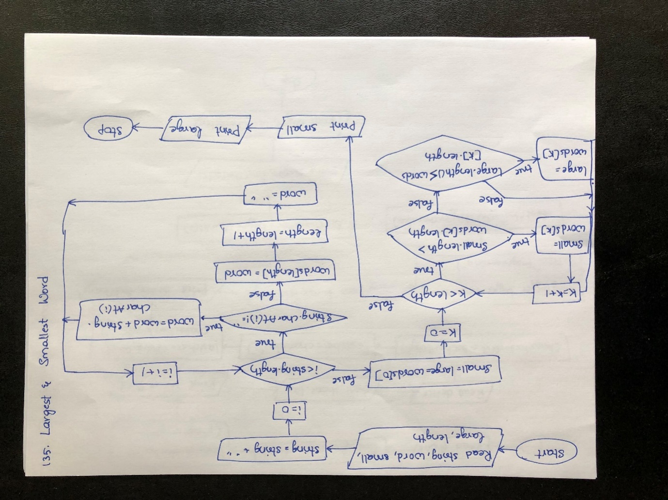

Algorithm

step 1: START

step 2: Read string,word,small,large,length

step 3: Concat string + " " and assign to string

step 4: Check for loop condition.If true,goto step 5 else goto step 10

step 5: Check if condition.If true,goto step 6 else goto step 7

step 6: Concat word + string.charAt(i) and assign to word and repeat step 4

step 7: Assign word to words[length]

step 8: Increment length value by 1

step 9: Assign "" to word and repeat step 4

step 10: Assign word[0] to small and large

step 11: Check for loop condition.If true,goto step 12 else goto step 16

step 12: Check if condition.If true,goto step 13 else goto step 14

step 13: Assign words[k] to small and goto step 14

step 14: Check if condition.If true,goto step 15 else repeat step 11

step 15: Assign words[k] to large and repeat step 11

step 16: Print small and large values

step 17: STOP

Program

**public class** LargestSmallestWord {  
**public static void** main(String[] args){  
 String string = **"Hardships often prepare ordinary people for an extraordinary destiny"**;  
 String word = **""**, small = **""**, large=**""**;  
 String[] words = **new** String[100];  
**int** length = 0;  
  
*//Add extra space after string to get the last word in the given string*string = string + **" "**;  
  
**for**(**int** i = 0; i <string.length(); i++){  
*//Split the string into words***if**(string.charAt(i) != **' '**){  
 word = word + string.charAt(i);  
 }  
**else**{  
*//Add word to array words*words[length] = word;  
*//Increment length*length++;  
*//Make word an empty string*word = **""**;  
 }  
 }  
*//Initialize small and large with first word in the string*small = large = words[0];  
  
*//Determine smallest and largest word in the string***for**(**int** k = 0; k < length; k++){  
  
*//If length of small is greater than any word present in the string  
 //Store value of word into small***if**(small.length() > words[k].length())  
 small = words[k];  
  
*//If length of large is less than any word present in the string  
 //Store value of word into large***if**(large.length() < words[k].length())  
 large = words[k];  
 }  
 System.***out***.println(**"Smallest word: "** + small);  
 System.***out***.println(**"Largest word: "** + large);  
 }  
  
}

O/P

Smallest word: an

Largest word: extraordinary

**127. Java Program to Find First and Last Occurrence of Given Character in a String**

Flow Chart

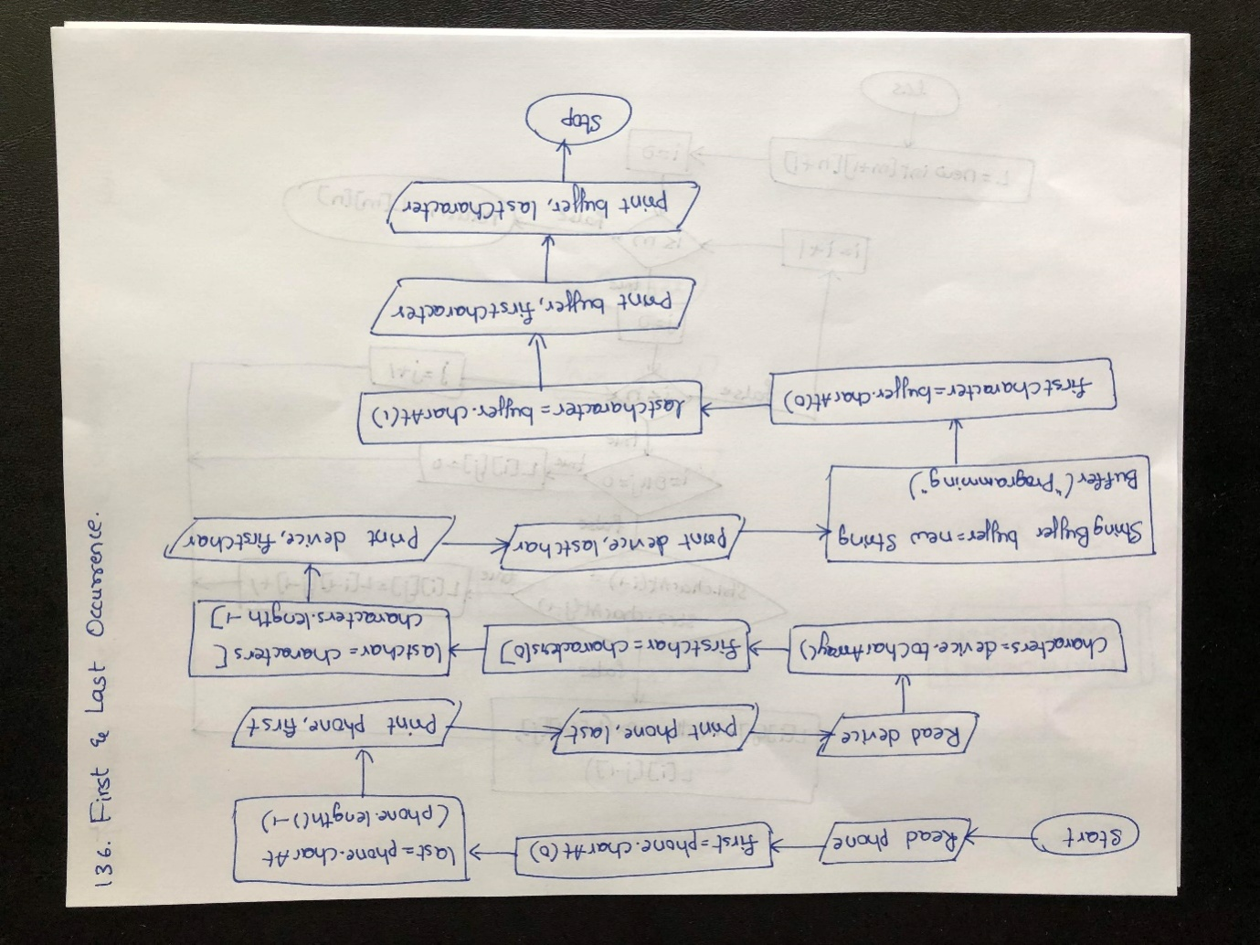

Algorithm

step 1: START

step 2: Read phone and assign phone.charA(0) to first

step 3: Assign phone.charAt(phone.length()-1) to last

step 4: Print phone,first values

step 5: Print phone,last values

step 6: Read device and assign device.toCharArray to characters

step 7: Assign characters[0] to firstChar

step 8: Assign charatcers[characters.length-1] to lastChar

step 9: Print device,fistChar values

step 10: Print device,lastChar values

step 11: Create a string buffer object buffer with value "Programming"

step 12: Assign buffer.charAt(0) to firstCharacter

step 13: Assign buffer.charAt(1) to lastCharacter

step 14: Print buffer,firtCharacter values

step 15: Print buffer,lastCharacter values

step 16: STOP

Program

**public class** FirstLastOccurrence {  
**public static void** main(String args[]) {  
*// You can use the charAt(int index) method to get the first and last  
// character of a String in Java.  
// suppose you want the first and last character from a String  
 // here first character of "iPhone"is "i" and last character  
// is "e"*String phone = **"iPhone"**;  
**char** first = phone.charAt(0);  
*// just like array, string index is zero based***char** last = phone.charAt(phone.length() - 1);  
*// last char is at index length - 1*System.***out***.printf(**"first character of string \"%s\" is '%c' %n"**, phone, first);  
 System.***out***.printf(**"last character of string \"%s\" is '%c' %n"**, phone, last);  
*// Alternatively, you can also get the character array from String  
 // and than extract first and last characters as shown below*String device = **"Bluetooth headset"**;  
**char**[] characters = device.toCharArray();  
**char** firstChar = characters[0];  
*// first character is from index zero***char** lastChar = characters[characters.**length**- 1];  
*// first character is from index length -1*System.***out***.printf(**"first character of string \"%s\" is '%c' %n"**, device, firstChar);  
 System.***out***.printf(**"last character of string \"%s\" is '%c' %n"**, device, lastChar);  
*// You can also use charAt() function to retrieve first and last  
// character from StringBuffer and StringBuilder as well*StringBuffer buffer = **new** StringBuffer(**"Programming"**);  
**char** firstCharacter = buffer.charAt(0);  
**char** lastCharacter = buffer.charAt(1);  
 System.***out***.printf(**"first character of StringBuffer\"%s\" is '%c' %n"**, buffer, firstCharacter);  
 System.***out***.printf(**"last character of StringBuffer\"%s\" is '%c' %n"**, buffer, lastCharacter);  
 }  
  
}

O/P

first character of string "iPhone" is 'i'

last character of string "iPhone" is 'e'

first character of string "Bluetooth headset" is 'B'

last character of string "Bluetooth headset" is 't'

first character of StringBuffer "Programming" is 'P'

last character of StringBuffer "Programming" is 'r'

**128. Java Program to Display the Characters in Prime Position a Given String**

Flow Chart

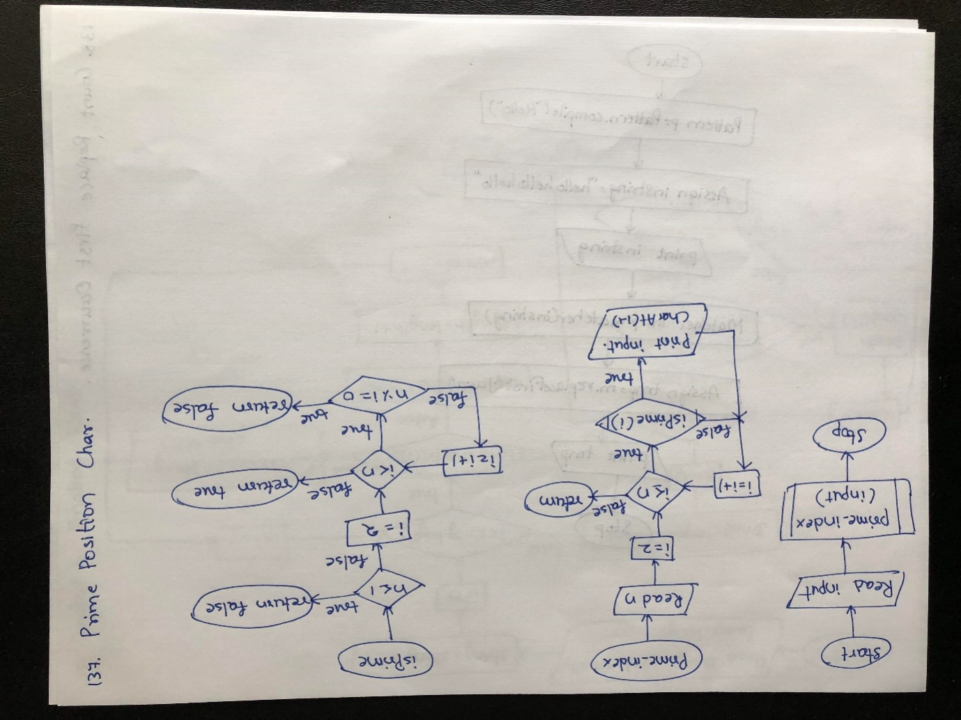

Algorithm

step 1: START

step 2: Assign "GeeksforGeeks" to input

step 3: Call prime_index method witth input argument

step 4: Enter prime_index method and assign input.length to n

step 5: Check for loop condition.If true,goto step 6 else goto step

step 6: Call isPrime method

step 7: Enter iPrime method and check if condition.If true,goto step 8 else goto step 9

step 8: Return false to step

step 9: Check for loop condition.If true,goto step 10 else goto step 12

step 10: Check if condition.If true,goto step 11 else repeat step 9

step 11: Return false to step 13

step 12: Return true to step 13

step 13: Return from method and check if condition.If true,goto step 14 else repeat step 5

step 14: Print input.charAt(i-1) value and repeat step 5

step 15: Return from prime_index method and goto step 16

step 16: STOP

Program

**public class** PrimePositionChar {  
**static boolean**isPrime(**int** n)  
 {  
*// Corner case***if** (n <= 1) **return false**;  
  
*// Check from 2 to n-1***for** (**int** i = 2; i < n; i++)  
**if** (n % i == 0)  
**return false**;  
  
**return true**;  
 }  
  
*// Function to print  
 // character at prime index***static void** prime_index(String input)  
 {  
**int** n = input.length();  
  
*// Loop to check if  
 // index prime or not***for** (**int** i = 2; i <= n; i++)  
**if** (*isPrime*(i))  
  
 System.***out***.print  
 (input.charAt(i - 1));  
 }  
  
*// Driver code***public static void** main (String[] args)  
 {  
 String input = **"GeeksforGeeks"**;  
  
*prime_index*(input);  
 }  
  
}

O/P

eesoes

**129. Java Program to Count Replace First Occurrence of a String**

Flow Chart

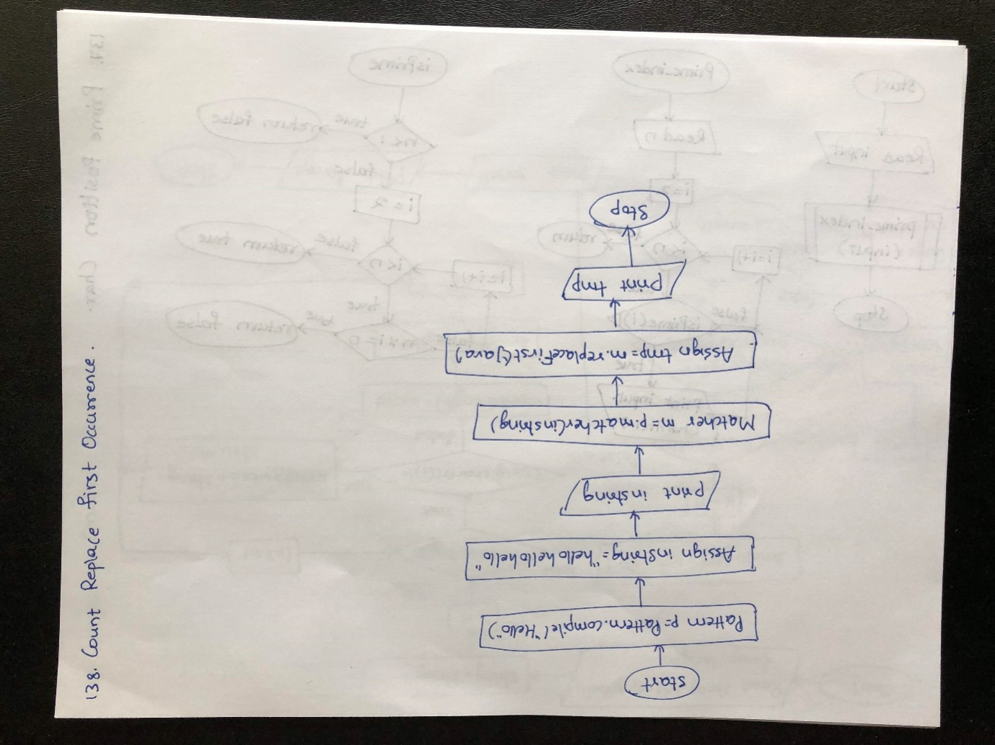

Algorithm

step 1: START

step 2: Create a pattern object and assign "hello" to p

step 3: Assign "hello hellohello" to instring

step 4: Print instring

step 5: Create a Matcher m with value p.matcher(instring)

step 6: Replace first "java" using m.replaceFirst method to tmp

step 7: Print tmp value

step 8: STOP

Program

**import** java.util.regex.Matcher;  
**import** java.util.regex.Pattern;  
  
**public class** CountReplaceFirstOccurrence {  
**public static void** main(String args[]) {  
 Pattern p = Pattern.*compile*(**"hello"**);  
 String instring = **"hello hellohello."**;  
 System.***out***.println(**"initial String: "**+ instring);  
 Matcher m = p.matcher(instring);  
 String tmp = m.replaceFirst(**"Java"**);  
 System.***out***.println(**"String after replacing 1st Match: "** +tmp);  
 }  
  
}

O/P

initial String: hello hellohello.

String after replacing 1st Match: Java hello hello.

**130. Java Program to Know the Last Index of a Particular Word in a String**

Flow Chart

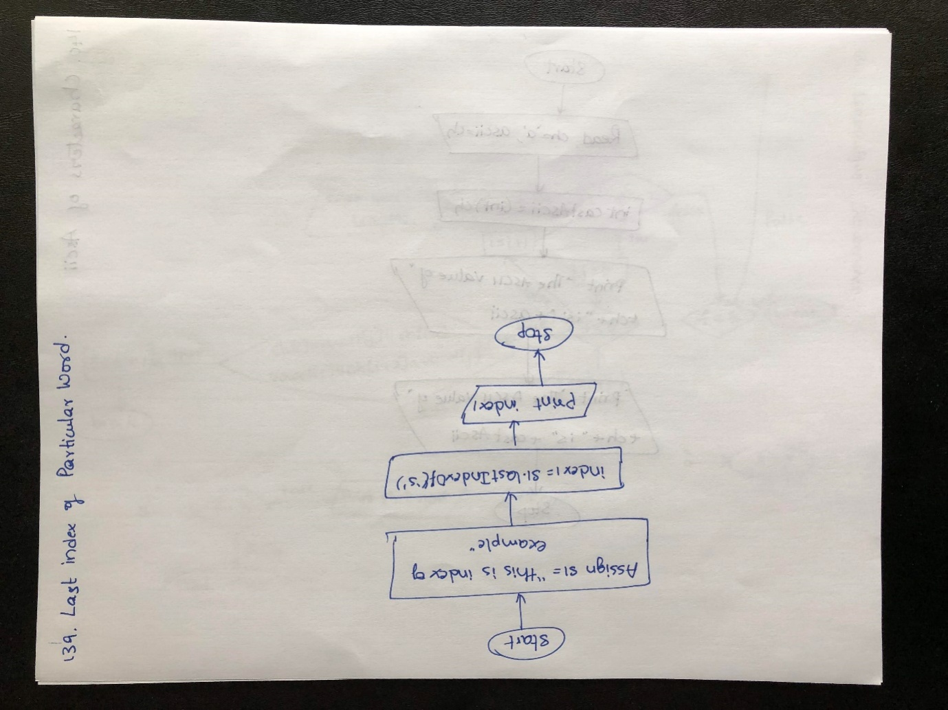

Algorithm

step 1: START

step 2: Assign "this is index of example" value to s1

step 3: Find last index of 's' and assign to index1

step 4: Print index1

step 5: STOP

Program

**public class** LastIndexOfChar {  
**public static void** main(String args[]){  
 String s1=**"this is index of example"**;*//there are 2 's' characters in this sentence***int** index1=s1.lastIndexOf(**'s'**);*//returns last index of 's' char value*System.***out***.println(index1);*//6*}  
}

O/P

6

**131. Java Program to Access the Characters or the Ascii of the Character Available in the String**

Flow Chart

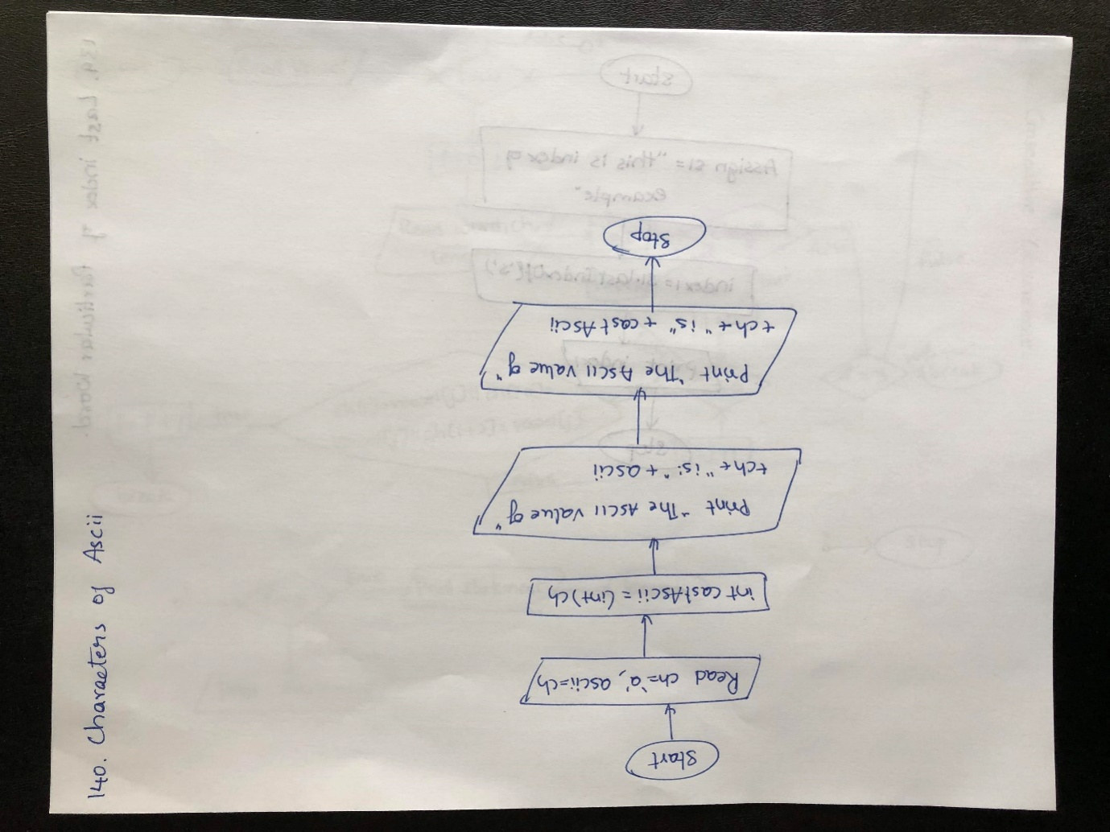

Algorithm:

step 1: START

step 2: Initialize ch to 'a' and ascii to ch

step 3: Perform Type casting of ch to int and assign to castAscii

step 4: Print ch and ascii value

step 5: Print ch and castAscii value

step 6: STOP

Program

**public class** AsciiChar {  
**public static void** main(String[] args) {  
  
**char** ch = **'a'**;  
**int** ascii = ch;  
*// You can also cast char to int***int**castAscii = (**int**) ch;  
  
 System.***out***.println(**"The ASCII value of "** + ch + **" is: "** + ascii);  
 System.***out***.println(**"The ASCII value of "** + ch + **" is: "** + castAscii);  
 }  
  
}

O/P

The ASCII value of a is: 97

The ASCII value of a is: 97

**132. Check whether second string can be formed from characters of first string**

**Flow Chart**

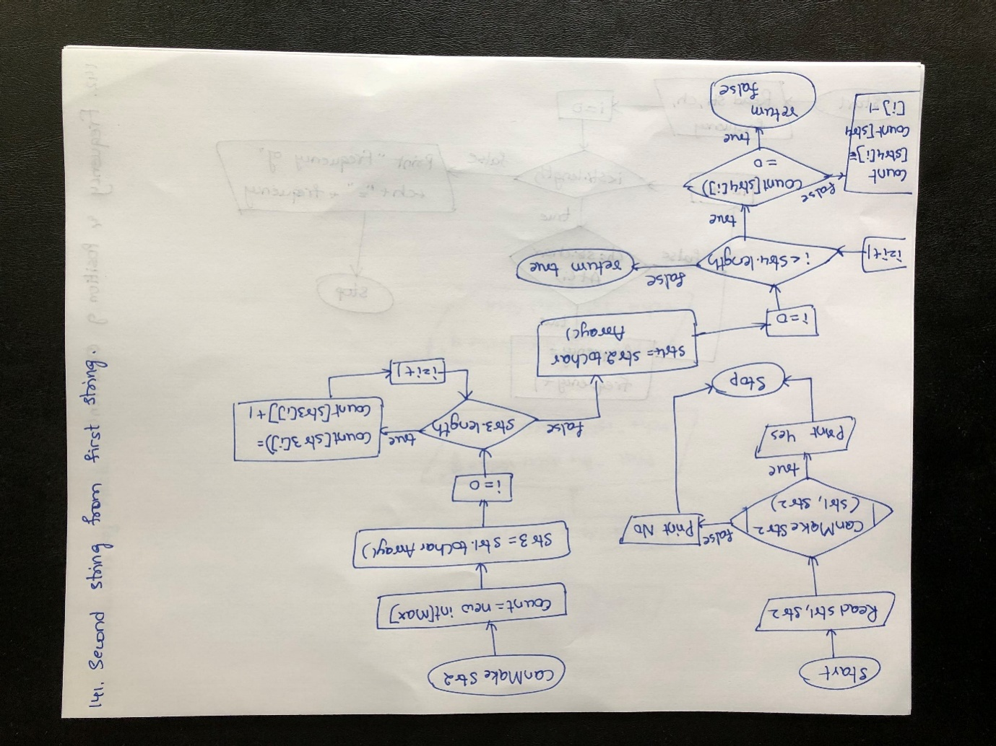

**Algorithm**

**step 1: START**

**step 2: Assign "geekforgeeks" value to str1 and "for" to str2**

**step 3: Call canMakeStr2 method with str1,str2 as arguments**

**step 4: Enter the method and initialize count,str3**

**step 5: Check for loop condition.If true,goto step 6 else goto step 7**

**step 6: Increment the value of count[str3[i]] by 1 and repeat step 5**

**step 7: Check for loop condition.If true,goto step 8 else goto step 11**

**step 8: Check if condition.IF true,goto step 9 else goto step 10**

**step 9: Return false to step 12**

**step 10: Decrement the count[str4[i]] value by 1 and repeat step 7**

**step 11: Return true to step 12**

**step 12: Return from method and check if condition.If true,goto step 13 else goto step 14**

**step 14: Print "Yes" and goto step 16**

**step 15: Print "No" and goto step 16**

**step 16: STOP**

Program

**public class** SecondFromFirst {  
**static int** *MAX* = 256;  
  
**static boolean**canMakeStr2(String str1, String str2)  
 {  
*// Create a count array and count frequencies  
 // characters in str1.***int**[] count = **new int**[*MAX*];  
**char** []str3 = str1.toCharArray();  
**for** (**int** i = 0; i < str3.**length**; i++)  
 count[str3[i]]++;  
  
*// Now traverse through str2 to check  
 // if every character has enough counts***char** []str4 = str2.toCharArray();  
**for** (**int** i = 0; i < str4.**length**; i++) {  
**if** (count[str4[i]] == 0)  
**return false**;  
 count[str4[i]]--;  
 }  
**return true**;  
 }  
  
*// Driver Code***static public void** main(String []args)  
 {  
 String str1 = **"geekforgeeks"**;  
 String str2 = **"for"**;  
**if** (*canMakeStr2*(str1, str2))  
 System.***out***.println(**"Yes"**);  
**else**System.***out***.println(**"No"**);  
 }  
  
}

O/P

Yes

**133. Java Program to Find Frequency & Position of Occurrence**

Flow Chart

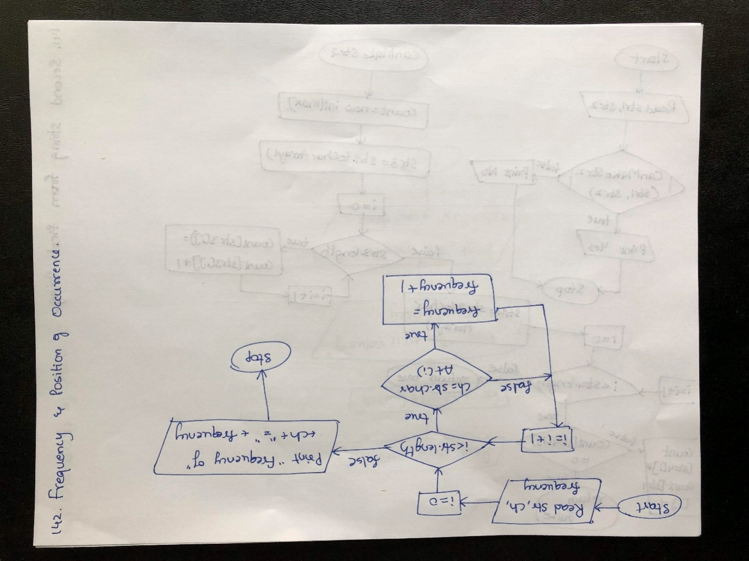

Algorithm

step 1: START

step 2: Assign "This website is awesome" to str

step 3: Assign 'e' to ch

step 4: Check for condition.If true,goto sttep 5 else goto step 7

step 5: Check if condition.If true,goto step 6 else repeat step 4

step 6: Increment frequency value by 1 and repeat step 4

step 7: Print frequency value and ch value.

step 8: STOP

Program

**public class** FrequencyAndPositionOccurence {  
**public static void** main(String[] args) {  
 String str = **"This website is awesome."**;  
**char** ch = **'e'**;  
**int** frequency = 0;  
  
**for**(**int** i = 0; i < str.length(); i++) {  
**if**(ch == str.charAt(i)) {  
 ++frequency;  
 }  
 }  
  
 System.***out***.println(**"Frequency of "** + ch + **" = "** + frequency);  
 }  
  
}

O/P

Frequency of e = 4

**134. Minimum number of deletions and insertions to transform one string into another**

**Flow Chart**

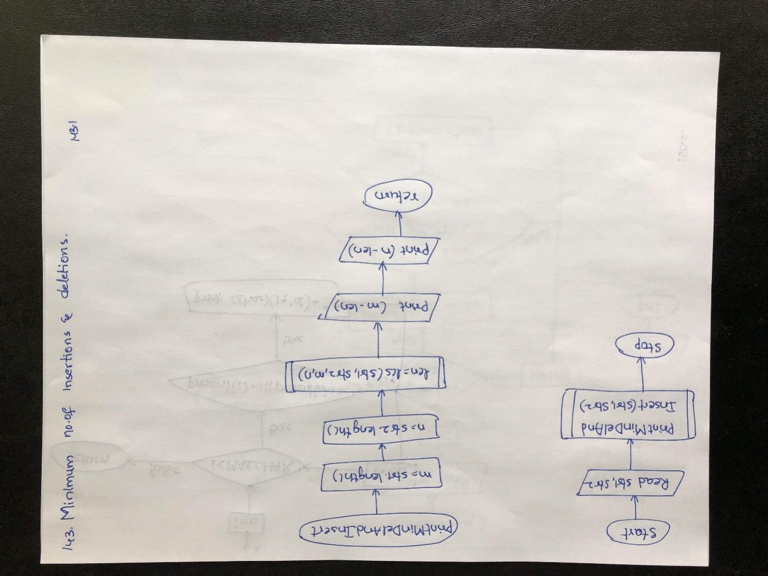

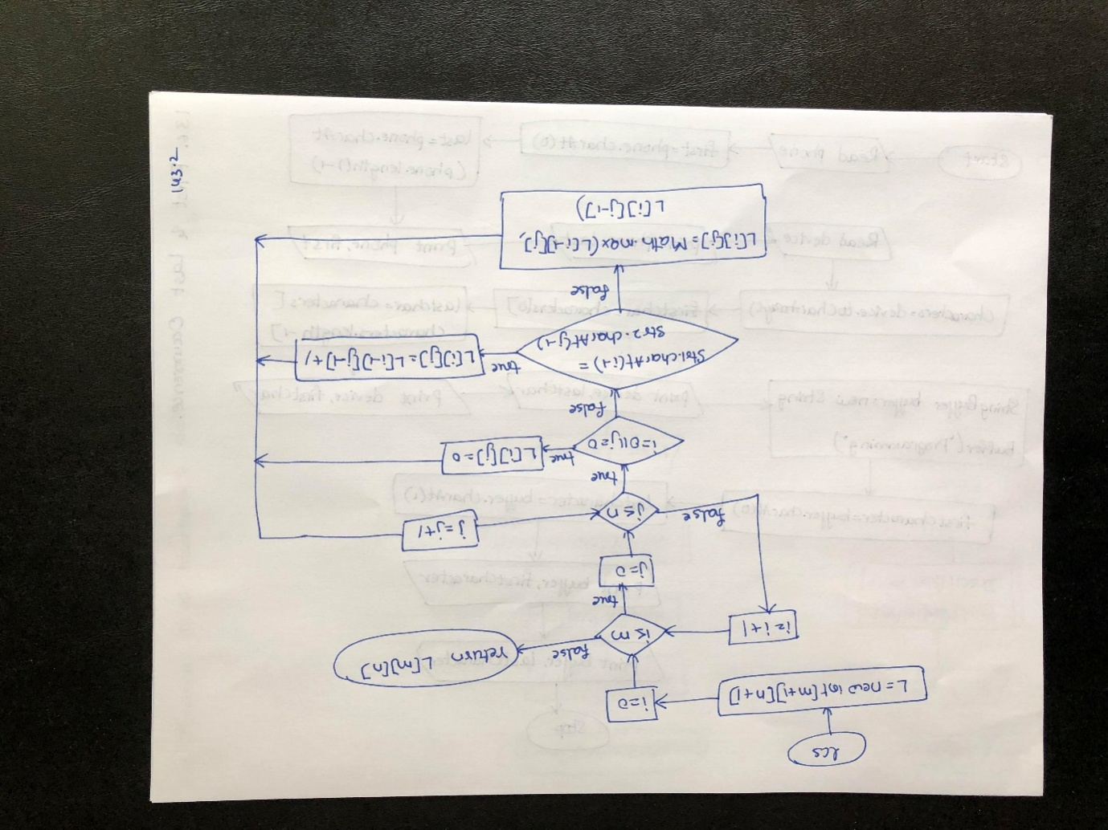

**Algorithm**

**step 1: START**

**step 2: Read str1 and str2**

**step 3: Call printMinDelAndInsert method with str1,str2 arguments**

**step 4: Enter the method and assign str1.length to n,str2.length to n**

**step 5: Call lcs method with str1,str2,m,n arguments**

**step 6: Enter into lcs method and create a integer array with m+1,n+1 as lenght**

**step 7: Check for loop condition.If true,goto step 8 else goto step 14**

**step 8: Check for loop condition.If true,goto step 9 else repeat step 7**

**step 9: Check if condition.If true,goto step 10 else goto step 11**

**step 10: Assign 0 to L[i][j] and repeat step 9**

**step 11: Check else if condition.If true,goto step 12 else goto step 13**

**step 12: Assign L[i-1][j-1] +1 to L[i][j] and repeat step 9**

**step 13: Assign MAth.max(L[i-1][j],L[i][j-1]) to L[i][j] and repeat step 9**

**step 14: Return L[m][n] to step 15**

**step 15: Return from lcs method and assign the value to len**

**step 16: Print m-len value with statement**

**step 17: Print n-len value with statement**

**step 18: Return from method and goto step 19**

**step 19: STOP**

Program

**public class** MinInsertDelToTransform {  
*// Returns length of length common  
 // subsequence for str1[0..m-1],  
 // str2[0..n-1]***static int** lcs(String str1, String str2,  
**int** m, **int** n )  
 {  
**int** L[][] = **new int**[m+1][n+1];  
**int** i, j;  
  
*// Following steps build L[m+1][n+1] in  
 // bottom up fashion. Note that L[i][j]  
 // contains length of LCS of str1[0..i-1]  
 // and str2[0..j-1]***for** (i = 0; i <= m; i++)  
 {  
**for** (j = 0; j <= n; j++)  
 {  
**if** (i == 0 || j == 0)  
 L[i][j] = 0;  
  
**else if** (str1.charAt(i-1) == str2.charAt(  
 j-1))  
 L[i][j] = L[i-1][j-1] + 1;  
  
**else**L[i][j] = Math.*max*(L[i-1][j],  
 L[i][j-1]);  
 }  
 }  
  
*// L[m][n] contains length of LCS  
 // for X[0..n-1] and Y[0..m-1]***return** L[m][n];  
 }  
  
*// function to find minimum number  
 // of deletions and insertions***static void** printMinDelAndInsert(String str1,  
 String str2)  
 {  
**int** m = str1.length();  
**int** n = str2.length();  
  
**int** len = *lcs*(str1, str2, m, n);  
  
 System.***out***.println(**"Minimum number of "**+  
**"deletions = "**);  
 System.***out***.println(m - len);  
  
 System.***out***.println(**"Minimum number of "**+  
**"insertions = "**);  
 System.***out***.println(n - len);  
 }  
  
*// Driver program to test above***public static void** main(String[] args)  
 {  
 String str1 = **new** String(**"heap"**);  
 String str2 = **new** String(**"pea"**);  
*printMinDelAndInsert*(str1, str2);  
 }  
  
}

O/P

Minimum number of deletions =

2

Minimum number of insertions =

1

**135. Java Program to Count a Group of Words in a String**

Flow Chart

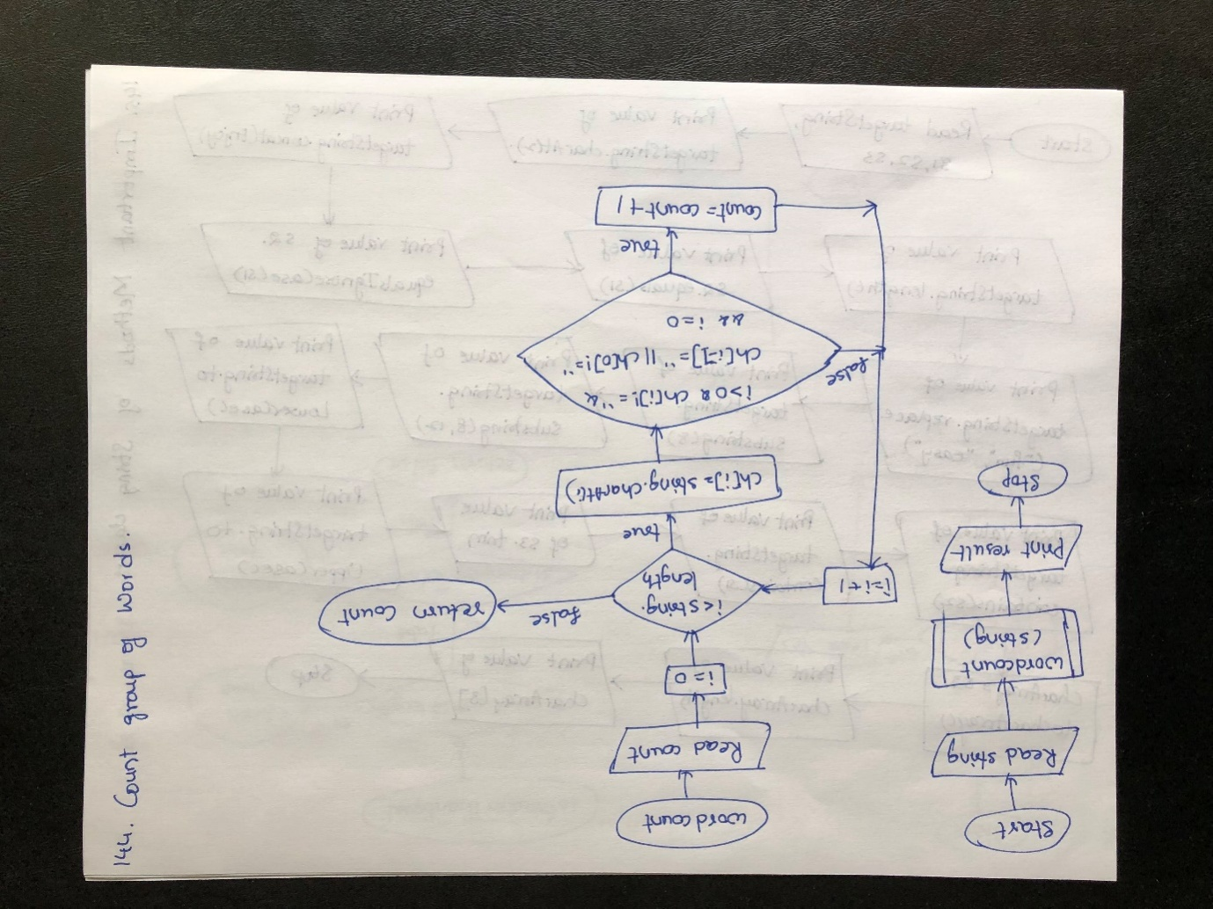

Algorithm

step 1: START

step 2: Assign "India is my country" to string

step 3: Call wordcount method with string argument

step 4: Enter the method and initialize count,ch array

step 5: Check for loop condition.If true,goto step 6 else goto step 9

step 6: Assign string.CharAt(i) to ch[i]

step 7: Check for loop condition.If true,goto step 8 else repeat step 5

step 8: Increment count value by 1 and repeat step 5

step 9: Return count to step 10

step 10: Return from method and print the value

step 11: STOP

Program

**public class** CountGroupOfWords {  
**static int** wordcount(String string)  
 {  
**int** count=0;  
  
**char** ch[]= **new char**[string.length()];  
**for**(**int** i=0;i<string.length();i++)  
 {  
ch[i]= string.charAt(i);  
**if**( ((i>0)&&(ch[i]!=**' '**)&&(ch[i-1]==**' '**)) || ((ch[0]!=**' '**)&&(i==0)) )  
 count++;  
 }  
**return** count;  
 }  
**public static void** main(String[] args) {  
 String string =**" India Is My Country"**;  
 System.***out***.println(*wordcount*(string) + **" words."**);  
 }  
}

O/P

4 words.

**136. Java Program to Create and Use Important Methods of String Class**

Flow Chart

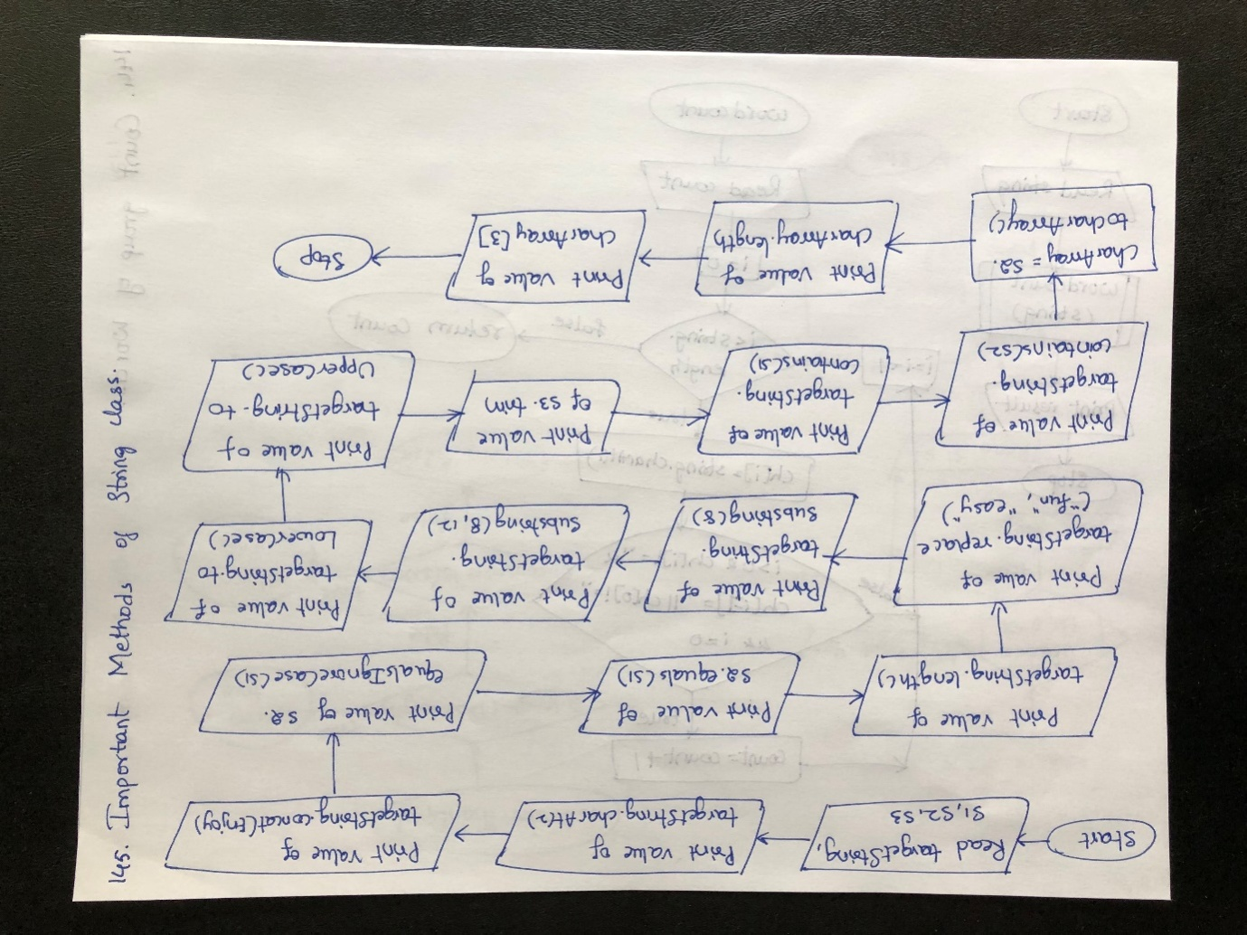

Algorithm

step 1: START

step 2: Read targetString,s1,s2,s3

step 3: Print the value of targetString.charAt(2)

step 4: Concat "Enjoy" to targetString and print the value

step 5: Check whether the strings are equal or not by using s2.equalsIgnoreCase(s1) and print value

step 6: Check whether the strings are equal or not by using s2.equals(s1)

step 7: Print the length of targetString

step 8: Replace string using targetString.replace("fun", "easy") and print the value

step 9: Create substring and print the result

step 10: Create substring using targetString.substring(8, 12) and print the result

step 11: Convert the string to lower case using targetString.toLowerCase() and print result

step 12: Convert the string to upper case using targetString.toUpperCase() and print rsult

step 13: Trim the string using trim method and print result

step 14: Check whether the string contains s1 using targetString.contains(s1) and print the result

step 15: Check whether the string contains s2 using targetString.contains(s2) and print the result

step 16: Initialize charArray and print the values of the array

step 17: STOP

Program

**public class** ImpMethods {  
**public static void** main(String[] args) {  
 String targetString = **"Java is fun to learn"**;  
 String s1= **"JAVA"**;  
 String s2= **"Java"**;  
 String s3 = **" Hello Java "**;  
  
 System.***out***.println(**"Char at index 2(third position): "** + targetString.charAt(2));  
 System.***out***.println(**"After Concat: "**+ targetString.concat(**"-Enjoy-"**));  
 System.***out***.println(**"Checking equals ignoring case: "** +s2.equalsIgnoreCase(s1));  
 System.***out***.println(**"Checking equals with case: "** +s2.equals(s1));  
 System.***out***.println(**"Checking Length: "**+ targetString.length());  
 System.***out***.println(**"Replace function: "**+ targetString.replace(**"fun"**, **"easy"**));  
 System.***out***.println(**"SubString of targetString: "**+ targetString.substring(8));  
 System.***out***.println(**"SubString of targetString: "**+ targetString.substring(8, 12));  
 System.***out***.println(**"Converting to lower case: "**+ targetString.toLowerCase());  
 System.***out***.println(**"Converting to upper case: "**+ targetString.toUpperCase());  
 System.***out***.println(**"Triming string: "** + s3.trim());  
 System.***out***.println(**"searching s1 in targetString: "** + targetString.contains(s1));  
 System.***out***.println(**"searching s2 in targetString: "** + targetString.contains(s2));  
  
**char** [] charArray = s2.toCharArray();  
 System.***out***.println(**"Size of char array: "** + charArray.**length**);  
 System.***out***.println(**"Printing last element of array: "** + charArray[3]);  
  
 }  
}

O/P

Char at index 2(third position): v

After Concat: Java is fun to learn-Enjoy-

Checking equals ignoring case: true

Checking equals with case: false

Checking Length: 20

Replace function: Java is easy to learn

SubString of targetString: fun to learn

SubString of targetString: fun

Converting to lower case: java is fun to learn

Converting to upper case: JAVA IS FUN TO LEARN

Triming string: Hello Java

searching s1 in targetString: false

searching s2 in targetString: true

Size of char array: 4

Printing last element of array: a

**137. Java Program to Check Whether Date is in Proper Format or Not**

**Program**

**import** java.text.ParseException;  
**import** java.text.SimpleDateFormat;  
**import** java.util.Date;  
  
**public class** DateValidator {  
**public static boolean**validateJavaDate(String strDate) {  
*/* Check if date is 'null' */***if** (strDate.trim().equals(**""**)) {  
**return true**;  
 }  
*/* Date is not 'null' */***else** {  
*/*  
 * Set preferred date format,  
 * For example MM-dd-yyyy, MM.dd.yyyy,dd.MM.yyyy etc.*/*SimpleDateFormatsdfrmt = **new** SimpleDateFormat(**"MM/dd/yyyy"**);  
sdfrmt.setLenient(**false**);  
*/* Create Date object  
 * parse the string into date  
 */***try** {  
 Date javaDate = sdfrmt.parse(strDate);  
 System.***out***.println(strDate + **" is valid date format"**);  
 }  
*/* Date format is invalid */* **catch** (ParseException e) {  
 System.***out***.println(strDate + **" is Invalid Date format"**);  
**return false**;  
 }  
*/* Return true if date format is valid */***return true**;  
 }  
 }  
  
**public static void** main(String args[]) {  
*validateJavaDate*(**"12/29/2016"**);  
*validateJavaDate*(**"12-29-2016"**);  
*validateJavaDate*(**"12,29,2016"**);  
  
  
 }  
}

O/P

12/29/2016 is valid date format

12-29-2016 is Invalid Date format

12,29,2016 is Invalid Date format

**138. Java Program to Validate an Email Address Format**

Flow Chart

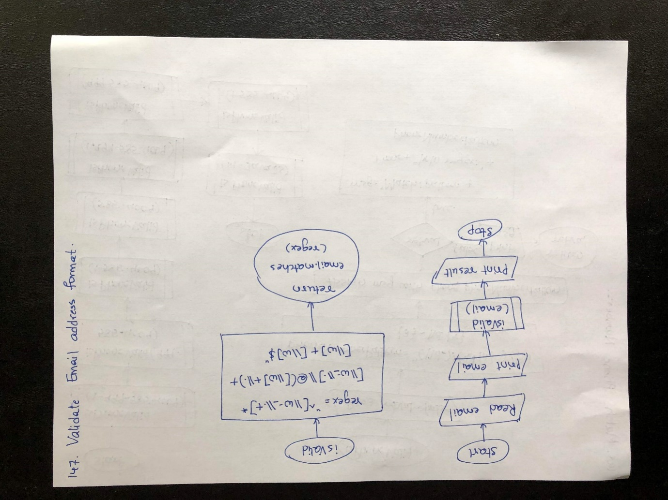

Algorithm

step 1: START

step 2: Assign email to john123@gmail.com

step 3: Print email

step 4: Call isValid method with email argument

step 5: Enter the method and assign the pattern to regex to validate

step 6: Return the value of email.matches(regex) to step 7

step 7: Return from method and pritn the result.

step 8: STOP

Program

**public class** EmailValidator {  
**static boolean**isValid(String email) {  
 String regex = **"^[\\w-_\\.+]*[\\w-_\\.]\\@([\\w]+\\.)+[\\w]+[\\w]$"**;  
**return** email.matches(regex);  
 }  
  
**public static void** main(String[] args) {  
 String email = **"john123@gmail.com"**;  
 System.***out***.println(**"The E-mail ID is: "** + email);  
 System.***out***.println(**"Is the above E-mail ID valid? "** + *isValid*(email));  
 }  
}

O/P

The E-mail ID is: john123@gmail.com

Is the above E-mail ID valid? true

**139. Java Program to Match Phone Numbers in a List to a Certain Pattern**

Flow Chart

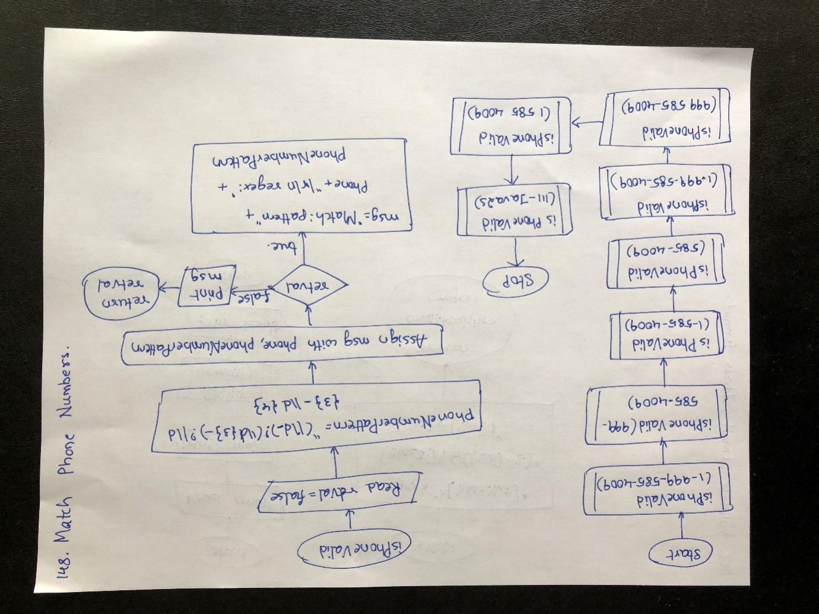

Algorithm

step 1: START

step 2: Call isPhoneValid method

step 3: Enter method and Initialize false to retval

step 4: Assign pattern to phoneNumberPattern

step 5: Assign "NO MATCH: pattern:" + phone + "\r\n regex: " + phoneNumberPattern to msg

step 6: Check if condition.If true,goto step 7 else goto step 8

step 7: Assign " MATCH: pattern:" + phone + "\r\n regex: " + phoneNumberPattern to msg

step 8: Print the msg value

step 9: Return retval value to step 10

step 10: Return from method and call isPhoneValid method with 999-585-4009 as argument and repeat step 3

step 11: Return from method and call isPhoneValid method with 1-585-4009 as argument and repeat step 3

step 12: Return from method and call isPhoneValid method with 585-4009 as argument and repeat step 3

step 13: Return from method and call isPhoneValid method with 1.999-585-4009 as argument and repeat step 3

step 14: Return from method and call isPhoneValid method with 999 585-4009 as argument and repeat step 3

step 15: Return from method and call isPhoneValid method with 1 585 4009 as argument and repeat step 3

step 16: Return from method and call isPhoneValid method with 111-Java2s as argument and repeat step 3

step 17: STOP

Program

**public class** PhoneNumberValidator {  
**public static void** main(String args[]) {  
*isPhoneValid*(**"1-999-585-4009"**);  
*isPhoneValid*(**"999-585-4009"**);  
*isPhoneValid*(**"1-585-4009"**);  
*isPhoneValid*(**"585-4009"**);  
*isPhoneValid*(**"1.999-585-4009"**);  
*isPhoneValid*(**"999 585-4009"**);  
*isPhoneValid*(**"1 585 4009"**);  
*isPhoneValid*(**"111-Java2s"**);  
 }  
**public static boolean**isPhoneValid(String phone) {  
**boolean**retval = **false**;  
 String phoneNumberPattern = **"(\\d-)?(\\d{3}-)?\\d{3}-\\d{4}"**;  
retval = phone.matches(phoneNumberPattern);  
 String msg = **"NO MATCH: pattern:"** + phone + **"\r\n regex: "** + phoneNumberPattern;  
  
**if** (retval) {  
msg = **" MATCH: pattern:"** + phone + **"\r\n regex: "** + phoneNumberPattern;  
 }  
 System.***out***.println(msg + **"\r\n"**);  
**return** retval;  
 }  
  
}

O/P

MATCH: pattern:1-999-585-4009

regex: (\d-)?(\d{3}-)?\d{3}-\d{4}

MATCH: pattern:999-585-4009

regex: (\d-)?(\d{3}-)?\d{3}-\d{4}

MATCH: pattern:1-585-4009

regex: (\d-)?(\d{3}-)?\d{3}-\d{4}

MATCH: pattern:585-4009

regex: (\d-)?(\d{3}-)?\d{3}-\d{4}

NO MATCH: pattern:1.999-585-4009

regex: (\d-)?(\d{3}-)?\d{3}-\d{4}

NO MATCH: pattern:999 585-4009

regex: (\d-)?(\d{3}-)?\d{3}-\d{4}

NO MATCH: pattern:1 585 4009

regex: (\d-)?(\d{3}-)?\d{3}-\d{4}

NO MATCH: pattern:111-Java2s

regex: (\d-)?(\d{3}-)?\d{3}-\d{4}

**140.Find all strings that match specific pattern in a dictionary**

**Program**

**import** java.util.HashMap;  
  
**public class** MatchInDictonary {  
*// Function to encode given string***static** String encodeString(String str)  
 {  
 HashMap<Character, Integer> map = **new** HashMap<>();  
 String res = **""**;  
**int** i = 0;  
  
*// for each character in given string***char** ch;  
**for** (**int** j = 0; j < str.length(); j++) {  
ch = str.charAt(j);  
  
*// If the character is occurring for the first  
 // time, assign next unique number to that char***if** (!map.containsKey(ch))  
map.put(ch, i++);  
  
*// append the number associated with current  
 // character into the output string*res += map.get(ch);  
 }  
  
**return** res;  
 }  
  
*// Function to print all the strings that match the  
 // given pattern where every character in the pattern is  
 // uniquely mapped to a character in the dictionary***static void** findMatchedWords(String[] dict, String pattern)  
 {  
*// len is length of the pattern***int** len = pattern.length();  
  
*// encode the string*String hash = *encodeString*(pattern);  
  
*// for each word in the dictionary array***for** (String word : dict) {  
*// If size of pattern is same as size of current  
 // dictionary word and both pattern and the word  
 // has same hash, print the word***if** (word.length() == len &&*encodeString*(word).equals(hash))  
 System.***out***.print(word + **" "**);  
 }  
 }  
  
*// Driver code***public static void** main(String args[])  
 {  
 String[] dict = { **"abb"**, **"abc"**, **"xyz"**, **"xyy"** };  
 String pattern = **"foo"**;  
  
*findMatchedWords*(dict, pattern);  
 }  
  
}

O/P

abbxyy

**141. Program to find uncommon characters of the two strings**

**Flow Chart**

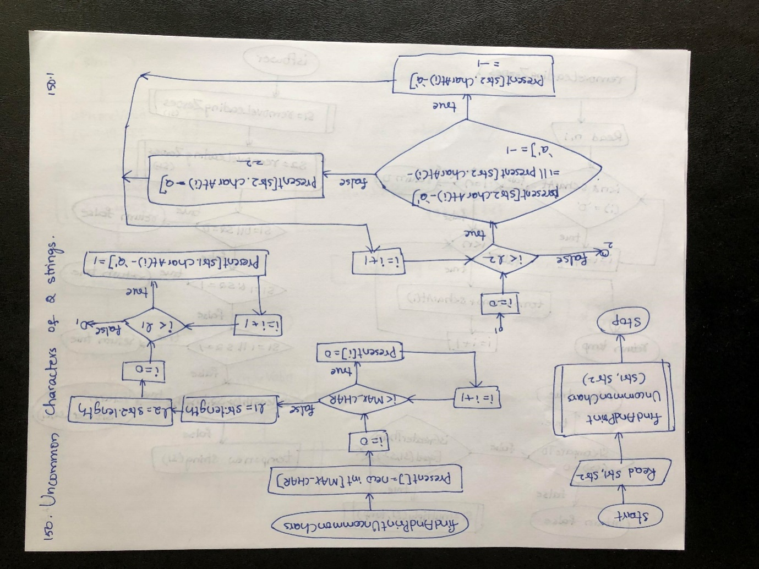

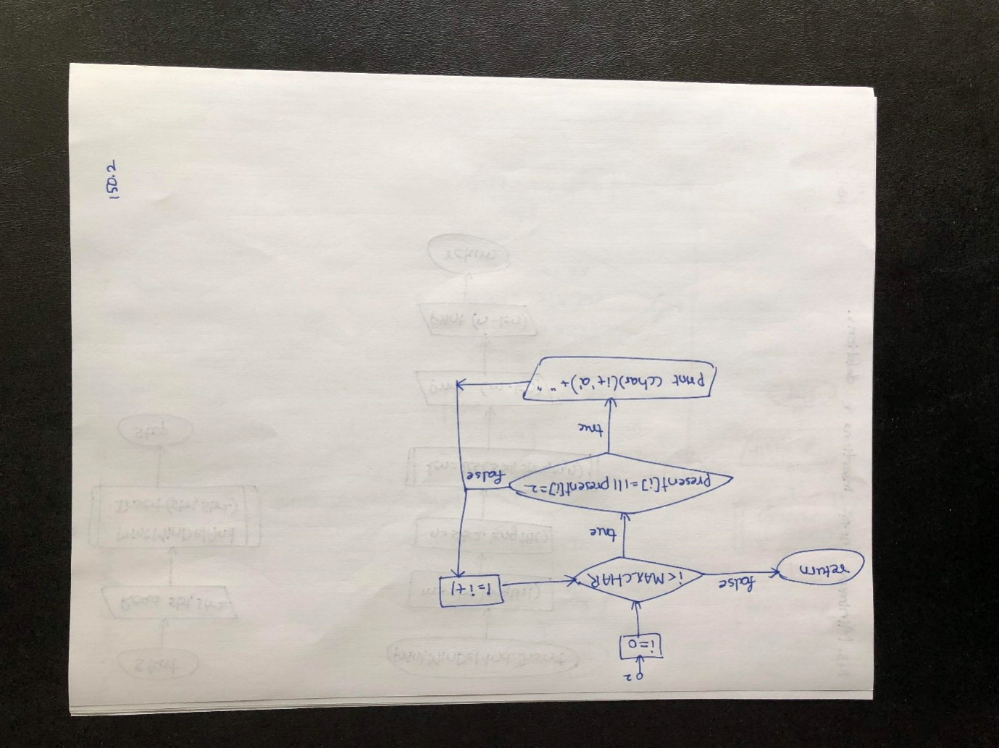

**Algorithm**

**step 1: START**

**step 2: Load UncommonChars class and MAX_CHAR static variable with 26 value**

**step 3: Execution starts with main method.Enter main method**

**step 4: Read str1,str2**

**step 5: Call findAndPrintUncommonChars method with str1,str2 arguments**

**step 6: Enter the method and creste present array with MAX_CHAR length**

**step 7: Check for loop condition.If true,goto step 8 else goto step 9**

**step 8: Assign 0 to present[i] and repeat step 7**

**step 9: Assign str1.length to l1 and str2.length to l2**

**step 10: Check for loop condition.If true,goto step 11 else goto step 12**

**step 11: Assign 1 to present[str1.charAt(i)-'a'] and repeat step 10**

**step 12: Check for loop condition.If true,goto step 13 else goto step 16**

**step 13: Check if condition.If true,goto step 14 else goto step 15**

**step 14: Assign -1 to present[str2.charAt(i)-'a'] and repeat step 12**

**step 15: Assign 2 to present[sr2.charAt(i)-'a'] and repeat step 12**

**step 16: Check for loop condition.If true,goto step 17 else goto step**

**step 17: Check if condition.If true,goto step 18 else repeat step 16**

**step 18: Print value of (char)(i+'a') and repeat step 16**

**step 19: Return to main method and goto step 20**

**step 20: STOP**

Program

**public class** UncommonChars {  
*// size of the hash table***static int** *MAX_CHAR* = 26;  
  
*// function to find the uncommon  
 // characters of the two strings***static void** findAndPrintUncommonChars(String str1,  
 String str2)  
 {  
*// mark presence of each character as 0  
 // in the hash table 'present[]'***int** present[] = **new int**[*MAX_CHAR*];  
**for** (**int** i = 0; i <*MAX_CHAR*; i++)  
 {  
 present[i] = 0;  
 }  
  
**int** l1 = str1.length();  
**int** l2 = str2.length();  
  
*// for each character of str1, mark its  
 // presence as 1 in 'present[]'***for** (**int** i = 0; i < l1; i++)  
 {  
 present[str1.charAt(i) - **'a'**] = 1;  
 }  
  
*// for each character of str2***for** (**int** i = 0; i < l2; i++)  
 {  
  
*// if a character of str2 is also present  
 // in str1, then mark its presence as -1***if** (present[str2.charAt(i) - **'a'**] == 1  
|| present[str2.charAt(i) - **'a'**] == -1)  
 {  
 present[str2.charAt(i) - **'a'**] = -1;  
 }  
  
*// else mark its presence as 2***else**{  
 present[str2.charAt(i) - **'a'**] = 2;  
 }  
 }  
  
*// print all the uncommon characters***for** (**int** i = 0; i <*MAX_CHAR*; i++)  
 {  
**if** (present[i] == 1 || present[i] == 2)  
 {  
 System.***out***.print((**char**) (i + **'a'**) + **" "**);  
 }  
 }  
 }  
  
*// Driver code***public static void** main(String[] args)  
 {  
 String str1 = **"characters"**;  
 String str2 = **"alphabets"**;  
*findAndPrintUncommonChars*(str1, str2);  
 }  
}

O/P

b c l p r

**142. Given two numbers as strings, find if one is a power of other**

**Flow Chart**

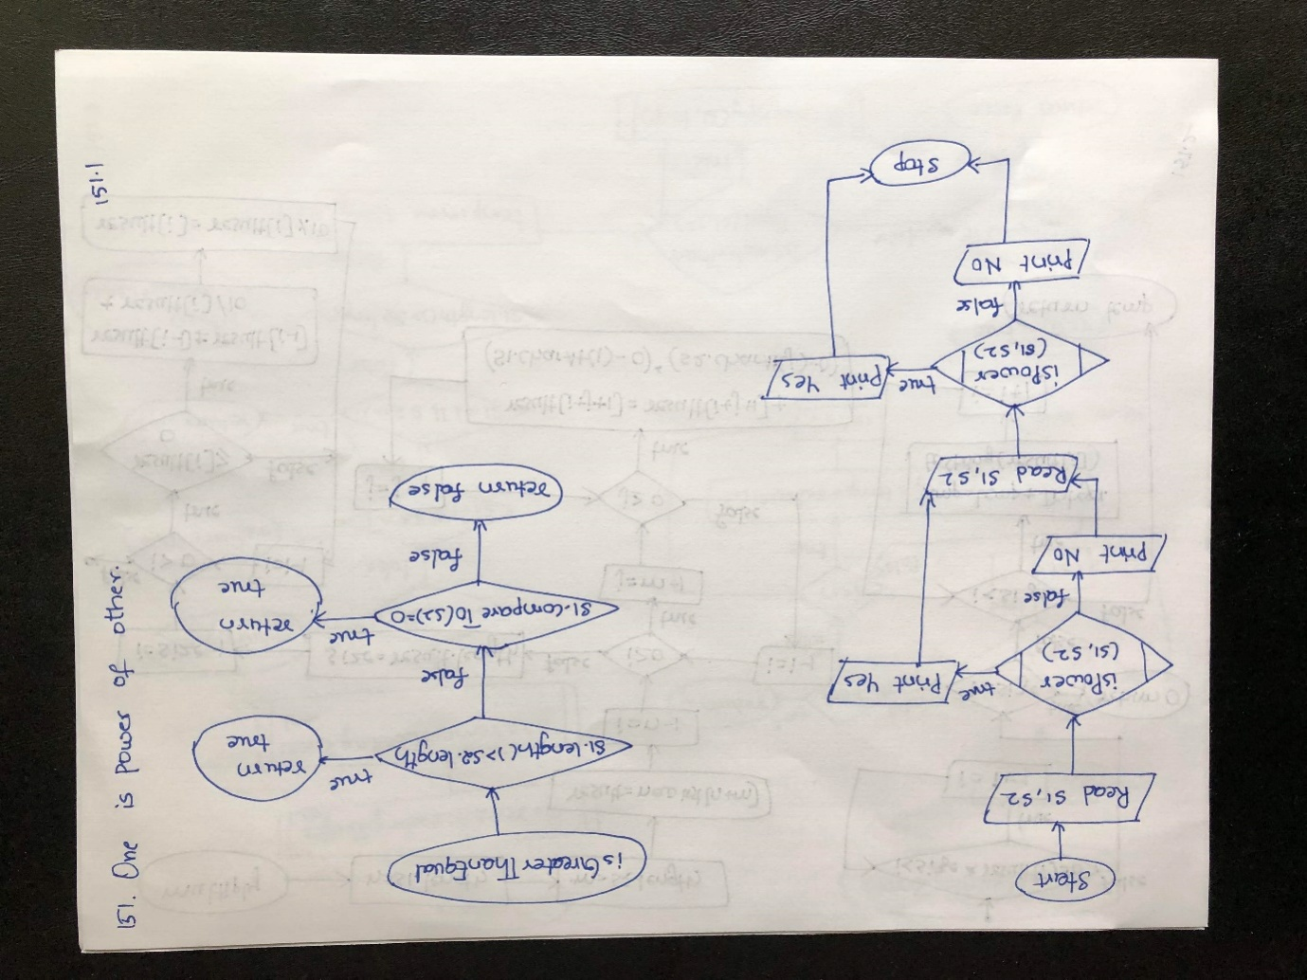

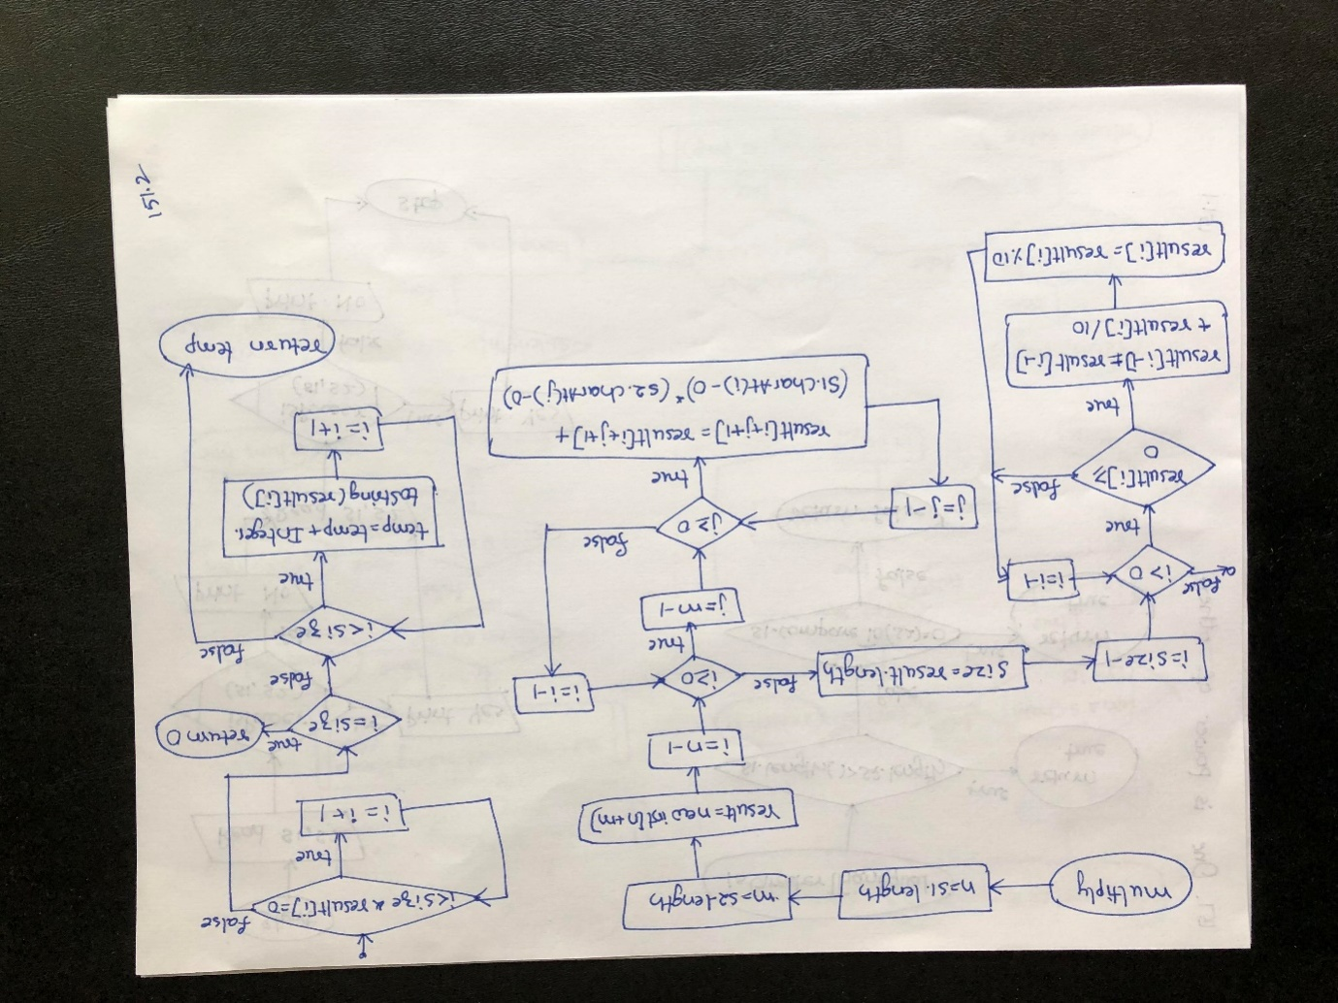

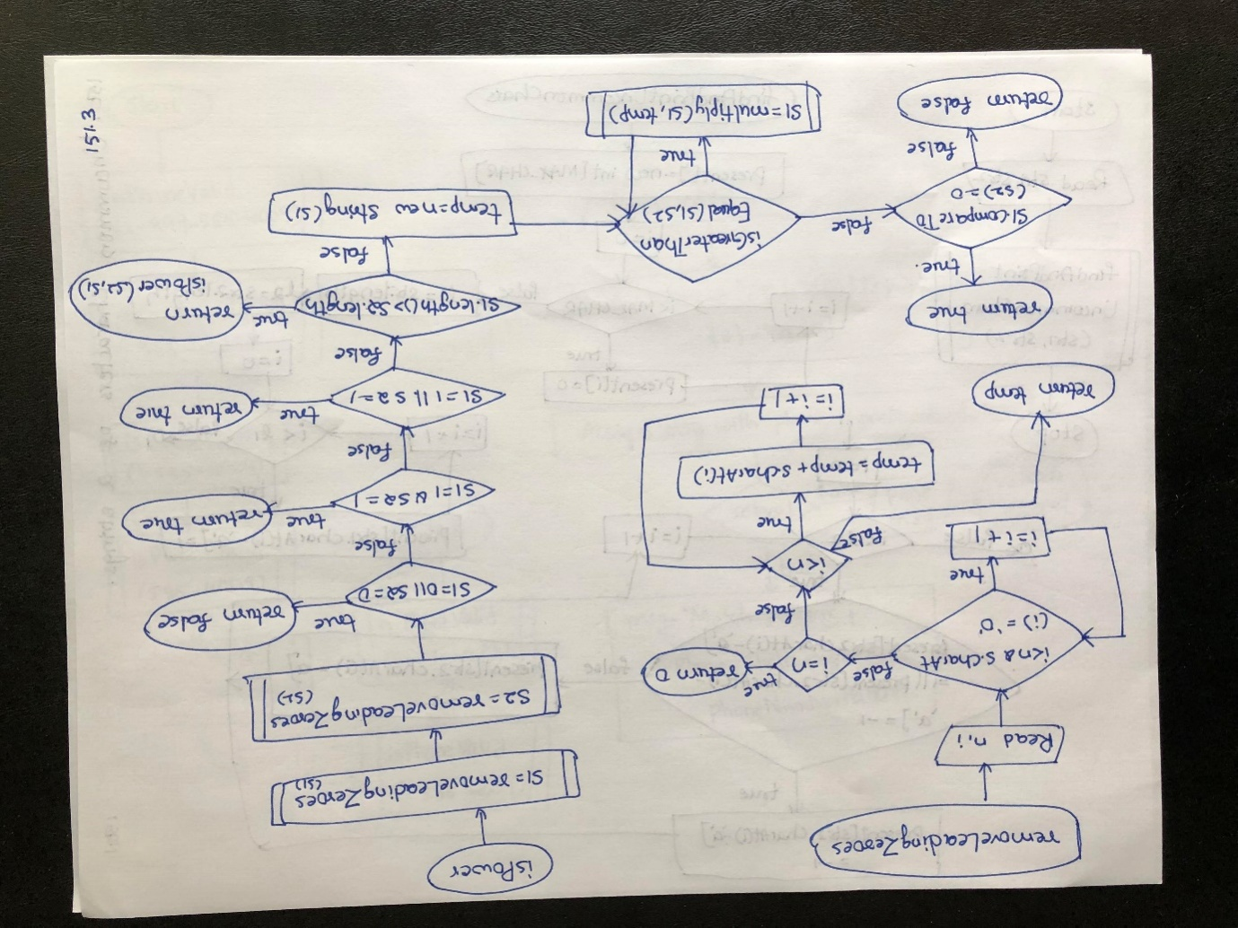

**Algorithm**

**step 1: START**

**step 2: Read s1,s2**

**step 3: Call isPower method with s1,s2 arguments**

**step 4: Enter isPower method**

**step 5: Call removeLeadingZeroes method with s1 argument**

**step 6: Enter the method and read n,i**

**step 7: Check while loop condition.If true,goto step 8 else goto step 9**

**step 8: Increment i value by 1 and repeat step 7**

**step 9: Check if condition.If true,goto step 10 else goto step 11**

**step 10: Return 0 to step 54**

**step 11: Assign "" to temp**

**step 12: Check while loop condition.If true,goto step 13 else goto step 15**

**step 13: Concat temp + s.charAt(i) and assign to temp**

**step 14: Increment i value by 1 and repeat step 12**

**step 15: Return temp to step 16**

**step 16: Return from removeLeadingZeroes method and assign the value to s1**

**step 17: Call removeLeadingZeroes method with s2 argument and repeat step 6.Assign the result to s2**

**step 18: Check if condition.If true,goto step 19 else goto step 20**

**step 19: Return false to step 54**

**step 20: Check if condition.If true,goto step 21 else goto step 22**

**step 21: Return true to step 54**

**step 22: Check if condition.If true,goto step 23 else goto step 24**

**step 23: Return true to step**

**step 24: Check if condition.If true,goto step 25 else goto step 26**

**step 25: Return the value obtained by calling isPowermehtod by repeating step 4 to step 51**

**step 26: Check while loop condition by calling isGreaterThanEqual method and goto step 27.If true,goto step 32 else goto step 51**

**step 27: Enter the method and check if condition.If true,goto step 28 else goto step 29**

**step 28: Return true to step 32**

**step 29: Check if condition.If true,goto step 30 else goto step 31**

**step 30: Return true to step 32**

**step 31: Return false to step 32**

**step 32: Call multiply method with s1,temp arguments and goto step 33**

**step 33: Enter multiply method and assign s1.length to n and s2.length to m**

**step 34: Check for loop condition.If true,goto step 35 else goto step 37**

**step 35: Check for loop condition.If true,goto step 36 else repeat step 34**

**step 36: Add result[i+j+1] + (s1.charAt(i) - '0') * (s2.charAt(j) - '0') and assign to result[i+j+1] and repeat step 35**

**step 37: Assign result.length to size**

**step 38: Check for loop condition.If true,goto step 39 else goto step 42**

**step 39: Check if condition.If true goto step 40 else repeat step 38**

**step 40: Add result[i - 1] + result[i] / 10 and assign to result[i-1]**

**step 41: Assign result[i] % 10 to result[i] and repeat step 38**

**step 42: Check while loop condition.If true,goto step 43 else goto step 44**

**step 43: Increment i value by 1 and repeat step 42**

**step 44:Check if condition.If true,goto step 45 else goto step 46**

**step 45: Return 0 to step 50**

**step 46: Check while loop condition.If true goto step 47 else goto step**

**step 47: Add temp +Integer.toString(result[i]) and assign to temp**

**step 48: Incement i value by 1 and repeat step 46**

**step 49: Return temp to step 50**

**step 50: Return from multiply method and assign the value to s1 and repeat step 26**

**step 51: Check if condition.If true,goto step 52 else goto step 53**

**step 52: Return true to step 54**

**step 53: Return false to step 54**

**step 54: Return from isPowermehtod and check if condition with the result from method.If true,goto step 55 else goto step 56**

**step 55: Print "Yes" and goto step 57**

**step 56: Print "No" and goto step 57**

**step 57: STOP**

Program

**public class** OnePowerOfAnother {  
**static boolean**isGreaterThanEqual(String s1,  
 String s2)  
 {  
**if** (s1.length() > s2.length())  
**return true**;  
**if** (s1.compareTo(s2) == 0)  
**return true**;  
**return false**;  
 }  
  
**static** String multiply(String s1, String s2)  
 {  
**int** n = s1.length();  
**int** m = s2.length();  
  
**int**[] result = **new int**[n + m];  
  
*// Multiply the numbers. It multiplies  
 // each digit of second string to each  
 // digit of first and stores the result.***for** (**int** i = n - 1; i >= 0; i--)  
**for** (**int** j = m - 1; j >= 0; j--)  
 result[i + j + 1] += (s1.charAt(i) - **'0'**) *  
 (s2.charAt(j) - **'0'**);  
  
*// If the digit exceeds 9, add the  
 // cumulative carry to previous digit.***int** size = result.**length**;  
**for** (**int** i = size - 1; i >0; i--)  
 {  
**if** (result[i] >= 10)  
 {  
 result[i - 1] += result[i] / 10;  
 result[i] = result[i] % 10;  
 }  
 }  
  
**int** i = 0;  
**while** (i < size && result[i] == 0)  
 i++;  
  
*// if all zeroes, return "0".***if** (i == size)  
**return "0"**;  
  
 String temp = **""**;  
  
*// Remove starting zeroes.***while** (i < size)  
 {  
 temp += Integer.*toString*(result[i]);  
 i++;  
 }  
**return** temp;  
 }  
  
*// Removes Extra zeroes from front of a string.***static** String removeLeadingZeores(String s)  
 {  
**int** n = s.length();  
**int** i = 0;  
**while** (i < n && s.charAt(i) == **'0'**)  
 i++;  
**if** (i == n)  
**return "0"**;  
 String temp = **""**;  
**while** (i < n)  
 {  
 temp += s.charAt(i);  
 i++;  
 }  
  
**return** temp;  
 }  
  
**static boolean**isPower(String s1, String s2)  
 {  
  
*// Make sure there are no leading zeroes  
 // in the string.*s1 = *removeLeadingZeores*(s1);  
 s2 = *removeLeadingZeores*(s2);  
**if** (s1 == **"0"** || s2 == **"0"**)  
**return false**;  
**if** (s1 == **"1"** && s2 == **"1"**)  
**return true**;  
**if** (s1 == **"1"** || s2 == **"1"**)  
**return true**;  
  
*// Making sure that s1 is smaller.  
 // If it is greater, we recur we  
 // reversed parameters.***if** (s1.length() > s2.length())  
**return** *isPower*(s2, s1);  
  
 String temp = **new** String(s1);  
**while** (!*isGreaterThanEqual*(s1, s2))  
 s1 = *multiply*(s1, temp);  
  
**if** (s1.compareTo(s2) == 0)  
**return true**;  
**return false**;  
 }  
  
*// Driver Code***public static void** main(String[] args)  
 {  
 String s1 = **"374747"**, s2 = **"52627712618930723"**;  
**if** (*isPower*(s1, s2))  
 System.***out***.println(**"Yes"**);  
**else**System.***out***.println(**"No"**);  
  
 s1 = **"4099"**;  
 s2 = **"2"**;  
  
**if** (*isPower*(s1, s2))  
 System.***out***.println(**"Yes"**);  
**else**System.***out***.println(**"No"**);  
 }  
  
}

O/P

Yes

No

**143.Find largest word in dictionary by deleting some characters of given string**

**Program**

**import** java.util.Arrays;  
**import** java.util.Vector;  
  
**public class** LargestWordDictionary {  
*// Returns true if str1[] is a  
 // subsequence of str2[]. m is  
 // length of str1 and n is length of str2***static boolean**isSubSequence(String str1,  
 String str2)  
 {  
**int** m = str1.length(), n = str2.length();  
  
**int** j = 0; *// For index of str1 (or subsequence)  
  
 // Traverse str2 and str1, and compare current  
 // character of str2 with first unmatched char  
 // of str1, if matched then move ahead in str1***for** (**int** i = 0; i < n && j < m; i++)  
 {  
**if** (str1.charAt(j) == str2.charAt(i))  
 {  
 j++;  
 }  
 }  
  
*// If all characters of str1  
 // were found in str2***return** (j == m);  
 }  
  
*// Returns the longest String  
// in dictionary which is a  
// subsequence of str.***static** String findLongestString(Vector<String>dict,  
 String str)  
 {  
 String result = **""**;  
**int** length = 0;  
  
*// Traverse through all words of dictionary***for** (String word : dict)  
 {  
  
*// If current word is subsequence of str  
 // and is largest such word so far.***if** (length <word.length() &&  
*isSubSequence*(word, str))  
 {  
 result = word;  
 length = word.length();  
 }  
 }  
  
*// Return longest String***return** result;  
 }  
  
*// Driver code***public static void** main(String[] args)  
 {  
 String[] arr = {**"ale"**, **"apple"**, **"monkey"**, **"plea"**};  
 Vector dict = **new** Vector(Arrays.*asList*(arr));  
 String str = **"abpcplea"**;  
 System.***out***.println(*findLongestString*(dict, str));  
 }  
  
}

O/P

apple

**144. Generate all binary strings from given pattern**

**Algorithm**

**step 1: START**

**step 2: Read input,str**

**step 3: Call print method with str,0 arguments**

**step 4: Enter if condition.If true,goto step 5 else goto step 6**

**step 5: Print str and return to step 13**

**step 6: Check if statement condition.If true,goto step 7 else goto step 12**

**step 7: Assign '0' to str[index]**

**step 8: Call print method with str,index+1 arguments and repeat step 4**

**step 9: Assign '1' to str[index]**

**step 10: Call print method with str,index+1 arguments and repeat step 4**

**step 11: Assign '?' t str[index]**

**step 12: Call print method with str,index+1 arguments and repeat step 4**

**step 13: Return from method**

**step 14: STOP**

Program

**public class** GenerateBinaryStrings {  
*// Recursive function to generate all binary  
 // strings formed by replacing each wildcard  
 // character by 0 or 1***public static void** print(**char** str[], **int** index)  
 {  
**if** (index == str.**length**)  
 {  
 System.***out***.println(str);  
**return**;  
 }  
  
**if** (str[index] == **'?'**)  
 {  
*// replace '?' by '0' and recurse*str[index] = **'0'**;  
*print*(str, index + 1);  
  
*// replace '?' by '1' and recurse*str[index] = **'1'**;  
*print*(str, index + 1);  
  
*// NOTE: Need to backtrack as string  
 // is passed by reference to the  
 // function*str[index] = **'?'**;  
 }  
**else***print*(str, index + 1);  
 }  
  
*// driver code***public static void** main (String[] args)  
 {  
 String input = **"1??0?101"**;  
**char**[] str = input.toCharArray();  
*print*(str, 0);  
 }  
  
}

O/P

10000101

10001101

10100101

10101101

11000101

11001101

11100101

11101101

**145.Find all palindromic sub-strings of a given string**

**Program**

**import** java.util.ArrayList;  
**import** java.util.List;  
  
**public class** PalindromeSubstring {  
**public static** List<String>allPalindromeSubstring(String s)  
 {  
 List<String> list = **new** ArrayList<String>();  
  
*// moving the pivot from starting till end of the string***for** (**float** pivot = 0; pivot < s.length(); pivot += .5) {  
  
*// set radius to the first nearest element  
 // on left and right***float** palindromeRadius = pivot - (**int**)pivot;  
  
*// if the position needs to be compared has an element  
 // and the characters at left and right matches***while** ((pivot + palindromeRadius) < s.length()  
&& (pivot - palindromeRadius) >= 0  
&& s.charAt((**int**)(pivot - palindromeRadius))  
 == s.charAt((**int**)(pivot + palindromeRadius))) {  
  
list.add(s.substring((**int**)(pivot - palindromeRadius),  
 (**int**)(pivot + palindromeRadius + 1)));  
  
*// increasing the radius by 1 to point to the  
 // next elements in left and right*palindromeRadius++;  
 }  
 }  
  
**return** list;  
 }  
  
*// Drivers code***public static void** main(String[] args)  
 {  
 List<String> list = *allPalindromeSubstring*(**"hellolle"**);  
 System.***out***.println(list.size());  
 System.***out***.println(list);  
 list = *allPalindromeSubstring*(**"geeksforgeeks"**);  
 System.***out***.println(list.size());  
 System.***out***.println(list);  
 }  
  
}

O/P

13

[h, e, l, ll, l, o, lol, lloll, ellolle, l, ll, l, e]

15

[g, e, ee, e, k, s, f, o, r, g, e, ee, e, k, s]